What I Love about America

Mitch Million’s Class
Central Carolina – Siler City

Objectives
Students will
- hear the experiences of someone who came to the United States and became a citizen and productive member of society.
- respond in writing with ideas that come as a result of hearing about this experience.

Procedure
- Manuel Colorado Reyes came to class to speak to the students about his experiences. He is an immigrant from El Salvador who went through a lengthy process to become a legal resident and eventually a citizen. Now he works for the Coalition for Family Peace in Chatham County.
- After the session, the students discussed what they love about America and about being in this country. Then they wrote their individual thoughts and feelings.

Observations
- In sharing their feelings, the students expressed some very interesting observations about America.



What I Love about America

I like to know people from other countries, their beliefs and traditions. I have known different kinds of food. America has clean streets. There is no overpopulation of dogs or cats. I have the opportunity to learn English and I have access to use internet absolutely free. I also have more purchasing power than in my country. I have seen animals like deers, racoons, possums, squirrels, snakes. I have seen a thing that I’ve never seen: the snow storm, and that was beautiful.

~Alma Valerio Perez

Graphic from http://office.microsoft.com/en-us/clipart/default.aspx

What I Love about America

I love America because this country has the best food and has more jobs for many people and some people are very friendly with the latin people. I love America because this country has the mountains and beach very pretty and the fall is very beautiful and I like the winter because the snow falls and I can play with this snow. I love America because I live better and I like the biggest stores because it has more different things. I love America because when I was child I dream with come here this country. I love America forever.

~Jose Morales

Graphics from http://office.microsoft.com/en-us/clipart/default.aspx

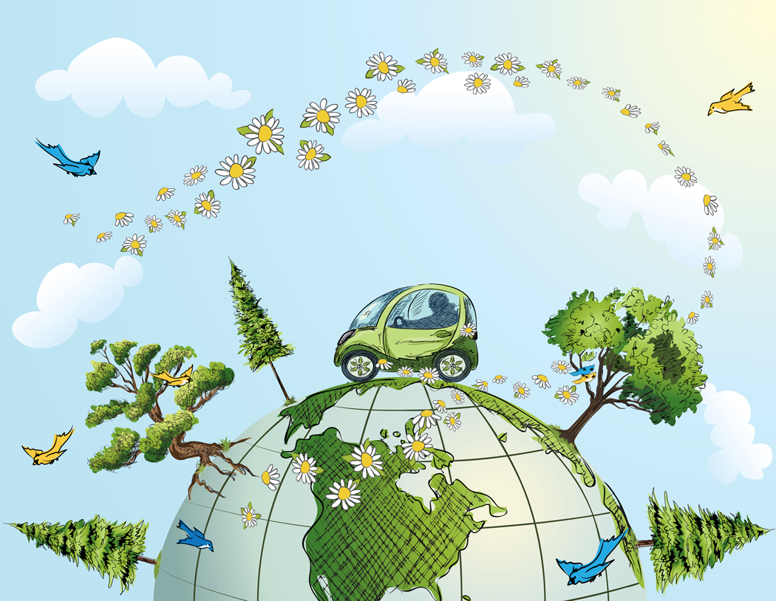
What I Love about America

I love it because you feel free to talk, to go places, and I don’t have to worry about have a kidnapping or pay to the police for their coffee. Plus I want to learn more English in the future, because I want to have a better job or help my children do their homework. I love this country because I have a car, food, house. In my country I never had a car or good food.

~Maria Flores
Graphic from http://office.microsoft.com/en-us/clipart/default.aspx
What I Love about America


I love this country because it has the opportunity for everybody who would like to reach it. This country gives us a better improvement to get our goal, I have seen many people that they start from the begin to reach what they want in their minds.
~Juan Alvarado
Graphic from http://office.microsoft.com/en-us/clipart/default.aspx

