What I like and don’t like about the United States.

By
Herculano
Lilia
Marcela
Felix
Antonio
Aidalmo
Elizabeth

Graphic from http://office.microsoft.com/en-us/clipart/default.aspx

My name is Herculano.
I like about the United State is Education.

I like about the United State is much larger.

I like about the United State is good for work.

I like about the United State is better cheaper food.

I like about the United State is better doctor.

I like about the United State is Medicaid.

I like about the United State is jobs/work morning noon and nithg.

I don’t like about the United State is nothing.

Graphic from http://office.microsoft.com/en-us/clipart/default.aspx

My name is Lilia.

I like about the Untied States when I go to the shoping.
I drive my car and cheaper food and Medicaid for my doouthers.

I don’t like about the United States price is more.

The English is hard.

I can not go to the visit my family.

Originally thought

I thought about the United States:

All the houses are big and new.

Graphic from http://office.microsoft.com/en-us/clipart/default.aspx

My name is Marcela.

I like about the United States?
Medicaid, education, the stores.

I don’t like about the Untied States?
Driving laws, no license, not much work.

I thought the United States had a lot of money to send money home.

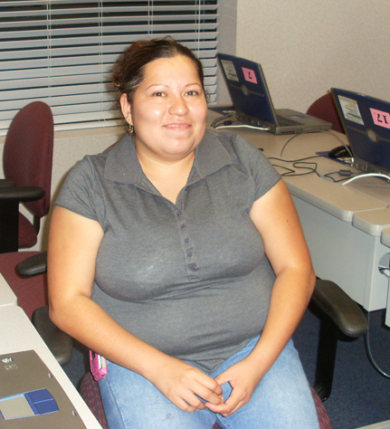

Graphic from http://office.microsoft.com/en-us/clipart/default.aspx

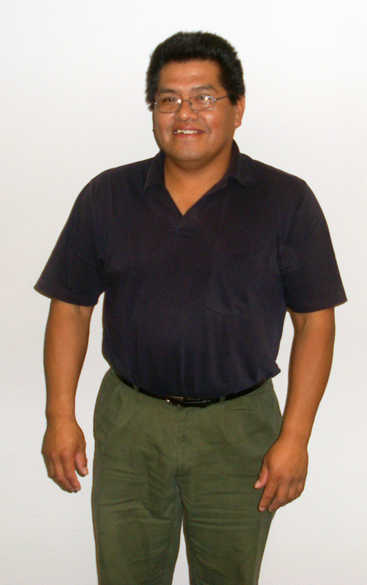
My name is Felix Morales

I like the United States is good for work.

I like jobs.

I like protection of animals.

I like education.

I like Freedom.

I like the stores.

Graphic from http://office.microsoft.com/en-us/clipart/default.aspx

What do you think about the Untied States?
What was Different than you originally thought?

Good

My name is Antonio, I like your education.

I like protection of animals.

I’m entertained by the store.

I like better doctor.

Bad

I don’t like discrimination.

I don’t like the price the gas.

I don’t like the economy.

Graphic from http://office.microsoft.com/en-us/clipart/default.aspx

My name is Adialmo.

I don’t like about the United State is
Bad for president not much work.

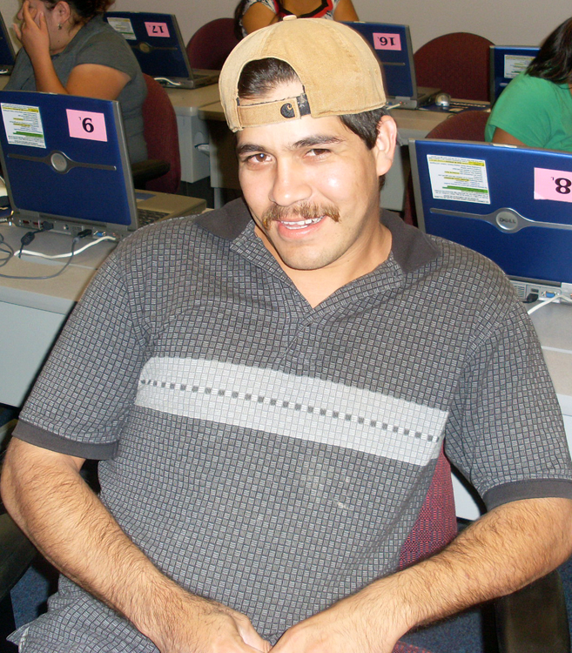

Graphic from http://office.microsoft.com/en-us/clipart/default.aspx

My name is Elizabeth.

I like about the United Staees?
Is better life for children, Medicaid.
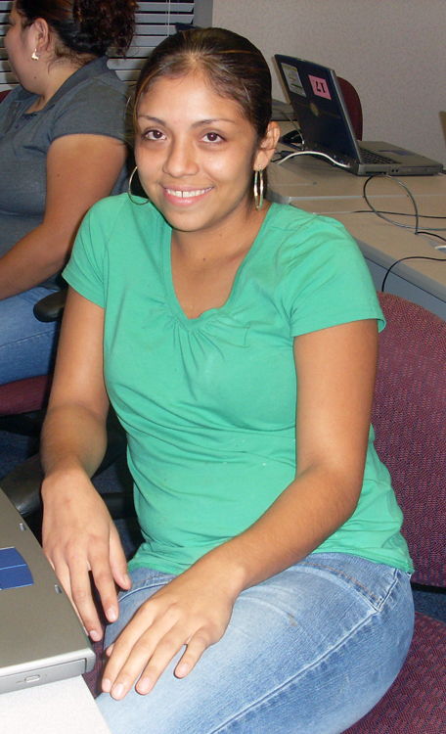
I don’t like abou the United State is
Driving laws. No license.

I though the United States had a lot of money.

Graphic from http://office.microsoft.com/en-us/clipart/default.aspx

