Freedom of Speech

By Tommiann Hill
Rockingham Community College



Graphic from http://office.microsoft.com/en-au/clipart/default.aspx

Objectives
Students will
- Learn the source that guarantees certain fundamental rights—such as freedom of speech—to everyone living in the United States.
- Participate in class discussion on What I Like and Dislike about the United States—a topic that encourages open expression of positive and negative opinions
- Use a simple format to write their likes and dislikes
- Share their work with classmates

Level
This project works at all levels of English instruction. My students are Beginning ESL students with limited English skills, and the majority of the class has been in the country less than one year. Their writing shows their ability using English, and the writing of more advanced students doing this exercise will reflect their greater competence with English. For this project, however, conveying the concept of freedom of speech is the central focus.

Approach
- Before class begins, write the following statement on the whiteboard:
What I Like and Don’t Like about the United States.

Graphic from
http://office.microsoft.com/en-au/clipart/default.aspx

- Prepare students to speak openly about their thoughts and feelings regarding the United States by asking them first about their country of origin. For example:
- Where are you from?
- What did you like about your country?
- What didn’t you like about your country?

- Encourage students to converse with one another about their native country. Allow students, who are shy and have limited English skills to participate in their own language. This helps students become less anxious about the “right” answer when speaking.

- Read the statement on the whiteboard. Then on one side of the board, write LIKE and on the other side of the board, write DON’T LIKE as shown in the example below:

What I like and don’t like about the United States

LIKE DON’T LIKE


- Facilitate the process of “open” speaking/talking. Begin with LIKE, and write the students’ spoken thoughts/ideas about what they like underneath the word. Encourage students to help classmates with limited English skills to translate their thoughts/ideas.
After exhausting all the LIKES, begin with DON’T LIKE. Typically students shy away from expressing any dislikes of the United States. Now is the time to introduce Freedom of Speech.

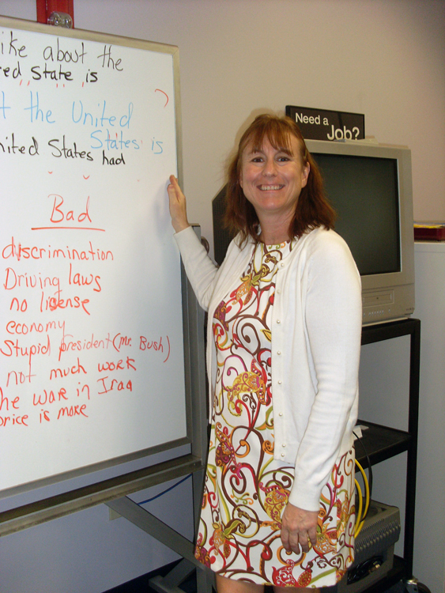
- Explain Freedom of Speech. Students frequently are unaware of the Bill of Rights and the fundamental rights of the people that it protects from government power.
Explain that the Bill of Rights is the First Ten Amendments to the Constitution. The First Amendment guarantees freedom of speech to everyone living in the United States whether they are a U.S. citizen or not.
After talking about the First Amendment, my students still had some difficulties with expressing any dislikes about the United States. However, their ultimate responses were very insightful and thought provoking.

Tommiann S. Hill
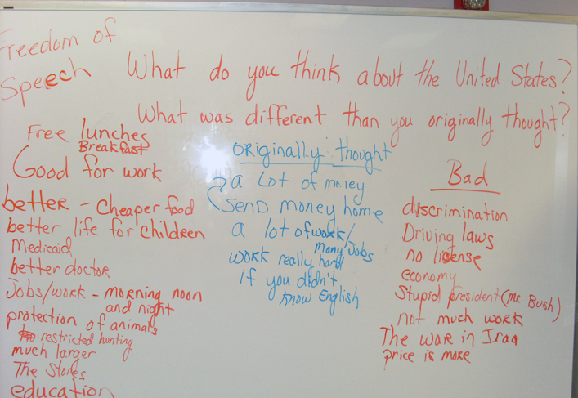
- Fact or Fiction? Ask students the following pair of questions:
What did you originally think about the United States?
What is different from your original thoughts?
I wrote the responses from my class in the middle of the board.

- This was my favorite part of the lesson. Students shared what their expectations and thoughts about the United States were before immigrating here. I was able to assure them that their original thoughts and feelings were not unusual or different from those of previous immigrants who—historically—thought the streets were paved with gold and all Americans were very rich. We compared the students’ pre-immigration ideas with the reality of their actual experiences in the U.S.A.

Compile Ideas and Thoughts
Give students a simple writing format to compile their ideas and thoughts:

Things I like about the United States. ________________.

Things I don’t like about the United States. ____________.

Originally I thought the United States ______________.

Allow them to use the ideas/thoughts on the white board as a guide. They may copy (beginning level) or free write (high intermediate or advanced levels) the thoughts and ideas that best represent them.


Have the students turn in their work. Carefully preserving their spelling and grammar, I typed the students’ writing in Microsoft Word and presented the class with their own thoughts in a booklet. My students enjoyed seeing their work in “published” form. A copy of their writing accompanies this document.

Graphic from
http://office.microsoft.com/en-au/clipart/default.aspx

