My American Dream

By Carol O’Brien
Central Carolina – Siler City

Objectives
Students will
- hear the experiences of someone who came to the United States and then went through the process of becoming a citizen and a productive member of society
- respond in writing with their own ideas that come as a result of hearing about this experience

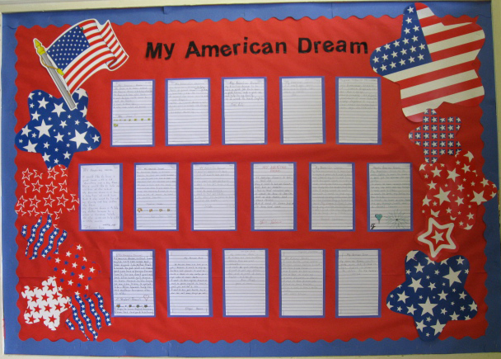
Procedure
- Manuel Colorado Reyes came to our class to speak to the students about his experiences. He is an immigrant from El Salvador and went through a lengthy process to become a legal resident and eventually a citizen. Now he works for the Coalition for Family Peace in Chatham County.
- After the session, I had the students to think about what he had said, and what their American Dream might be. I wrote a sample on the board to give them ideas and possibly provide vocabulary words. The students then wrote about their own thoughts and aspirations.
- When they were finished, each student read aloud his or her story to the class.
- I had them write a final copy on lined paper, and then I displayed them on a bulletin board in our room. You can read their work on the following pages.

Comments
- This was a very interesting lesson that the students seemed to really get into and enjoy.
- Displaying the writing allows the students to read one another’s work, as can students from other classes.
- I was pleased and somewhat surprised at the depth of understanding the students had and how well they expressed themselves.

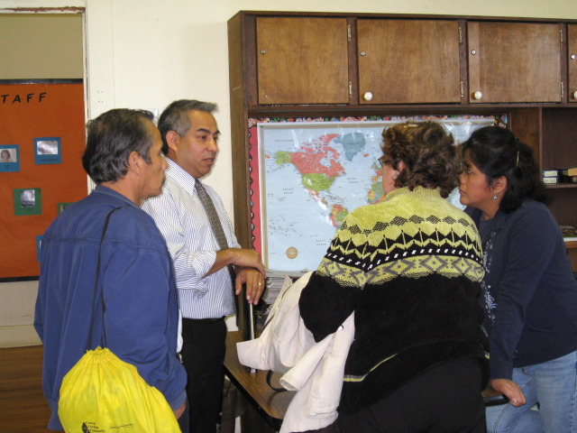

Our speaker chats with interested participants.



My American Dream

My American dream is first learn English, so I can work and have a good Job. After that I want to get a lot of money and can buy a house for my family so we don’t pay rent and also want get money to have money in the bank so we can have a quiet life. Also I want help to my mother because she is old.
Rubi Perez
Graphic from http://office.microsoft.com/en-us/clipart/default.aspx
My American Dream
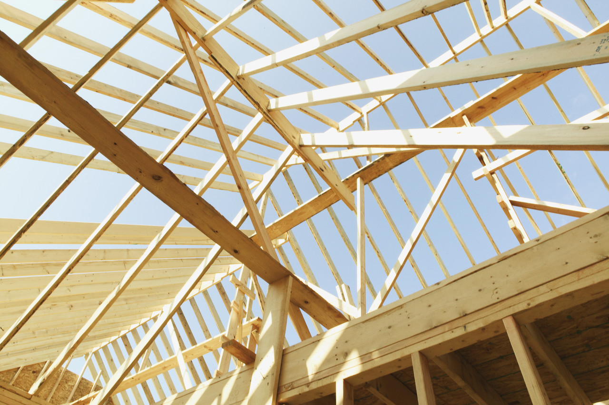
I came to the united states to earn money because I want to have a nice House. Also I want to help my family and to help my sister get a good Education in Mexico. I need to have a good job. I need to learn English. Also I need to have a better future. and many things.
Santos Gonzalez
Graphic from http://office.microsoft.com/en-us/clipart/default.aspx

My American Dream



My American Dream is to have a good job.
Then I need to help my family and help my daughter get a good education also
I want to have a good car and a big home and many things.
But I need to Learn English to have Good work.

Efrén Valencia

Graphic from http://office.microsoft.com/en-us/clipart/default.aspx

My American Dream

My American dream is to look for a job, because I want to help my brothers and parents. I want to build a house in my country for a life wher I come back
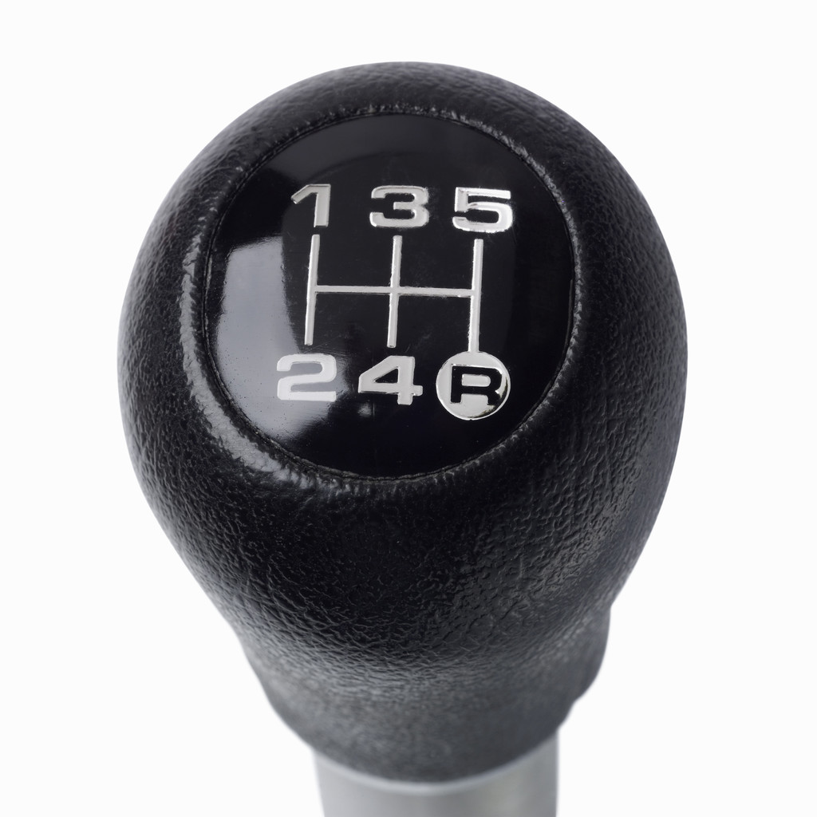
I want to learn English, because I need to speak English to have a good job and that I like
I want to have good health, buy a new car and many things for me.

Eleazar Herrera

Graphic from http://office.microsoft.com/en-us/clipart/default.aspx
My American Dream

My American dream is to learn English in maybe 2 years so I need to learn and obtain my GED and then look for good work in order to have money so that my daughters can study for the career that they like. I also want to work because I need to help my husband to pay bill and can in the future buy a beautiful house. My dream is that I can bring my mother to United States and she can stay with me a long long time.
Xochitl Salazar

Graphic from http://office.microsoft.com/en-us/clipart/default.aspx

My American Dream

I would like to have a good house with a lot of furniture and a big farm. Also I would like to help my children at the school. My American dream is to have a long time of work here. But, I also want to live with my family and buy clothes for them. My American dream is to help my father because he is alone in Veracruz State. He also needs my help with a little money. Artemio’s hope.
Artemio Feliciano

Graphic from http://office.microsoft.com/en-us/clipart/default.aspx

My American Dream
My American Dream is to learn English to get my G.E.D. in order to get a good job for a good Education for my children and I want to have a nice and big house with a nice pool. I also want to help my parents. I want to have a lot of money to travel to another country.

Miguelina Zagada
Graphic from http://office.microsoft.com/en-us/clipart/default.aspx

My American Dream


My American dream is to learn English. I want to have a good job to provide for my family. I want to have enough money to pay my bills and buy things I need and I like. I want to form my family in the U.S.A. I want to have a nice house, one car, strength, health, and a driver’s license.
Miguel Carpio

Graphic from http://office.microsoft.com/en-us/clipart/default.aspx

