America through My Eyes

By Dr. Nutan Varma, Ph.D.
Central Carolina – Harnett Campus

Objectives
Students will
- Improve their oral and written communication skills
- Understand how to use and integrate technology (computer skills) into a writing assignment
- Feel less reluctant about writing and gain self confidence as a writer
- Exhibit a more positive attitude toward writing in English

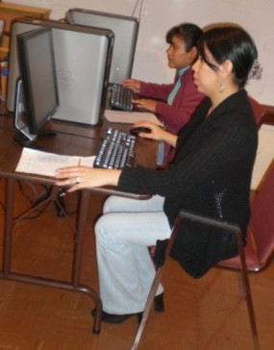
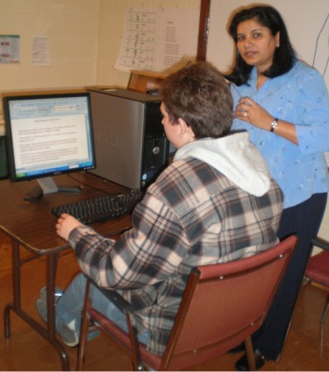

Level
I have a multilevel class of beginning, intermediate and advanced-level students.

Time
This class meets three days a week for four hours a day. We spent two hours daily for three consecutive days on this project.

Background
First of all, I explained to my students that I wanted them to write some of their thoughts about America or Americans, and that their opinions are neither right nor wrong. The purpose of this assignment is for them to communicate clearly-- writing in English--what they feel or think.

Selecting Topics
We did extensive research on the internet and held a group discussion in the class to pick topics that the students would find comfortable and familiar to write about. We selected five topics that relate to the United States from different perspectives.

- My Vision of U.S. Citizenship
- Moving to America: A Culture Shock
- My American Dream
- Obesity Taxes on Unhealthy Foods: Is It Fair?
- I Moved to America!

One of my students is planning to apply for U.S. citizenship soon. She decided to write about the importance of U.S. citizenship for an immigrant from her own perspective. My beginning students tended to opt for writing about moving to America. Samples of my students’ writing are included at the end of this lesson plan.

Procedure
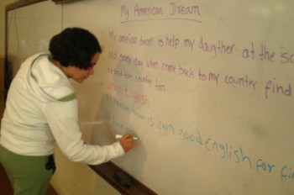
We picked one topic at a time. I wrote the title on the board and asked each student to come up with one idea or his/her own experience on the particular topic. I encouraged them, especially the beginners, to write on the board. They were allowed to discuss and help each other in this process.
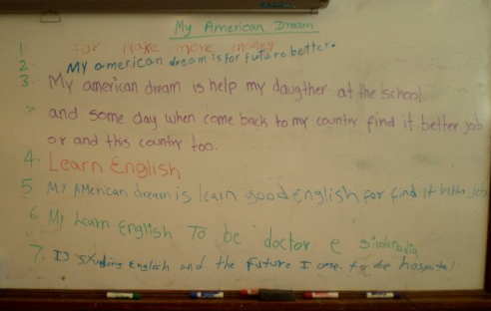

Next each student picked one topic for their own writing. Before they started their actual writing, I encouraged them to go on the computer and surf the internet to explore their particular topic.

To make the writing project easier for my beginners, I asked them to use graphic organizers for documenting their ideas. Graphic organizers help students brainstorm, sequence, and organize the events. Different kinds of graphic organizers such as story star, fishbone, 5 W’s chart, tree chart, and others are available on the internet. (Use any search engine to look for graphic organizers.) My beginners used ‘story star’ and ‘5 W’s chart’ for their stories.

My students occasionally used illustrations to support their writings. Afterward, they typed their handwritten stories on the computer.

Observations
My students were highly motivated, but at the same time they were nervous too. They tried their best to communicate their ideas, thoughts, and experiences through writing and group discussion.

Their primary writing problems typically involved difficulty expressing concepts and ideas in English. In my opinion it's better to focus first on content rather than grammar problems in the context of their writing.

Some of the students were initially reluctant, but with their classmates’ help and my assistance they did this work successfully. They liked sharing their thoughts/ideas and experiences with each other in the class. Toward the end, I found the students were less hesitant and less overwhelmed by the writing assignment. They were more confident and comfortable using technological tools throughout the writing process.

As a teacher I will continue to explore the use of technology in teaching writing and find ways to help my students help themselves improve their academic writing skills.
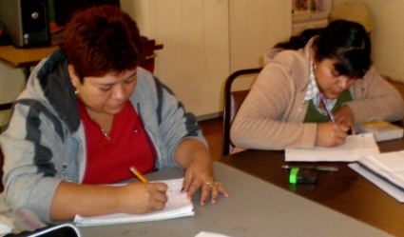

My References

1) Obesity Tax
http://www.dailyspark.com/blog.asp?post=should_we_impose_an_obesity_tax_on_soft_drinks

2) http://www.sixwise.com/newsletters/07/05/16/norway-seriously-considers-an-obesity-tax-should-the-us-impose-one-too-tell-us-what-you-think.htm

3) Culture Shock
www.orphanagesupport.org/information/CultureShock-PartII.pdf

4) Graphic Organizers
http://www.eduplace.com/graphicorganizer/

5) American Dream
http://web.mit.edu/cultureshock/fa2006/www/essays/mydream.html

6) Graphics (clip art)
http://office.microsoft.com/en-us/clipart/default.aspx

Graphic from http://office.microsoft.com/en-us/clipart/default.aspx

Graphic Organizer: Story Star



Title

 | Writing | Illustrations
Who
What
Where
When
Why
Graphic Organizer: 5 W’s Chart

My Vision of U.S. Citizenship

By: Bibiana Pardo B.

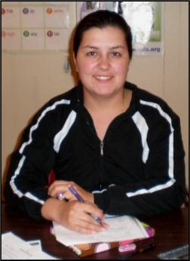

I was born in Colombia and Lived there for 24 years.

I’m married. My Husband is north American.

I need to imigrate into this country, Because his work is here.

Shortly after arriving, I discovered that the U.S. is a big country
with much advanced tech and many laws and regulations.

Right now I go to English class to improve my English.

I need my citizen ship to live in this country as a US citizen.

So I can vote and find good job in the office.

Moving to America: A Culture Shock

By: Paulina Flores
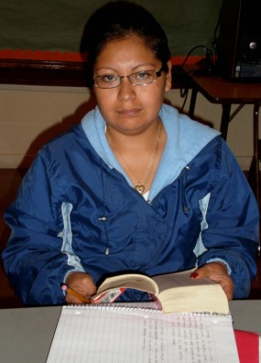

I’m Paulina Flores from Mexico My hosband work in wood floor
My children are 9 year and the other is 3 years

We moved to America on 1991
We moved to have better Job, better home, better life

It’s no easy. In Mexico is diferent lenguege
the people speaking Spanish. American speaking ingles

the food is good in Mexico. Peoples eat spice in the food
And in America food not spicy.

In Mexico is diferent festival and in America diferent.

My children born in this contry They likes American culture
But me and my hosband Mexican. It’s difficolt!
Graphic from
http://office.microsoft.com/
en-us/clipart/default.aspx
Moving to America: A Culture Shock
By: Felipe Arroyave

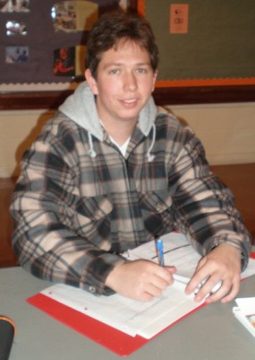
Hello every one, my name is Felipe Arroyave, I am from Bogota Colombia, and I came to the United States in November 2008 to learn and improve my english. I’m a Microbiology student in Colombia.

In this moment I can feel some culture shock, ‘cause this country have different statements and rules. All the people in other countries think that America will be, the best future for there families, but they don’t know about the culture shock, ‘cause in their countries the models are different than here in America.

First of all in Colombia the children doesn’t has a lot of independence ‘cause they live with their parents maybe all the life, but here in the United States the children has a lot of independence and most of the time they move on with his friends or with his girlfriend to a small house or to an apartment.

Second, in Colombia the parents can educate their children in the way that they preffer. They can scream and spank them, but always they must have a good reason to do it. In contrast here in the United States you can’t scream or hit your child ‘cause it’s illegal, and in the schools the kids learn kind of things their parents can’t do.

In conclusion, I can say that here in the United States the life is better for all the opportunities that the people have, but I preffer my country, ‘cause I lived there all my life and I’d go back there in May 24, 2009 ‘cause I love the way that I can live there, and I don’t want to live a culture shock in the six months that I’m going to be here in the United States.
Moving to America: A Culture Shock

By: Rosa Ochoa

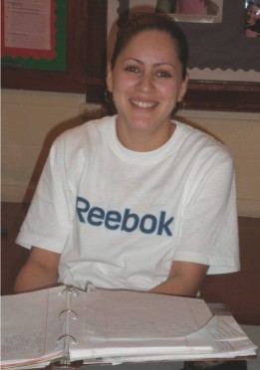

My name is Rosa Ochoa. I was born in Mexico.

When I moved to America there was a lot different from my country.

First I didn’t speak English. That was so difficult for me because when I went to High school I didn’t understand anything.

The other thing different was the food. It had different taste.

It was difficult for me to get used to different money than Mexico.

But now I feel better because I can speak English and I can read.
My American Dream

By: Nuvia Vasquez
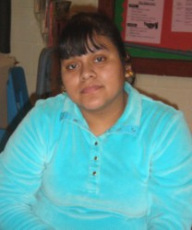

My name is Nuvia Vasquez De Leon.

I am from Guatemala.

I am come here in 2002.

I am married. I have 2 daugthers.

I am come here for find a better life,
and work for make more money,
For eat better than my country, and for better house.

In this moment my dream is learn English
for help me and my daughter in the store, in the school,
and in the doctor clinic.
My American Dream

By: Susana Hernandez
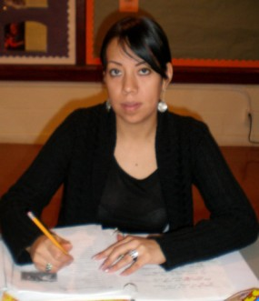

My name is Susana. I’m from Mexico. I’m come to USA in 2003. I’m married and I have a daughter.

The reason for come here is for find a better life and security and make more money for get a comfortable and beautiful house. My husband hard work will one day make good business while I learn English for help me in the daily life, in the hospital, in the store, in the school and also help my daughter at the school so in the future she can be a successful person in her life.

In this moment my dream is learn more English and speak good English too. I want to get ready for one opportunity of find good job in this great country.

Obesity Taxes on Unhealthy Foods: Is it fair?

By: Ana Morales
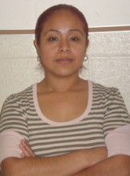

I’m Ana Morales. I from Mexico, Veracruz.

Mi opinion is the higher taxes on unhealthy foods in my opinion are unfair.

The taxes in North Carolina are the highest taxes in the United States.

I do feel that obesity is a real problem for adults and children.

The people who have weight problems due to over eating junkfood can only help themselves.
They are adults.

Mi opinion is government not interfere.

More education is necessary on unhealthy foods.
Obesity Taxes on Unhealthy Foods: Is it fair?

By: Benita Escandon
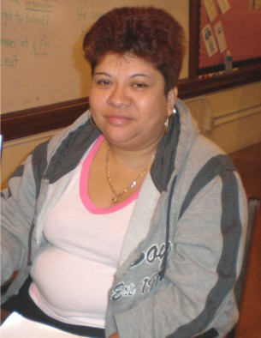

My name BENITA.

My question is why paid heavy taxes in the food.

The food is good for everyone.

It is better to paid more taxes on the cigarret and Alcohol.

So more peoples are healthy.

The world is better smoking free.
President should lower the price of healthy food.

Peoples need educaton for healthy food.

So more families are HAPPY.

Graphic from
http://office.microsoft.com/en-us/clipart/default.aspx
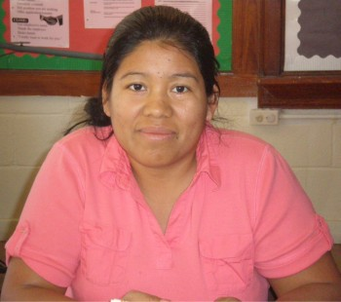
I Moved to America

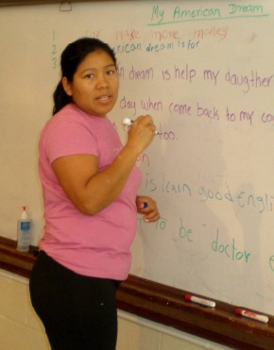
By: Estela Castro
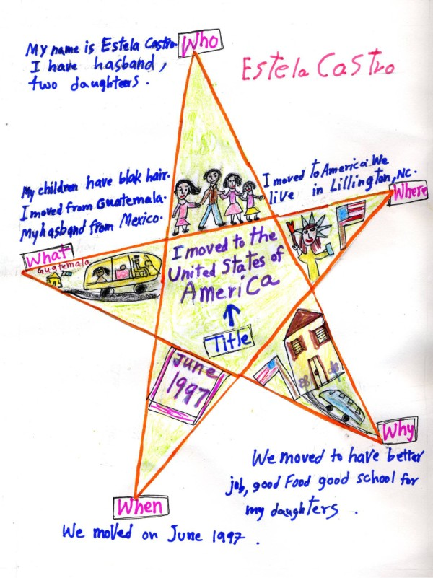

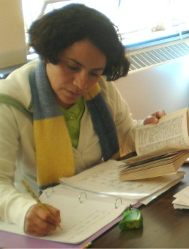

I Moved to America
By: Miguelina L. Suazo
Who | I am Miguelina.  I have husband.  My two girls ten and five. My is beautiful FamilY.
What | I moved from Mexico.  Say bye my family in Mexico. | 
Where | I came to The united states of America. Now setelled in north Carolina. | 
When | I come America in October 1997 with mi family. Now live in LiLLington. | 
Why | I come America for learn English.  We like street clean, lot of money, good job, and free school.
Graphics fromhttp://office.microsoft.com/en-us/clipart/default.aspx

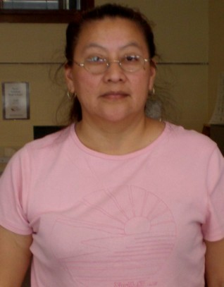
I Moved to America
By: Artemia Coronel
Who | I’m Artemia Coronel.  I have three children.  I am from Mexico. I love my family.
What | We my family and I  move from Mexico.  I have 3 brothers in Mexico.  I miss my family.
Where | We move to America.  I live in Lillington North carolina.  I go CCC college for learn English. | 
When | We come to America on May 1994. Live here for 14 years.
Why | I move to have better life, more money, good house, good car. | 
Graphics fromhttp://office.microsoft.com/en-us/clipart/default.aspx
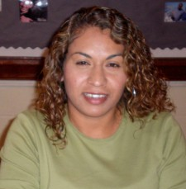
I Moved to America
By: Ana Lilia De Paz
