America Faces Her Future
By Scott Crisco
Stanly Community College

Teaching Objective
Students will increase their knowledge about American government through reading, discussing, and writing about social, economic, and political concerns and issues.

Goal 1: Vocabulary
I began this project with the following basic terms that students need in order to talk about the social, economic, and political issues facing America in 2009. The students looked up definitions, learned to pronounce, and learned to use these terms. They wrote sentences with the words to show they understood the meanings.
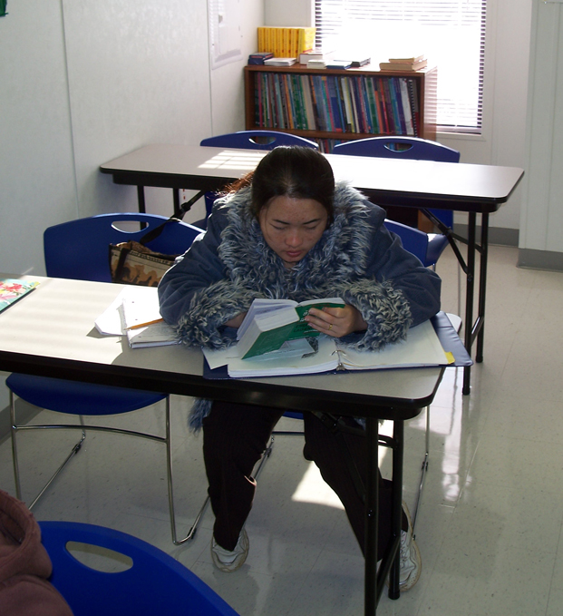
employment | credit
economy | interest rate
education | bankruptcy
war | dropout rate
global warming | Middle East
medical reform | Obama
unemployment | Medicare
 | recession

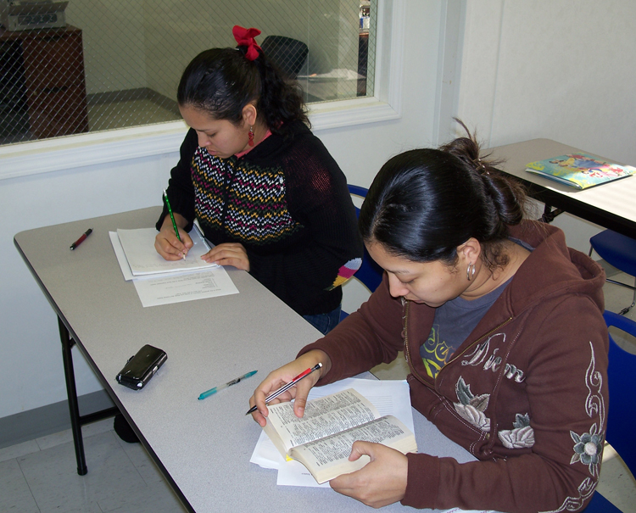

Goal 2: Writing
My next step in this project was to give students the handout to complete. It was called “What is the greatest concern or issue you think the United States will face in the New Year?” I again went over the vocabulary terms as they relate to our government. The students then wrote about what they think will be the most important issue. They typed their writing on the computer. I made the most critical corrections and gave their papers back and asked them to re-type the corrected version on the same page. A copy of the handout I used for this assignment is included at the end of this project plan, as is the students’ finished written work.

Goal 3: Gaining Greater Knowledge
Our class also prepared by working on some lessons from the CD titled “The Disk Library Volume 1, NC Lesson Plans for ESL.” The specific lessons used are from the Caldwell section year 1 and 2:
1. Common Medical Terms
2. U.S Money
3. Banks
4. Budgeting Skills
We did these particular lessons over a three-week time period.

These same lessons are available online in The Virtual Library. Go to http://www.nc-net.info/ . In the menu on the left side of your screen, highlight Teaching Resources and move across and down to click on ESL. Scroll down and click on Caldwell’s EL/Civics Education Curriculum. On the descriptive screen that comes up, there is a bar that says Project—Year 1—Year 2—Year 3
- Click on Year 1 for the lessons on Common Medical Terms and U.S. Money.
- Click on Year 2 for the lessons on Banks and Budgeting Skills.

Goal 4: Read and React
In preparation for the objective, I had the class read an article from Newsweek titled “Don’t Keep Talking Happy Talk” dated 10-06-08. (To find a copy, use your favorite search engine and enter Daniel Gross Happy Talk October 2008. At the time of this writing the article was available online at http://www.newsweek.com/id/161198.)

The article title is a reference to the Rogers and Hammerstein song “Happy Talk” in the show “South Pacific.” The character Bloody Mary sings, “Talk about things you like to do.” A major point of the writer is that happy talk or “spin” by financial media organizations, by government organizations (Securities and Exchange Commission), and by incumbent politicians has kept America from facing and working to resolve economic problems until those problems have become devastating.

I had the class to do the Worksheet titled “What Makes Me Happy”. We went over the underlined words to be sure the students understood them. A copy of the worksheet is included at the end of this project plan, as is the students’ written work.

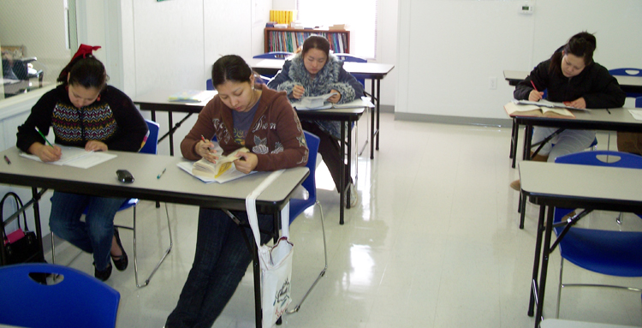

Goal 5: Reading and Discussion
As another approach to our main objective, I had the class read and discuss a 1-7-09 article from the MSNBC web site titled “No end in sight for job market woes.” (To find a copy, use your favorite search engine and enter No End in Sight for Job Market Woes January 7, 2009 MSNBC. At the time of this writing the article was available at http://www.msnbc.msn.com/id/28545660/ )

For this exercise, I as the instructor read a condensed version of the article to my class. We then discussed a few terms the students were not familiar with. I made sure the class understood the basic meaning of the article. We discussed things like:
1. 2.4 million jobs lost
2. unemployment
3. layoffs
4. bare-bones mentality
5. jobless benefits
6. Wall Street
7. investors
8. Dow Jones
9. forecast
10. the Labor Department

Goal 6: Speaking
The last assignment for my class was working on a dialogue titled “Conversation on the Economy.” I went over the worksheet with the students and then had them come in front of the class with a partner and read their conversations out loud.

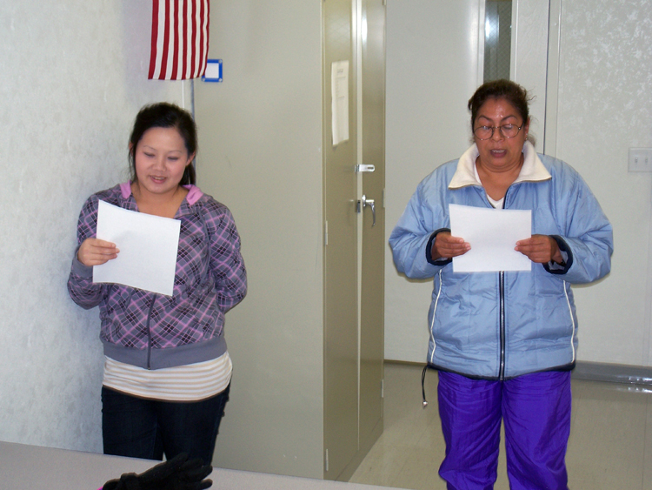

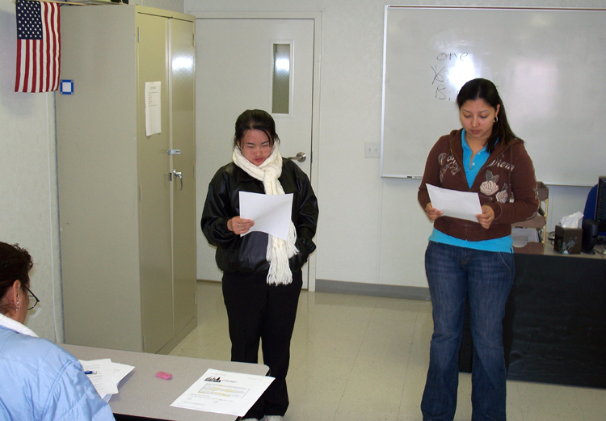

What is the greatest concern or issue you think the United States will face
in the New Year?

Please choose one topic that you think is the most important issue and write two paragraphs about it. You may continue on the back of this page if you need more space.
- Employment 5. Global Warming
- Economy 6. Medicine
- Education 7. Others
- War

________________________________________________________________________________________________________________________________________________________________________________________________________________________________________________________________________________________________________________________________________________________________________________________________________________________________________________________________________________________________________________________________________________________________________________________________________________________________________________________________________________________________________________________________________________
What Makes Me Happy?

With everything bad in the news lately, it is hard to find contentment and happiness. On T.V and newspapers the news looks very bad for our economy. With unemployment rates going up and the Stock Market going down we seem to focus on this more and more. Please write for me your thoughts and ideas about what will make you happier this year. Please write at least 10 sentences to explain your thoughts.

_____________________________________________________________________________________________________________________________________________________________________________________________________________________________________________________________________________________________________________________________________________________________________________________________________________________________________________________________________________________________________________________________________________________________________________________________________________________________________________________________________________________________________________________________________________________________________________________________________________________________________________________________________________________________________________________________________________________________________________________________________________________________________________________________________________________
Conversation on the Economy

Student 1 How is it going today?

Student 2 Okay I guess, I am just tired of looking for a job.

Student 1 I know what you mean; I’ve been looking for a job for 5 months now and no one is hiring.

Student 2 I guess times are bad for everybody. I saw on T.V. that the unemployment rate for the U.S. is about 8%.

Student 1 The unemployment rate, what is that?

Student 2 The unemployment rate is the percentage of Americans that have lost their jobs or don’t have jobs now.

Student 1 It is hard to be unemployed. I went to the bank yesterday to get a loan for a used car. They said they could not give a loan because I did not have a job or good credit.

Student 2 I’m sorry to hear that. With the bad economy, even the banks are having tough times.

Student 1 I hope our new President will be able to help the U.S and the economy!

Student 2 Me too! That is why I’m trying to get as much education as I can now, so when the economy starts to get better I will be able to find a good job.

Student 1 That is smart. I think I will try to go back to school to help me find a job.

Student 2 Good luck, and let me know if you hear about a job.

Student 1 I will, and if you hear about a job let me know also.

The most important issue in the U.S.A.
By: Lilia

This government have what working mach about the global warming because be damage all the world. This government need to help kep our world cleen and beutiful. The most important issue in the us is our environment. I need cleen water and air for to breeth. I hope in this new year the us has better airs and lands.

Corrected

This government has a lot of work to do for global warming, because it will damage the whole earth. The government will need to keep our world clean and beautiful. The most important issue in the U.S. is our environment. We need clean water and air to breath. I hope this new year we have better air and land.

Graphic from http://office.microsoft.com/en-us/clipart/default.aspx
The Most Important Issue
By Mee Moua

I think we need more jobs because many people have in the Employment for A everg body but we bave some more people need to look wrok in the Employment . I think we need more wrok because we many times they think a the Education and Economy food for Averg bady because they don’t bave food for A verg body to eat is fried and grapes and A verg thing food.

Graphics from http://office.microsoft.com/en-us/clipart/default.aspx

Why Education is important to me.
By: Mee Moua

I like com in the school because aeverg times I don’t know some thing my teacher teel me to learn English. I to learn English at home because some tiemes I need some body help me to English that is good for me know English a lot.In the my self I leke to get my brain to remember my English
I leke of the Education to the my frined because some time I don’t understand study my wrok .


Graphic from http://office.microsoft.com/en-us/clipart/default.aspx
The most important issue for the U.S.A.
By: Melida Amaya

I think from this moment the most important issues is the Economy. Every single family is having problems with money and it is very hard because there are so many people without jobs.

I think it is necessary to generate more jobs, so many people who come to the United State because it is the country of Opportunity. At this moment the people want to go back to their own country. The situation in this country is getting worse, the new goverment has to do something right now.

Corrected

I think from this moment the most important issue is the economy. Every single family is having problems with money and it is very hard because there are so many people without jobs. I think it is necessary to generate more jobs so many people who come to the United States will have more opportunities. At this moment the people want to go back to their own country. The situation in this country is getting worse. The new government has to do something right now!

Graphic from http://office.microsoft.com/en-us/clipart/default.aspx

The most important issue in the U.S.A.
By: Va Yang

I think the most important in us is employment, because rigth now a lot of people lost their job. And somehow it very hard to surport their family. I hope this year the government will fix it. And to assit all the employees have job to supost their family.
I think the important in us is way, because if we still have war our community will has a lot of problem with all the education, so I think if we have no war our community will look better.

Corrected

The most important issue in the U.S.A is
By: Va Yang

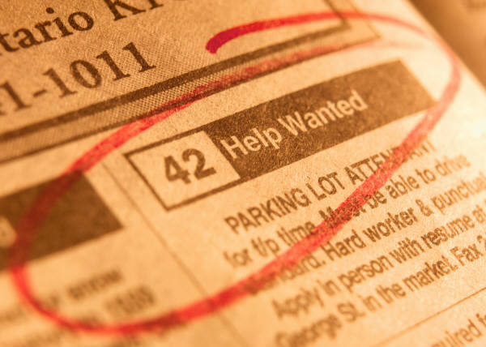
I think the most important issue in U.S is employment, because right now a lot of people have lost their jobs. Sometimes it is very hard to support their families. I hope this year the government will try to fix and assist all the employees who have lost jobs to support their families.
I think the important issue in U.S is if we still have war our community will have a lots of problems with all the education, so I think if we have no war our community will look better.

Graphic from http://office.microsoft.com/en-us/clipart/default.aspx
The most important issue
for the U.S.A in the coming year is
By: Veronica Henriquez

I think the most important issue that I can say is the economy, because like it is right now; looks very bad for our next generation.
Our government has to work hard to make the things change! Because of the economy many people are loosing their jobs.
Economy I think is what moves everything else, because if the economy is good everybody have jobs, parents can effort to pay for education, people can pay their medicine.
When I saw on television . News like young students have to quit school because, they need to work just to help their parents; that is terrible!
Makes me think! How is going to be? 10 years later!
HAVE YOU ASKED YOURSELF?
HOW IS GOING TO BE FOR YOUR CHILDREN?
IF THE ECONOMY GET WORTH!

Corrected

I think the most important issue that I can say is the economy, because right now it; looks very bad for our next generation.
Our government has to work hard to make things change! In this economy many people are loosing their jobs.

The economy I think is what moves everything else, because if the economy is good everybody has jobs, parents can effort to pay for education, and people can pay for their medicine.

I saw on television that young students have to quit school because they need to work just to help their parents. That is terrible!
It makes me think! How is going to be 10 years later?

HAVE YOU ASK YOURSELF HOW IS GOING TO BE FOR YOUR CHILDREN IF THE ECONUMY GET WORSE?

Graphic from http://office.microsoft.com/en-us/clipart/default.aspx
What Makes Me Happy?
By: Va Yang

With everything bad in the news lately, it is hard to find contentment and happiness. On T.V. and the newspapers the news looks very bad for our economy. With unemployment rates going up and the Stock Market going down we seem to focus on this more and more. Please write for me your thoughts and ideas about what will make you happier this year. Please write at least 10 things to explain your thoughts.



1. My family

2. be heathy

3. Jobs

4. Moneys

5. House

6. Cars

7. School

8. Children

9. Surport

10. Weight

Graphic from http://office.microsoft.com/en-us/clipart/default.aspx
What Makes Me Happy?
By: Mee Moua

With everything bad in the news lately, it is hard to find contentment and happiness. On T.V. and the newspapers the news looks very bad for our economy. With unemployment rates going up and the Stock Market going down we seem to focus on this more and more. Please write for me your thoughts and ideas about what will make you happier this year. Please write at least 10 things to explain your thoughts.

1. children

2. money

3. know English


4. be beathy

5. my family

6. my morther fatner love me

7. Car

8. I happy because I have my ter cher tell me learn English

9. I have house

- My husband love me

Graphic from http://office.microsoft.com/en-us/clipart/default.aspx
What Makes Me Happy?
By: Melida

With everything bad in the news lately, it is hard to find contentment and happiness. On T.V. and the newspapers the news looks very bad for our economy. With unemployment rates going up and the Stock Market going down we seem to focus on this more and more. Please write for me your thoughts and ideas about what will make you happier this year. Please write at least 10 things to explain your thoughts.

1. Stable Job.
2. Learn english very well.
3. Study a profession.

4. I would like to go to my country to visit my mother and father.
5. Build a house in my country.
6. Be healthy
7. I want to lose weigth
8. Get my license to drive.
9. I think if I have my first child that can make me happy too.
10. Be fine in my relation with my husband.

Graphic from http://office.microsoft.com/en-us/clipart/default.aspx
What Makes Me Happy?
By: Lilia

With everything bad in the news lately, it is hard to find contentment and happiness. On T.V. and the newspapers the news looks very bad for our economy. With unemployment rates going up and the Stock Market going down we seem to focus on this more and more. Please write for me your thoughts and ideas about what will make you happier this year. Please write at least 10 things to explain your thoughts.

1. walk with my puppys make me happening

2. see the television

3.bay car

4.have mony

5.can I drave

6.togo walk

7.to go school

8.be in my home

9.have my family

10..eat my food favorite to go of shoping

Graphic from http://office.microsoft.com/en-us/clipart/default.aspx

