Letters from Home

By Central Carolina – Harnett Campus

Objectives
Students will
- Develop an abiding respect for the American soldier--those ordinary men and women who volunteer to protect and preserve America even though they personally may face great danger/death keeping freedom alive
- Remember our military men and women by writing letters of appreciation and encouragement to soldiers serving abroad
Background
Letters from Home were written by ESL students from all campuses and sent to the Marines in Iraq. The letters that were sent did not include the source of the decorative graphics, but--for purposes of this project--the graphics are credited on each letter.

Central Carolina – Harnett Campus
Dr. Nutan Varma’s mixed-level class wrote valentines and did the typing themselves. This was an opportunity for some students to use the computer for the very first time, while others were more experienced and added their own WordArt to their writing. Additional decorative graphics were added in the editing process.
Graphic from http://office.microsoft.com/en-us/clipart/default.aspx

For 2-14-09

Dear Marine,

Hello! My name is Estela
I’m 31 years- old
I’m studying English ,
I from Guatemala.
I come America in 1997
I live in Norte Carolina.
I am very happy and
I wish what you to come back
and see your family and
very happy Valentin day.

Thank you.

Best wishes,

Estela

Graphic from http://office.microsoft.com/en-us/clipart/default.aspx

For February 14, 2009

Hi Marine

My name is Susana. I’m from mexico city. I’m 27 year old. I’m study Englis on Comunity College in Lillington NC. I written this letter with my best wishes for you and every body over there. I’m very thankful for your job and your effort, but I hope the war finish very soon, because I don’t agree with the war. I think the war is the wrong way most of the times to fixed problems into the countrys and between the countrys too, because many many people die and our soldiers too. But, I reconozing your labor and effert for built better life to our families and our children. I know then you are who suffer most the consequences of the war. For this reason, I feel happy for this oportunity for say
thanks for your job.
thanks for your life!
thanks for your value!
thanks for your effert!

I hope then you return safely home soon for what you and your family enjoy togeder every day of your lifes.

Happy Valentines Day. Our prayers is with you.
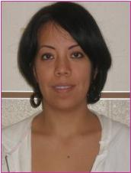
God bless you.
Susana

Graphic from http://office.microsoft.com/en-us/clipart/default.aspx


For February 14, 2009

Dear Marines

Hello! My name is Artemia Coronel V.
I am From Mexico. I Have 3 children.
They are my family. I love very much.
I live in LillinGton N.C. for 4 years and
I’M in ESL English class.
You are strong. I hope so retorn home safely.
come back safe. Thank you
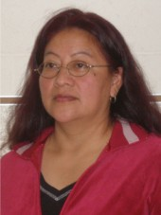
Happy valentine’s day.

Artemia

Graphic from http://office.microsoft.com/en-us/clipart/default.aspx

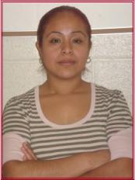

Dear Marines:
My name is Ana Morales, I’m from
Mexico.

I study ESL on Central Carolina Community College

on North Carolina. I write this letter for give thank you

for help protect a United States of America. I’m very

thankful you for protect my life and everybody life. I know

you not have your family now but they wait very much and love you.

You always think a God bless and God care your life.

You are always my Brothers.
You are always my friends.
You are always my Heroes.

Happy Valentine’s day!
You are Our Heroes

Ana Morales

Graphic from http://office.microsoft.com/en-us/clipart/default.aspx


For 2-14-09

Hello Marine,
I am Ana Lilia De Paz and I’m 33 years-old.
I’m studying English CCC College North Carolina.
I’m in America 12 years. I’m from Mexico.
I wish you happy Valentine Day.
Come back to you family. Your family miss you.
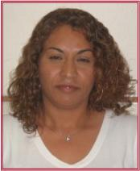
Thank you.

be careful.

Ana Lilia De Paz

Graphic from http://office.microsoft.com/en-us/clipart/default.aspx


For 2-14-09

Dear Marine

My name is Paulina Flores I’m from Mexico

I live in the USA for 10 years and

I’m student Inglish in Lillington N.C.

My wish is that you come back this Valentines Day

to stay with your families;

Thank you for your Help to our countrie America

Happy Valentines Day

Good luck

Paulina Flores

Graphic from http://office.microsoft.com/en-us/clipart/default.aspx


For February 14, 2009

Hello Dear Marine.
My name is Nuvia Vasquez. I’m from Guatemala C.A.
I study at school the english in North Carolina.
I livin in North Carolina for 6 year.
I came to north Carolina 2002. I’m very Happy.
I want you to come back to you Family.
You doing Good job.
Thank you For reading my letter and
God bless you and protect you for ever.
Happy Valentin Day

Nuvia Vasquez

Graphic from http://office.microsoft.com/en-us/clipart/default.aspx


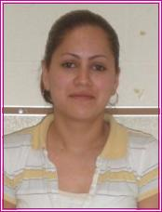

Dear Marines
For 2/14/09

Hello!

My name is Rosa Ochoa. I am from Mexico. I am learning English in CCC College in Lillington N.C. I want to thank all of you for fighting for our country. My best wishes for every single one of you. I want to wish you a great Valenten’s day. Even though you are not with your family, remember that your family will always be with you. Remember that all our contry’s hearts will always be with you. My wish this Valenten’s day is for everyone of you be back home with your family and with all your loved ones. You guys deserve the best for being so brave for defending our beautiful contry.
Happy Valenten’s day! Thank you for reading my letter.

Sincerely,
Rosa Ochoa
You Are Our Heroes

Graphic from http://office.microsoft.com/en-us/clipart/default.aspx
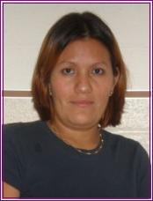
Hello, Marine

I’m Rosy from Chia Pas, Mexico.
I’m study at school CCCC. Lillington, N.C.
I come America in 1999.
I live in Norte Carolina.
Thank you for protect our contry America.
You are great. we are prod of you.
Com bak home and see your family.
I wish you very happi valentines day!
god save your life.

Rosy
Graphics from http://office.microsoft.com/en-us/clipart/default.aspx

Central Carolina Community College

Dear Marine The Heroes

Hell o I’m Marta Navarro, I’m 67 years old. Im from El Salvador

I live in U.S. and Am learning English in school in lilington N.C.

I last week passed the U.S. Naturalization Tests. Thank God. I’m

very happy My wish is that you all retorn your home. I pray the lord

for you family, for you protection. Thank you for Help to our

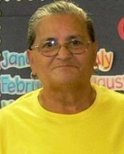
countrie. Retorn to America.

Happy Valentines Day

Good Luck, Love for you.

Marta Navarro

Graphic from
http://office.microsoft.com/en-us/clipart/default.aspx


HELLO Marine

My Neme Is Blanca
I from el Salvador
I go to English Class in CCCC Lillington
My teacher is Ms. Varma
I thank my teacher Bcause she helps learning English
I thank God For giving you long life. You are brave.
I wish you Happy Valentime Day

God Bless you.

Blanca

Graphic from http://office.microsoft.com/en-us/clipart/default.aspx



Hello Marine,

My name is Victoria. I’m from Mexico. I wish this valentine’s day you are home with your family. Give peace and Serenity in the homes of those that couldn’t go back home, they will always be remembered as heros.

Serenity
Obligation
Loalty
Difference
Integrity
Eternity
Remembered forever
thank for help. we salute you.



Victoria

Graphics from
http://office.microsoft.com/en-us/clipart/default.aspx

