Helping at Head Start

A COMMUNITY VOLUNTEER ACTIVITY WITH THE
JOHNSTON-LEE-HARNETT COMMUNITY ACTION HEAD START
By Dr. Nutan Varma
Central Carolina - Harnett Campus

Choosing a Volunteer Opportunity
The Lillington campus in Harnett County is one of the locations where Johnston-Lee-Harnett Community Action Head Start offers community services. There is always a need for volunteers at this campus.


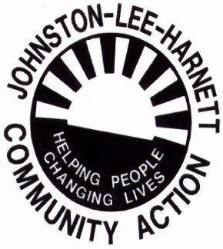

Head Start is a comprehensive preschool education program to strengthen both the young child and the entire family. The program gives families living in poverty an access to services that were previously unattainable and helps them move toward self-sufficiency.

I talked with Ms.Vania McNeill, the Area Manager of the Lillington Head Start Campus, about our ESL students volunteering in the children’s classrooms to help the teachers and children in their daily curriculum and class activities. She was convinced, and she allowed my students to volunteer in the children’s classrooms.
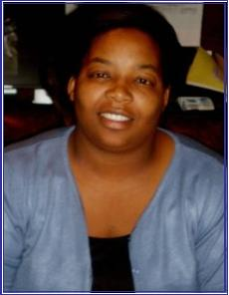
Ms. Vania McNeill,
Area Manager

I further talked with the Head Start classroom teachers to get ideas about the kinds of class activities they wanted for their children. In compliance with their daily lesson plans, it was appropriate for my students to review and then teach Human Body Parts, Body Ailments, and the Five Senses to the children.
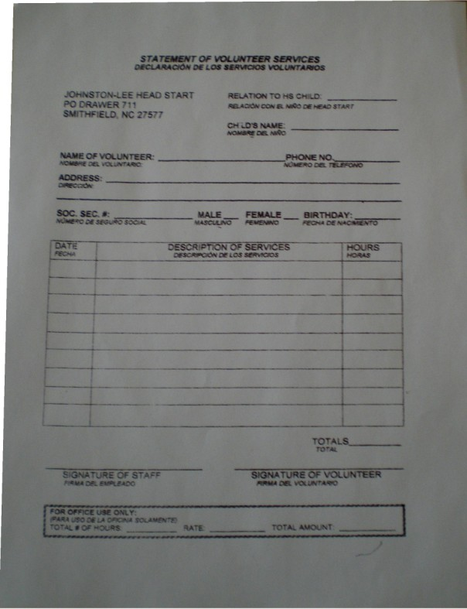
I presented this volunteer opportunity to my class of mixed level ESL students, giving them sufficient instructions about this community work: its purpose, plan, duration; and the steps to be followed. They were excited, enthusiastic, and motivated!

In accord with Head Start’s policy, my students each filled out a Head Start Volunteer Form, giving information such as name, address, phone number, and birth date, along with dates, hours worked, and a description of services on the given day. After our last visit--when the lead teachers signed the forms and gave them to the volunteers--thirteen ESL students had given a total of 38.5 volunteer hours!

Dual Objectives
ESL Students will
- Learn/review vocabulary related to human body parts in English
- develop self-confidence while working outside their own classroom environment
- have a sense of self-satisfaction in helping one of the most vulnerable parts of the community
Head Start children will
- listen and participate in the reading, writing, and other classroom activities
- be able to recognize and name different body parts

Activity Parameters
- Time: Four Head Start visits, one each week, with a time commitment of 1-2 hours per visit
- Number of Head Start Children: 15-20 per classroom
- Ages of Children: 3 and 4 years old

Steps to Success
Keeping in mind the Head Start children’s ages and their limited attention span, we planned to reach them through combinations of media, games, and activities related to body parts, ailments, and the five senses. ESL students prepared the following materials to use on our visits:
- Posters
- Books
- Flash Cards
- Games
- Activity Sheets
- Mini Books

The First Volunteer Visit

To allow my ESL students time to get comfortable and get familiar with all the Head Start teachers, staff, and children, we decided to volunteer around the campus in general on the first day. ESL students helped teachers in finding and cutting out some labels for classroom cubbies, fixing children’s naptime beds, supervising children in the playground and, finally, helping staff and teachers in the cafeteria by arranging lunch tables and serving food to the children.

My students liked it since they had completely new ways of learning, working, and getting along with people outside their classroom environment. The teachers and staff at Head Start were very cooperative. They also provided free lunch to my students. That was a great start! My students were excited and eager to work in children’s classrooms next week!

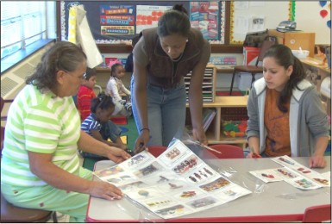

Student Volunteers Cutting Out Labels

The Second Volunteer Visit

Background:, I divided my students into two groups and we henceforth volunteered in classroom # 3 and classroom # 5.

Classroom #3 Classroom #5
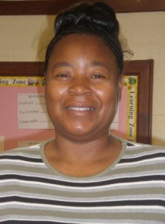
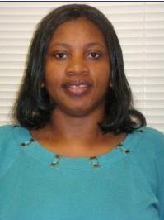
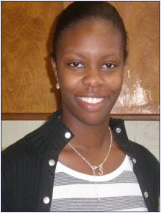
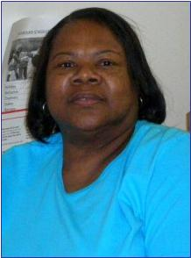
Ms. Mamie Chalmers, Ms. Sha Parker, Ms. Penny McDougald, Ms. Lynette Brown,
Lead Teacher Teacher Assistant Lead Teacher Teacher Assistant

Preparation
Before volunteering in children’s classrooms, my ESL class made both posters and books on human body parts to use with the children. They repeatedly reviewed the names of all body parts from the handouts provided in our class to make sure that they remembered all the names in English.

Student Volunteers Making Body Part Posters
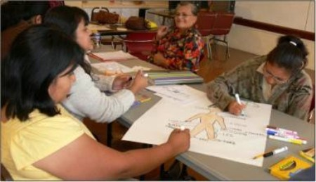
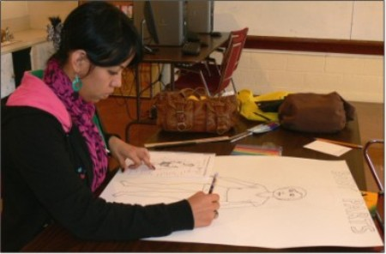
Posters Created by Student Volunteers
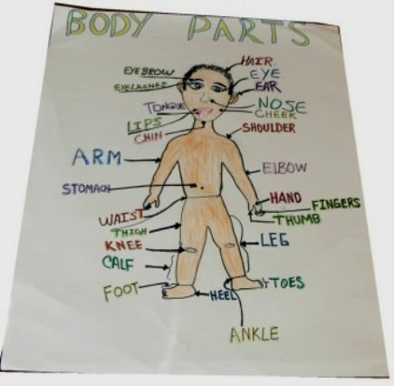

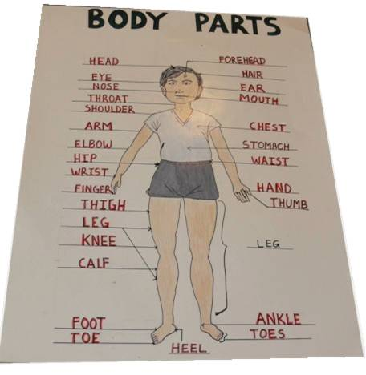

Books Made by Student Volunteers
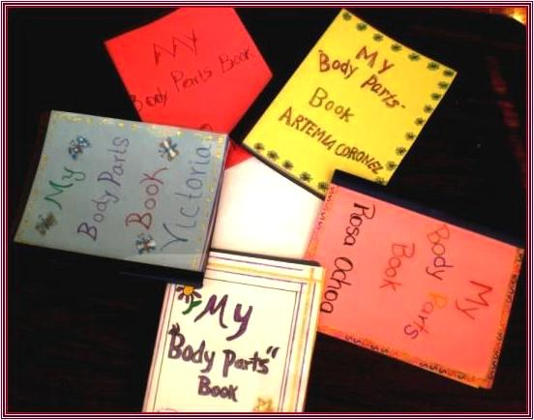

We also planned several games and activities in order to maintain children’s interest and attention and to make learning fun. We played the games and worked on the activities at our location so that the ESL volunteers would be comfortable while working with the preschool children.

In the Head Start Classroom
1. Introductory Game. We started by playing a “getting to know you” icebreaker game with the children. We brought rolls of toilet paper. We each took several squares of toilet paper, and then we asked each child to take some--at least three. The children found it really funny to see the toilet roll in their study area out of its usual territory in “the restroom.” Following children’s general tendency, each child wanted to take lots of toilet papers without having any clue about what was to come.
After everybody in the class had some squares of toilet paper, we counted the squares we had, and then we had to tell that many things about ourselves. Each child had to do the same. They had to tell their names, ages, favorite food, favorite colors, etc. They enjoyed it, and this game made them familiar and comfortable working with us. We were not strangers any more.
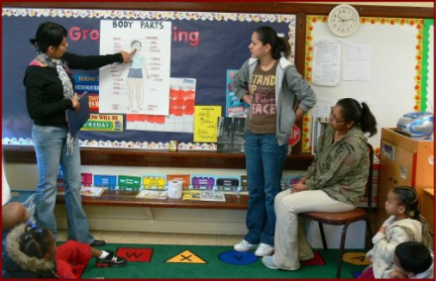
2. Instruction. Next we put the Body Parts posters on the bulletin board and the student volunteers taught the children to recognize and name the body parts. Volunteers were pronouncing the vocabulary and the children were repeating after them.

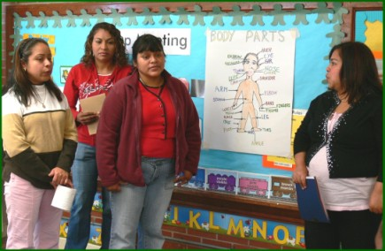
Classroom # 3

Classroom # 5
We distributed the Body Parts books. The children told the names of the pictures on each page of the book and pointed to their own body parts accordingly. It was surprising and pleasing to see the children paying so much attention and learning so fast.
3. Dissonance Game: This game involves learning/reviewing the names of body parts. Start the game by tapping your nose as you say aloud, “Nose, Nose, Nose”. The children follow and tap their noses likewise as they say, “Nose, Nose, Nose” along with you. Repeat the same steps about three times with other body parts. Then say a body part, for example, “Mouth, Mouth, Mouth” but point to a different body part such as your head. The children should recognize the word “mouth” and should point to the mouth instead of the head. Children who point to their head while saying the word “mouth” are eliminated and must sit down. Keep repeating the steps with different body parts until you get a winner. This helps children learn vocabulary and enhances their attention to words.

Student volunteers played this game with the children in both classrooms. Each volunteer took a turn leading and we continued the game until one child was left standing. Nevertheless--keeping in mind children’s feelings--we recognized each child as a winner because they all worked hard.

4. Prizes: We brought some Halloween goodies for the children. At the end of the session, we announced that everybody won a prize since they did a wonderful job. That was the most exciting moment for them. They were so happy showing and sharing their prizes with their friends.
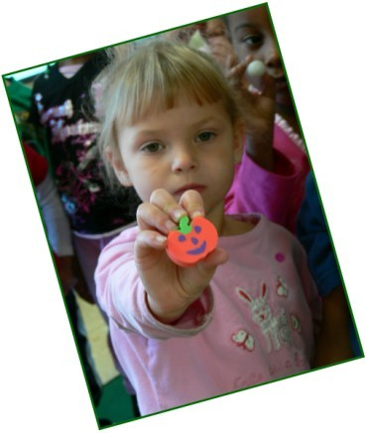
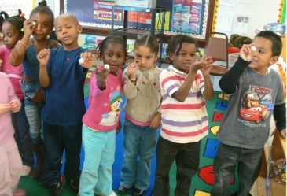
Summary Work in the ESL Classroom
After we came back at our own classroom location, I asked my ESL students to write picture stories on their work and experience as volunteers in children’s Head Start classrooms. They drew and colored pictures showing the locations of themselves, the children, their teachers, and classroom objects in the classrooms such as bookcases, tables, and chairs. They wrote corresponding stories according to their academic levels. They seemed to enjoy this summary activity. Samples of their work are shown on the following pages.
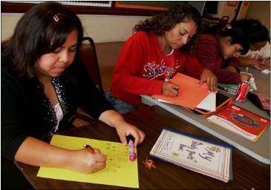

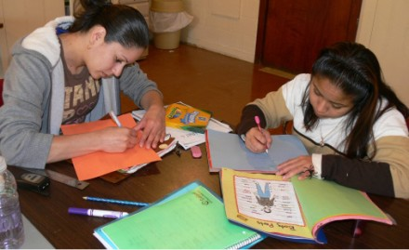

ESL Students Writing Picture Stories

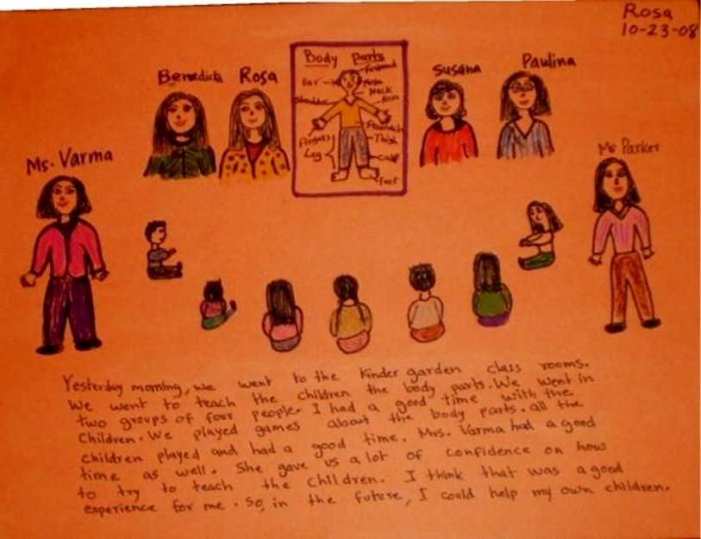

Picture Story by an ESL Advanced-Level Student

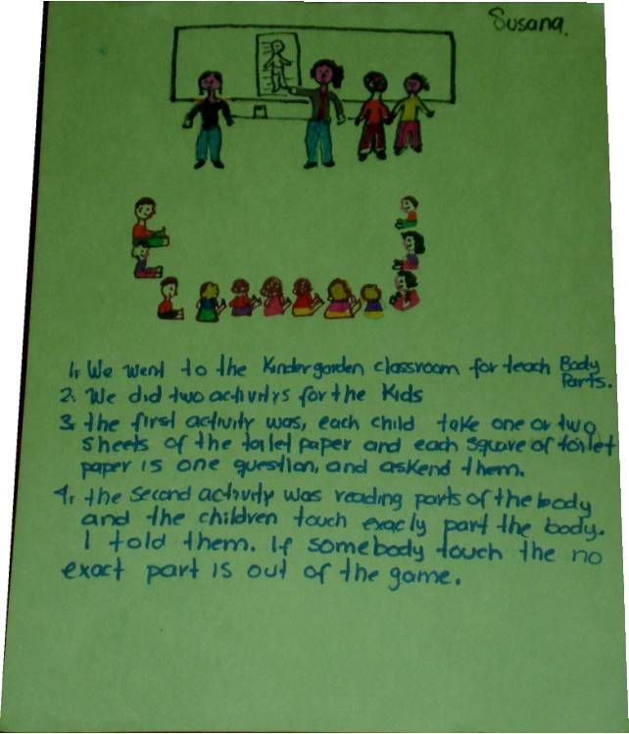
Picture Story by an ESL Intermediate Level Student

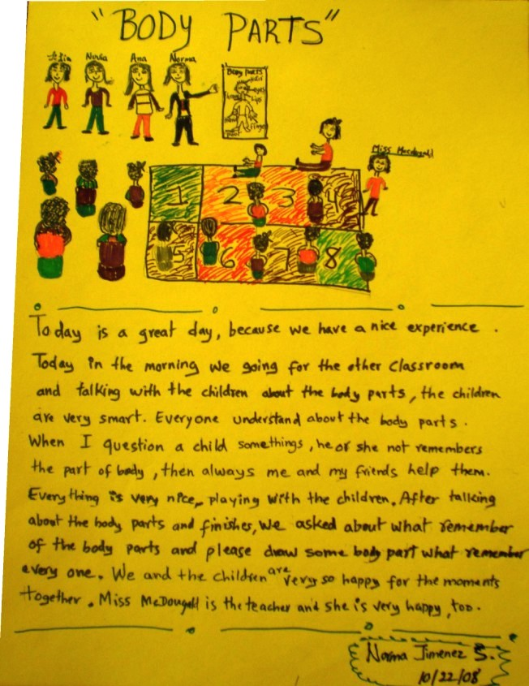
Picture Story by an ESL Low-Intermediate Level Student (#1)

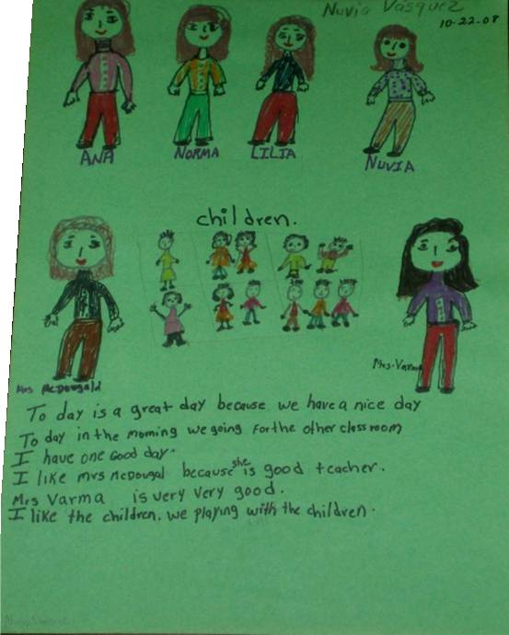
Picture Story by an ESL Low-Intermediate Level Student (#2)

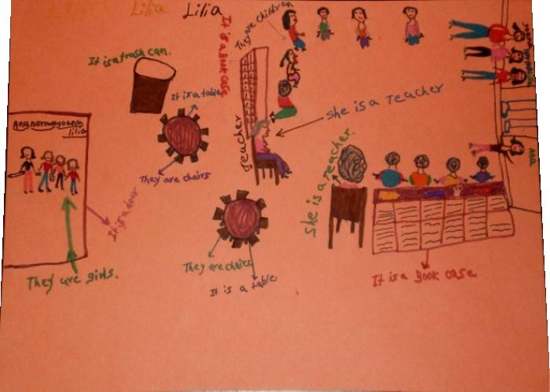
Picture Story by an ESL Beginner-Level Student

The Third Volunteer Visit

Preparation: Student volunteers made twenty-six flash cards (4.25” x 5.5”) of body parts to use in playing a vocabulary game with the children to review the names of body parts. We drew and colored flash cards, using the following sites for ideas:
- http://www.eslflashcards.com/ and
- http://www.esl-kids.com/flashcards/bodyparts.html.
We chose flash cards to incorporate visual images in the classroom while helping children learn new body-related vocabulary.

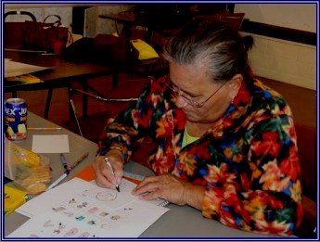
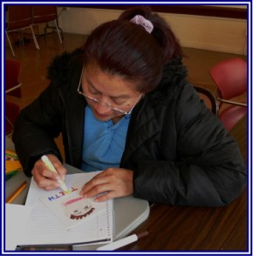

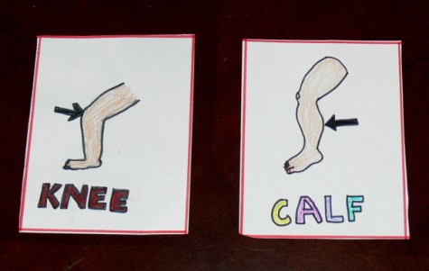
Flash Cards on Body Parts

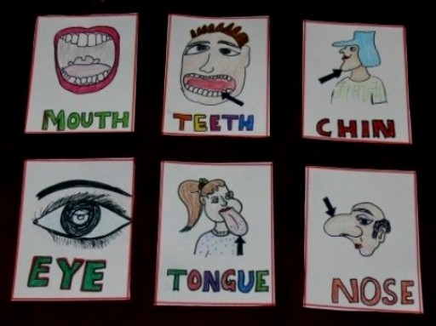

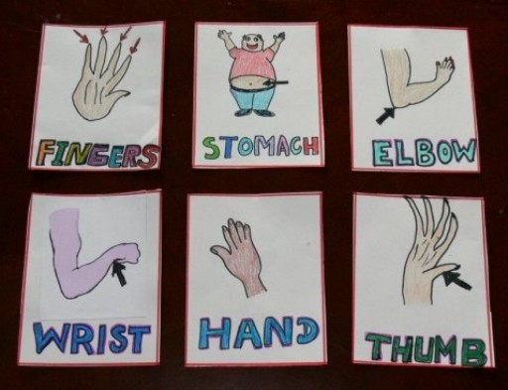
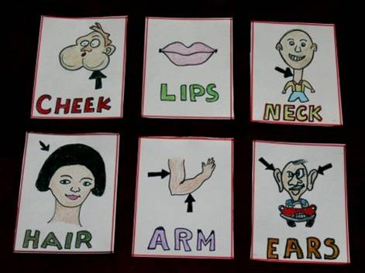

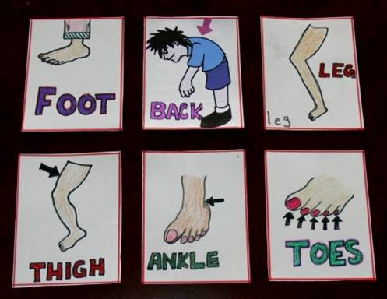
In the Head Start Classroom

- Introductory Video. We used “English Academic Success for You (EASY), Unit-8.” Unit 8 of this VHS cassette demonstrates human body parts. (See http://www.easyeld.com/.) The children were very responsive to the video! While watching, they were attempting the funny instructions given in the video, such as touch your back with your left foot, touch your head with your right foot, clap with your right hand and left foot. They were having fun while learning facts in a manner that kept them entertained.
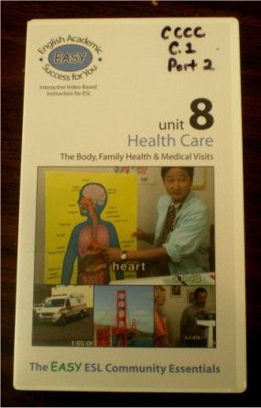
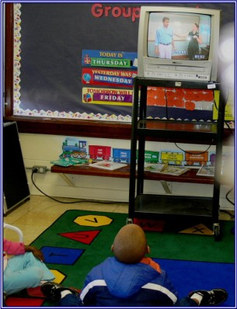

- Drawing and Coloring Activity. Next we gave each child an activity sheet with an oval shape (i.e. face) drawn on it. We divided the children into three groups with one student volunteer per group as a team leader. The children had to draw and color different parts of the face on the activity sheet by following the instructions given by their team leader. For example, draw a round pink nose in the center of the face. Their classroom teachers also helped the children in this activity. Everyone really did a fantastic job! A blank activity sheet and an example of one child’s work are shown on the following pages.

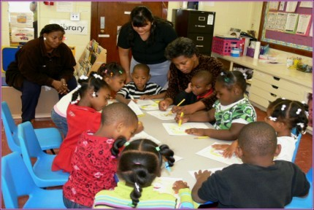

Classroom #5

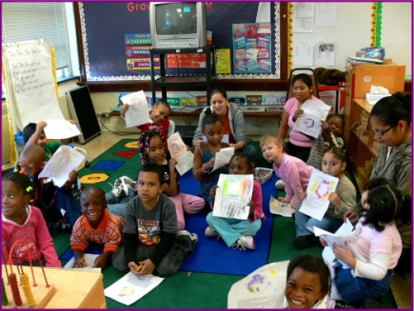
Classroom #3

Draw the Face



1. Draw a round pink nose in the center of the face.
2. Draw an open mouth below the nose. Color the
lips red.
3. Draw white teeth inside the mouth.
4. Draw black hair on the head.
5. Draw two ears, one on each side of the face.
6. Draw two oval blue eyes on the face.
7. Draw two black eyebrows, one over each eye.
8. Draw a blue hat on the head.
9. Color the background yellow.
10. Color the face light brown.
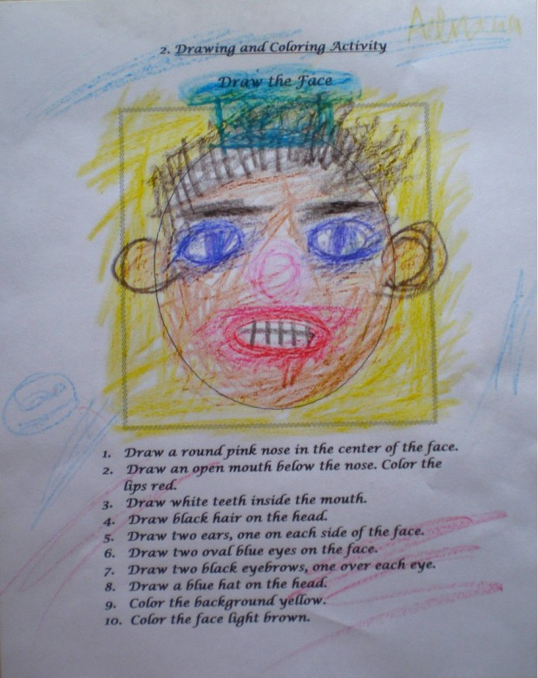
A Child’s Finished Creation

3. Game: Hop and Say with Rock, Paper, Scissors. (See http://www.english-4kids.com/hopnsay.html.) To play, line up a number of flash cards across the floor in a row. Two teams stand at opposite ends of the row. When the teacher starts the game, the first student on each team starts to jump on the first card. Every time a student jumps on a card she/he reads aloud what is written on the card. (Older students may be asked to make a sentence with the words on the cards.) When the two team players meet on the row,
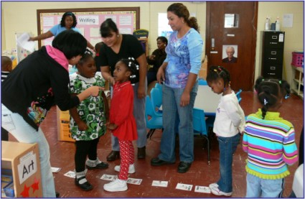

they have to do the old guessing game of ROCK, PAPER, SCISSORS. The student who looses the ROCK, PAPER, SCISSORS game leaves the row and goes to the back of his or her team’s line. The next player in his/her team restarts the game for their team. The next teammate in the line should be ready to start immediately when she/he realizes that the team player has lost the rock paper scissors guessing part. The idea is not to let the other team player get to the end of the row. If the other team player gets to the end of the row, his/her team wins.

How to play Rock, Paper and Scissors: (For this game, see http://en.wikipedia.org/wiki/Rock,_Paper,_Scissors#Game_play.) Both players call out “Rock! Paper! Scissors! Shoot!” On each word raise one hand in a fist and swing it down on the word. On the fourth time (saying “shoot!”), the players change their hands into one of three gestures:
- Rock is represented by a clenched fist.
- Paper is represented by an open hand, with the fingers connected.
- Scissors are represented by the index and middle fingers extended and separated.

Rock blunts scissors; rock wins.
Paper covers rock; paper wins.
Scissors cut paper; scissors win.
If both players choose the same gesture, repeat the ROCK, PAPER, SCISSORS game again until one person wins.
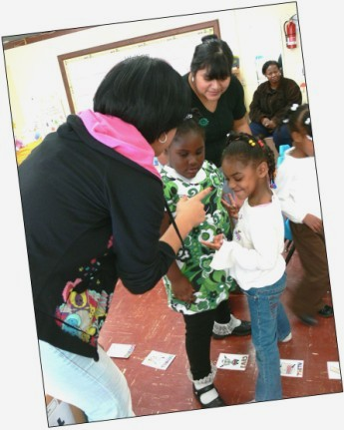
We used all the twenty-six flash cards to play this game with the children. They liked the game and wanted to play it again and again!
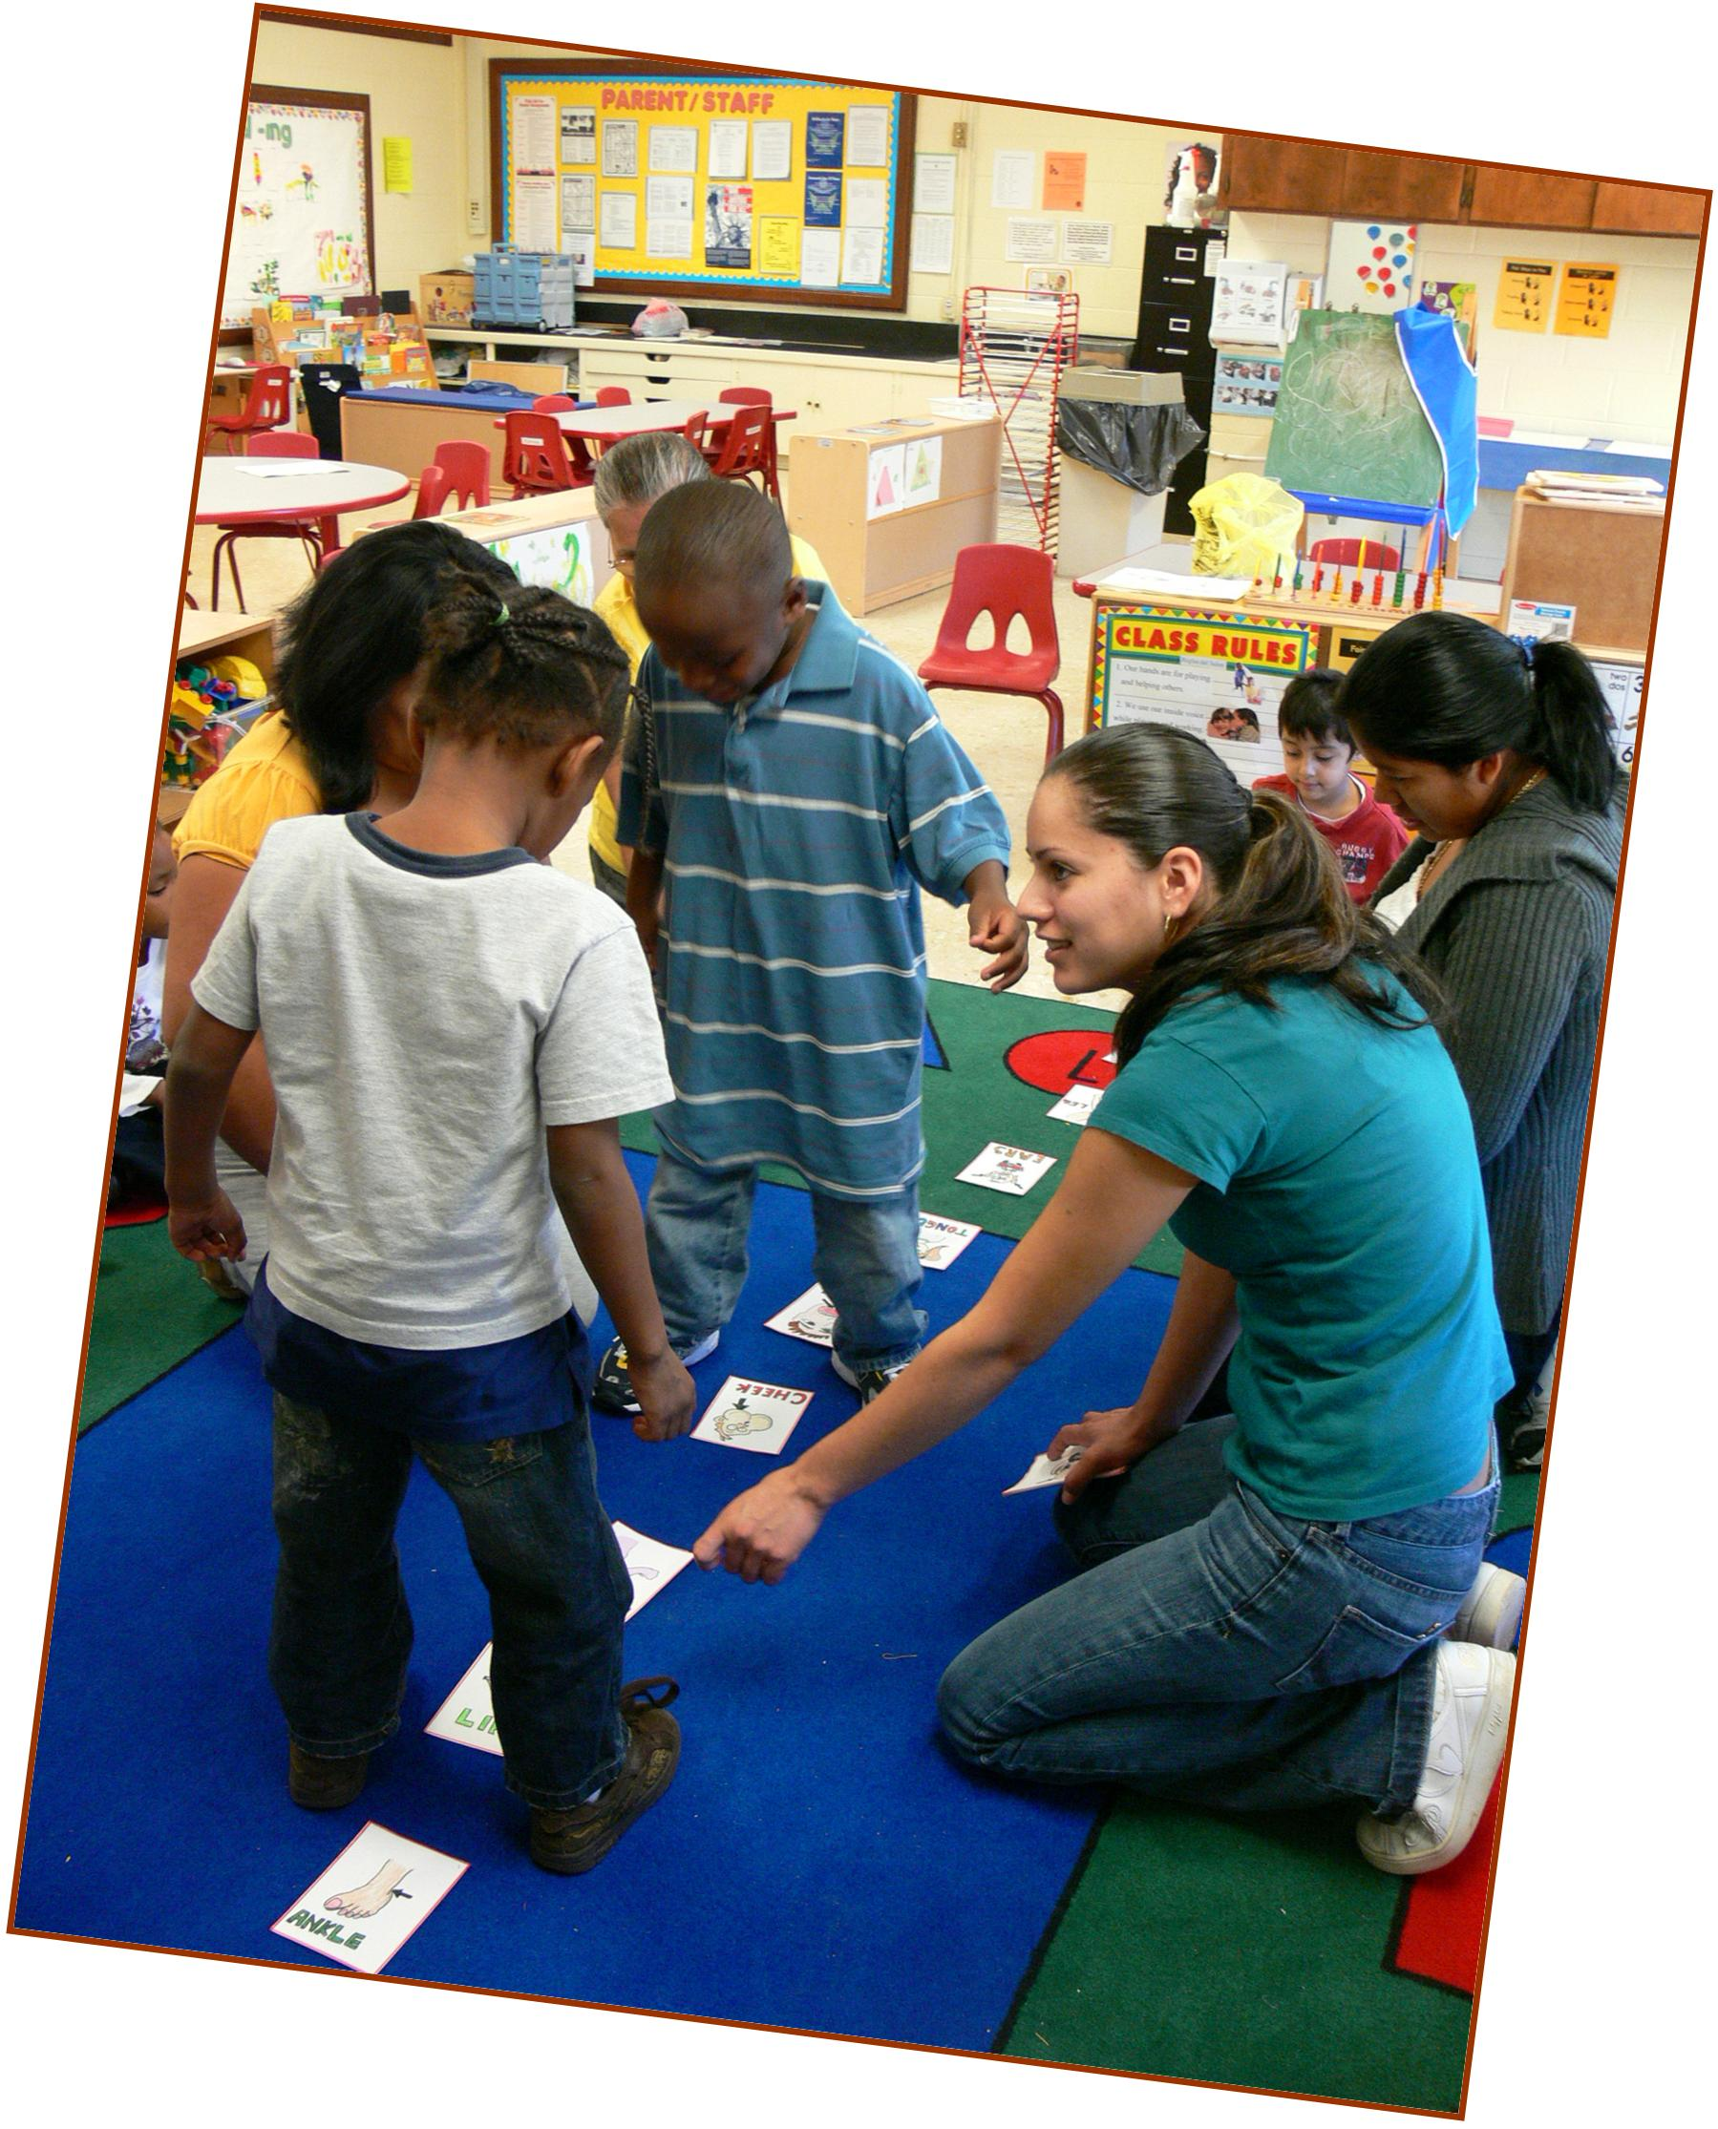
At the end of the session the children drew prizes from a prize box that we brought with us. They were happy, but they asked us to bring candy and chocolates for their prizes next time!
The Fourth Volunteer Visit

Student Volunteers Creating Flash Cards
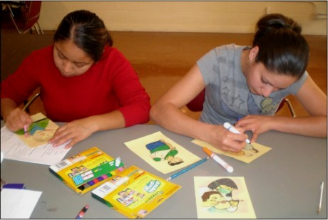
Preparation: We planned various activities and games to make learning fun, entertaining, and memorable for the children. Student volunteers prepared the following teaching aids:
a. Eleven flash cards (5.5” x 8.5”) on body ailments
b. Five flash cards (5.5” x 8.5”) on the five senses
c. Mini book (4.25” x 5.5”) on five senses

Body Ailment Flash Cards
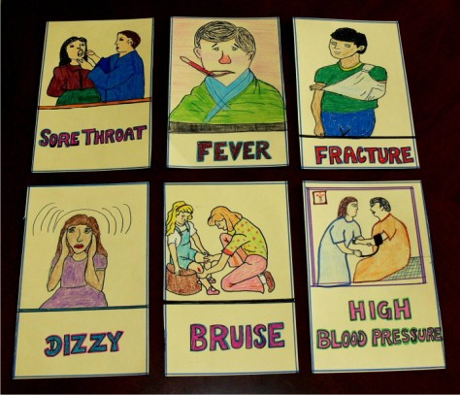

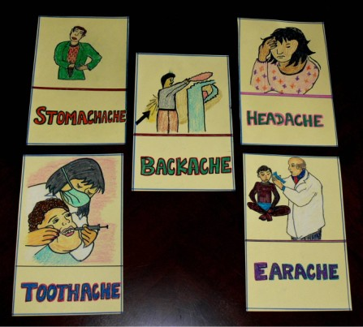

Using http://esl.vcc.ca/eslvoc/ESLWEB/aches.htm and clip art from http://office.microsoft.com/en-us/clipart/default.aspx for ideas, the students drew and colored flash cards for body ailments.
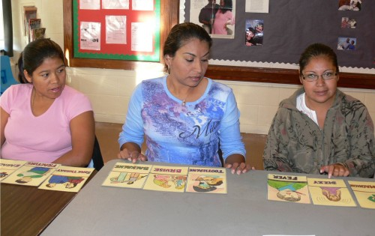

Student Volunteers Reviewing Vocabulary on Body Ailments

Student volunteers learned/reviewed the vocabulary and pronunciation for different ailments and the five senses. They reviewed the flash cards thoroughly so they would be confident while teaching the children. They practiced a game called “Doctor, Doctor” so they could play it in the children’s classrooms to help the children understand and remember different ailments associated with different body parts. We were well prepared for our fourth visit!

In the Head Start Classroom

1. Instruction: Body Ailments. We started by teaching the children a series of body ailments using the flash cards we had made. While pronouncing the name of each ailment, ESL student volunteers acted the ailment. For example, while showing the flash card and pronouncing the word “stomachache,” one of the volunteers was holding her stomach and pretending as if her stomach really hurt. At the same time, the children had to mimic the volunteer. They were laughing and having fun.
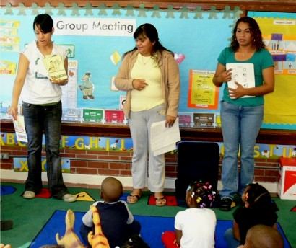

2. A Role Play Game: Doctor, Doctor!

For this game, one of the student volunteers played the role of a doctor. The children stood in a line. Another student volunteer pronounced the name for a particular ailment such as “headache” and asked the first child in the line to walk to the doctor and pretend he/she had a headache. The conversation (song) between the child and the doctor follows. (See http://genkienglish.net/doctor.htm.)

Child: Doctor! Doctor! My head hurts! (Sing two times.)
Doctor: Are you okay?
Child: No, I’m not.
Doctor: Are you okay?
Child: No, I’m not (irritated voice).

The Doctor takes out a “medicine” from her bag and asks the child to “take” it immediately. Surprisingly that medicine turns out to be a small wrapped candy. Wow!

Doctor: Are you okay now?
Child: Yes, I am (in a very exciting and loud voice)!

Then the child goes to the back of the line. The next child in the line is asked to act out another ailment such as a stomachache. The game continues until all the children in the line have a chance to act out an ailment and get a piece of candy (medicine) from the doctor. (The children wanted to play the game again so that they could get more candy. They asked the doctor, “Can we have more medicine please?”)
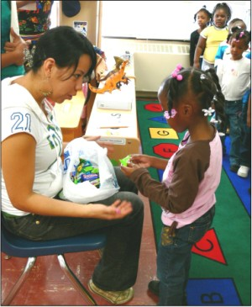
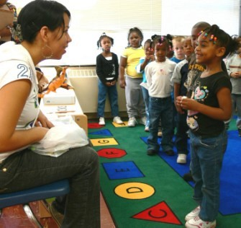

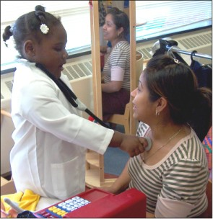
Then we exchanged our roles. Now, the kids were doctors and we were patients. Student volunteers (or patients) were pretending to show certain symptoms and the kids (or doctors) had to name that symptom such as a backache or a toothache. They were extremely happy and feeling proud of themselves to examine and diagnose their patients with the different ailments!

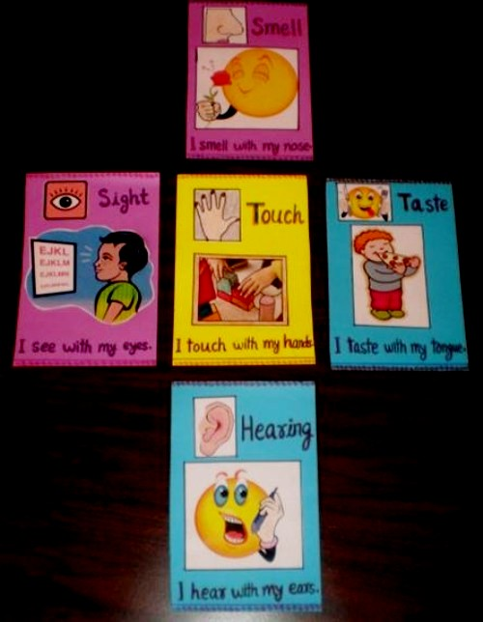
3. Instruction: The Five Senses: Student volunteers used the flash cards that they had made earlier with clip art to teach the children about the five senses—smell, taste, hearing, sight, and touch.

The children looked at the pictures on each flash card and said aloud the name of the particular sense on that card. For example, they were shown the card for “smell” and asked to name the sense and the body part used for that sense. The children shouted, “Smiley smells a flower! We smell with our nose.” The process was repeated with the other four senses.

Finally, each child made a mini book on the five senses. We gave each child two coloring sheets. Each had four rectangular boxes representing four mini book pages, for a total of eight pages in all. We printed these from http://www.enchantedlearning.com, an inexpensive subscription site. The mini word book includes a page for each of the five senses, a page for a favorite sense, and front and back covers. (From http://www.enchantedlearning.com, click on Printable Books for Early to Fluent Readers. Scroll down and click on Mini Books. Scroll down again and click on Five Senses Mini Word Book. You need to have a site subscription to use this resource. See http://www.enchantedlearning.com/support/.)

The kids cut each sheet into four pages, cutting along the dark lines with the help of their team leader (i.e., student volunteer). They stapled the pages together on the left, making sure that the title page saying “Five Senses Book” was on the top.

Then the children copied the names of the five senses and colored the corresponding pictures, i.e. eye, nose, tongue, ear, and hand. On the back page saying “This book belongs to …” they drew their own picture in the box and wrote their name in the space provided.

It was a good activity, giving the children an opportunity to practice different skills like reviewing the alphabet, vocabulary, reading, writing, cutting, drawing, and coloring. This exercise kept them very busy.

The following pages give a sample of a completed mini book by one of the children.

A Child’s Creation
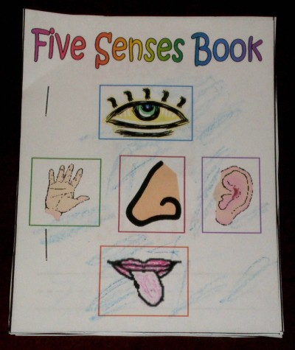

Front Page

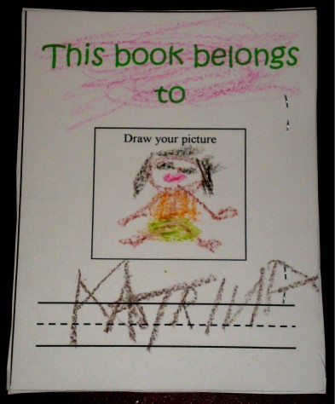

Back Page
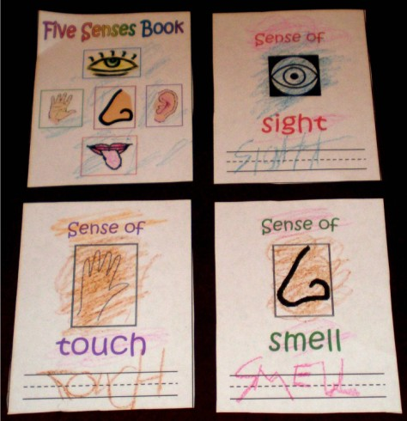

Pages 1 - 4

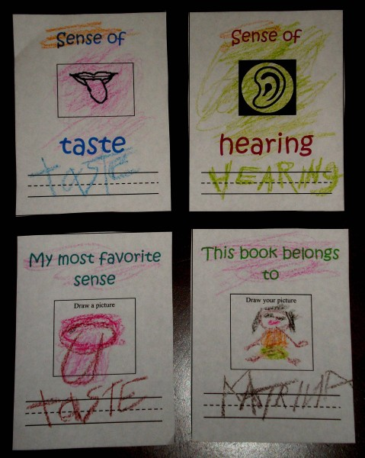

Pages 5 - 8

Farewell. It was our last day volunteering at Head Start. The ESL student volunteers and I loved working with the little children. I was deeply touched when they asked me in a gloomy voice, “Where are you going? Please, don’t go.” When I asked for a big hug, they all ran toward me as if they wanted to be the first one to give me a hug.
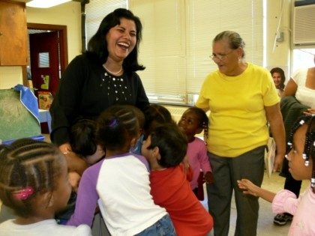

I credit our success to all my sincere, dedicated, and hardworking students. We celebrated our volunteer experience at a local restaurant.
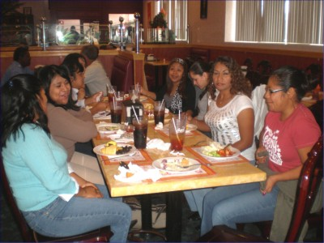

Finally, all the four Head Start teachers (Ms. McDougald, Ms. Chalmers, Ms. Brown, and Ms. Parker) were friendly, easy to get along with, and fully cooperative. They appreciated our efforts to teach the children. They liked all the games and activities we used to make learning fun and memorable. They also acknowledged our hard work and dedication toward the children.

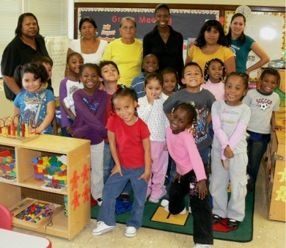

Classroom #3

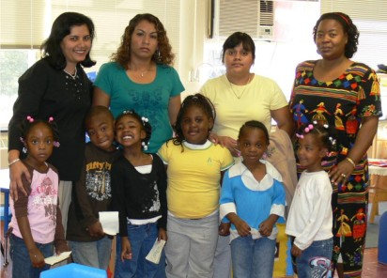

Classroom #5

