The Goodwill Tree

By Tommiann Hill
Rockingham Community College


Graphic from http://office.microsoft.com/en-au/clipart/default.aspx

Overview
Our ESL class meets at Reidsville’s Goodwill Resource Center. The Basic Skills program has an extensive collaborative partnership with Goodwill, and we are extremely grateful for their kindness in offering us the use of their facilities.

The Reidsville Goodwill Resource Center has recently redone their store. As our community service project, the class helped to beautify their grounds with a start on new landscaping. The ESL program donated a Japanese Maple tree. Goodwill selected the location for the tree: a spot where they plan a future picnic area. The ESL students did the planting, an activity that made them truly proud. Next year, we hope to add flowers to Goodwill’s planned picnic area.

Objective
The purpose of this project is to convey the concept that community service is a characteristic of good citizenship. Students learn about community service through the following activities:
- Participating in class discussions
- Using a simple format to guide their beginning writing
- Developing and sharing written letters of thanks to the Reidsville Goodwill Resource Center
- Contributing their time and labor to planting the Goodwill Tree, our class community service project

ESL Level
My class consists of beginning students. Most of them have been in the country less than one year. This project works equally well with more advanced students. Their discussion and writing simply reflect their greater competence with English.

ACTIVITIES

Class 1 (2 ½ hours)

- Before class begins, write the following statement on the whiteboard:
What did your home town/country do to help others?

Graphic from
http://office.microsoft.com/en-au/clipart/default.aspx

- Prepare students to speak openly about things their native town/country did to help others by giving some guiding questions. For example:
- Did people in your town get together to help others?
- How did your town help others?
- What kinds of things did people in your country do to help others?

- Encourage students to converse in pairs or small groups about the questions. Allow those who are shy and have limited English to participate in their own language. This helps students to be less anxious about the “right” answer when speaking.

- Read aloud the statement that you put on the whiteboard, and facilitate the process of open class discussion on the topic.

- Write students’ answers on the whiteboard underneath the question, “What did your home town/country do to help others?”
I should note that answers to the question were difficult for many of my students to put into words: even the more advanced students had trouble. I had to “prompt” them a bit with some of my own answers, and then everyone got started. I also found it useful to encourage students to help classmates who have limited English skills to translate/express their thoughts/ideas.
When this activity is completed, students have a resource of ideas and vocabulary on the whiteboard. They may draw from these as they copy/write the thoughts and ideas that best represent them personally in the compilation described on the next page.
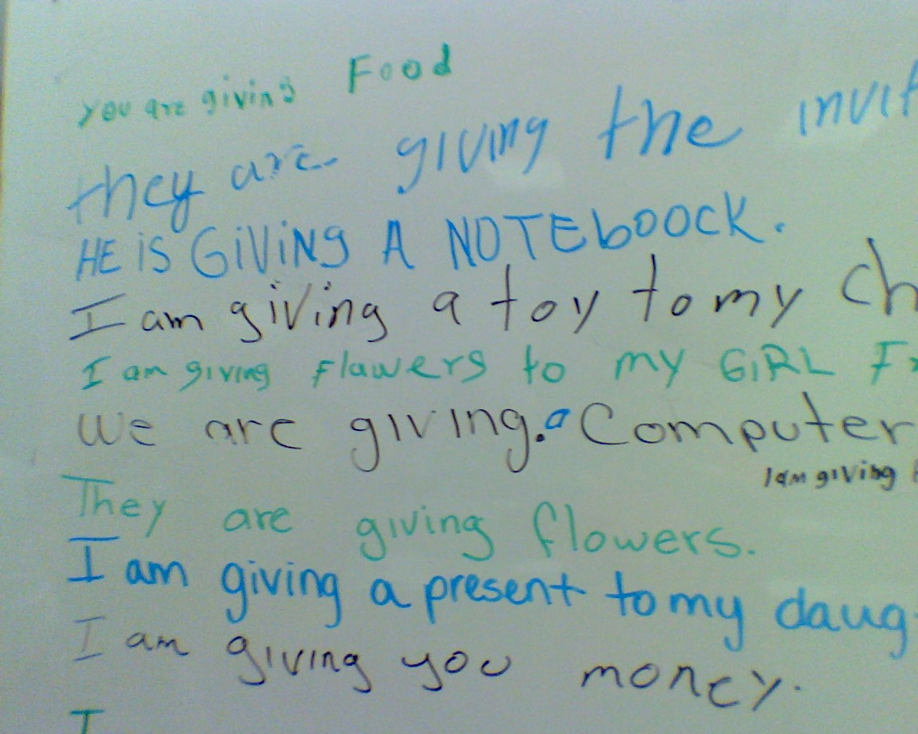
- Review the verb “to give.” A handout is attached. The photo shows my students’ practice work on the whiteboard.

- Finally, ask students to compile their ideas and thoughts in writing using the easy format shown below. (A handout for this exercise is attached.) Students may fill in the blanks by choosing fitting answers from the ideas/thoughts on the white board.

We give____________
Our family gives______________
My friends give____________________

We gave_____________
Our family gave__________
My friends gave_____________

Class 2

- Recap from the previous class and answer any questions.

- Now it is time to explain the concept of community service and how ordinary citizens make a difference in their community by becoming involved in helpful acts both big and small.

- Ask students what they think Americans do to help others. Encourage students to share their ideas and thoughts. Record them on the board.

- It is an easy segue from discussion about what Americans do to help others to talking about Goodwill as a non-profit community service agency. ¹ People in our local community contribute in large and small ways to help Goodwill carry out their mission, and Goodwill generously helps our class by giving us nice facilities for the ESL program.

- Ask students about what they like about the facility.

- Write their answers on the whiteboard.

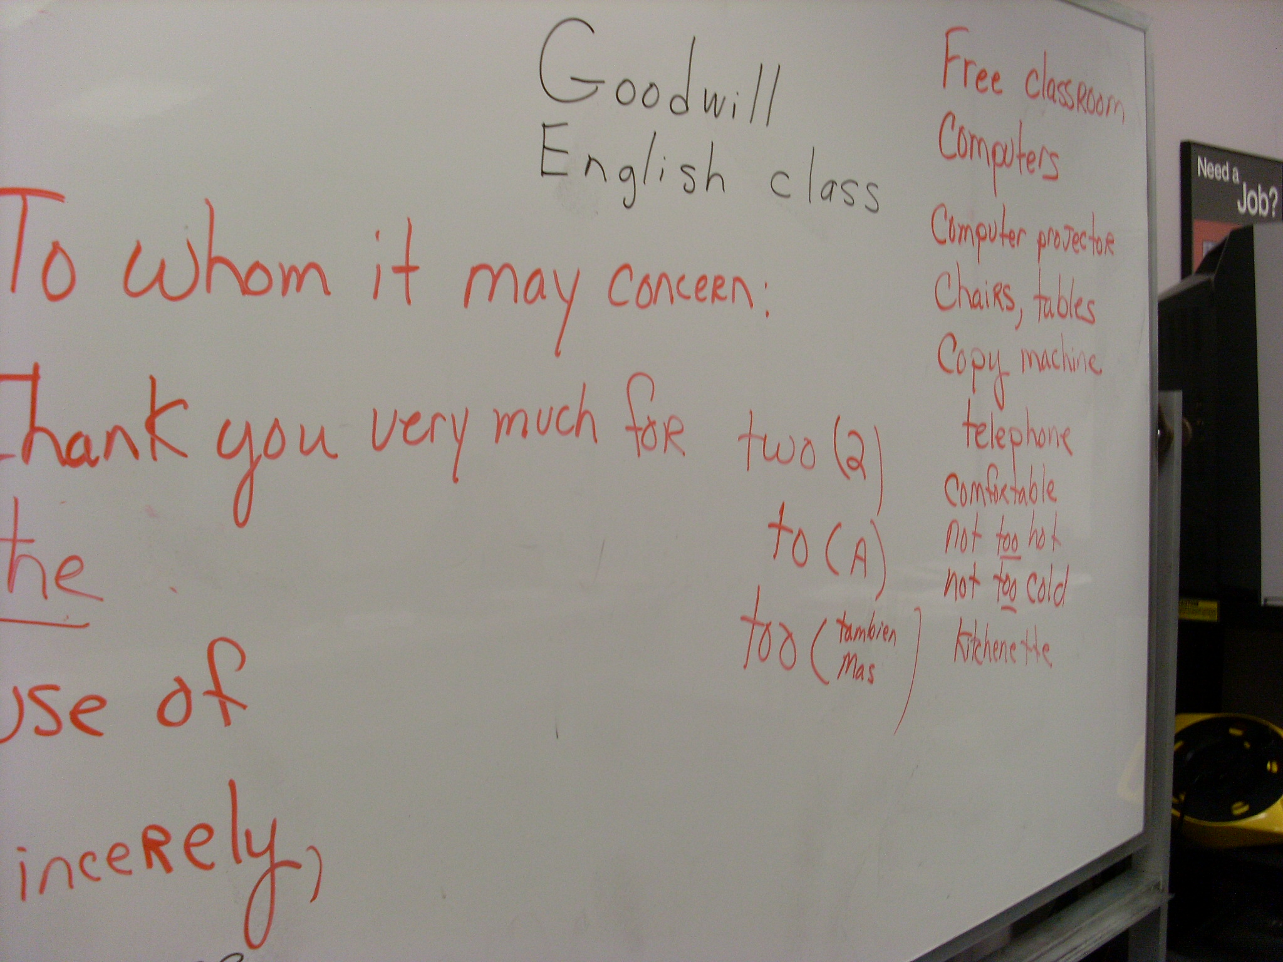
- Facilitate Thank You letters to Goodwill by allowing students to reference the whiteboard while writing individual letters.
I compiled all the students’ letters into a booklet (see accompanying document) which—with some bad photos—was given to a local Goodwill representative. She plans to present it to the Greensboro Goodwill headquarters.

The Planting
The students were thrilled with donating a Japanese Maple to the Goodwill facility. They and worked hard on a cold dark night to plant it. Pictures of the planting are not as good as we had hoped: unfortunately my flash didn’t work. Afterward, I bought pizzas to acknowledge everyone’s help in planting the tree and we celebrated.
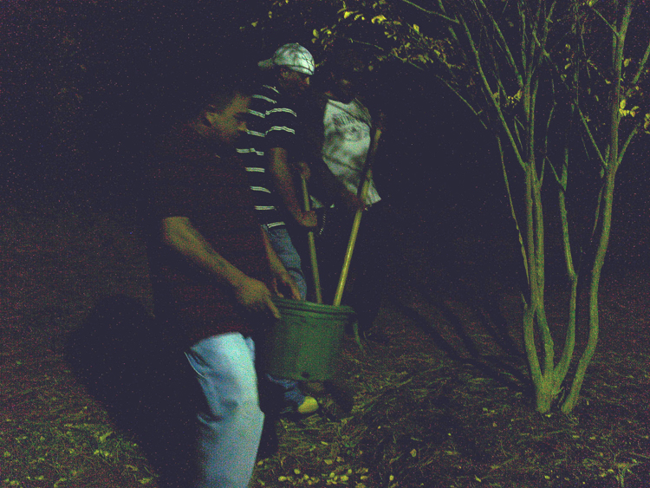

Instructor Comments
I really enjoyed this lesson and learned a little more about the different cultures and their meaning of “community service.” These students expressed willingness and truly wanted to participate in this project. I am proud of this beginning class for giving their all in what was, for them, a difficult lesson. They succeeded beyond my expectations.

_________
¹Goodwill began in the late 1890’s when Methodist minister Edgar J. Helms started collecting unwanted household goods. He employed the community’s jobless immigrant population to repair and refurbish them. Workers were paid from income generated by resale of the items. Over the years Goodwill redirected its services to the population in need, including people with physical, mental, and emotional disabilities as well as people lacking work experience and dependent on public support. By building partnerships within the community, Goodwill today provides vocational evaluation, job training, employment, and job placement services in the community. Our ESL class is an example of one of those partnerships. (See http://www.triadgoodwill.org/about_triadgoodwill.html.)
THE VERB TO GIVE

Present “to give” Past “gave”

I give I gave
you give you gave
he gives he gave
she gives she gave
we give we gave
they give they gave

I am giving__________
You are giving________
He is giving__________
We are giving________
They are giving_______

Examples
She gives candy to my children.
I gave my child a car.
I am giving my child a computer.

Vocabulary
Community
Food Bank
Volunteer

Worksheet on Community Service

In your country, what types of things did you do to “give back” in your community?

Present

We give________________

Our family gives___________

My friends give____________

Past

We gave____________________

Our family gave______________

My friends gave_______________

Is it different in America? If so, how?

