Exercise Your Right to Vote!

By Scott Crisco
Stanly Community College

Objectives
Students will
- Develop an awareness of why American citizens vote and how the voting process in the United States works

- Do a small public service project for our campus to raise awareness and encourage citizens to go to the polls

Graphic from
http://office.microsoft.com/en-au/clipart/default.aspx

Community Setting
Teaching about the right to vote during a presidential election—as we did—has the advantage of daily media attention being given to real candidates in a real election. Democracy in progress surrounds students and provides an extraordinarily effective atmosphere for teaching students why citizens vote and how the process works.

What is Voting? How Does it Work?
During a period of 3 to 4 weeks I used a variety of Civic/voting lesson plans.¹ See the endnotes for a resource list. We watched the INS videos about the rights and responsibilities of citizenship² and the naturalization process.³ We also discussed political ad campaigns and why they are important in our democracy. At the end of these lessons, our ESL class went on a field trip to an actual voting place. The students watched me go through the whole process from start to finish. When we returned from the voting place, we had some very lively discussions about the process.

Getting Out the Vote
For a public service project, our students went into each of our Basic Skills classes and handed out cards that read “Exercise your right, vote!”
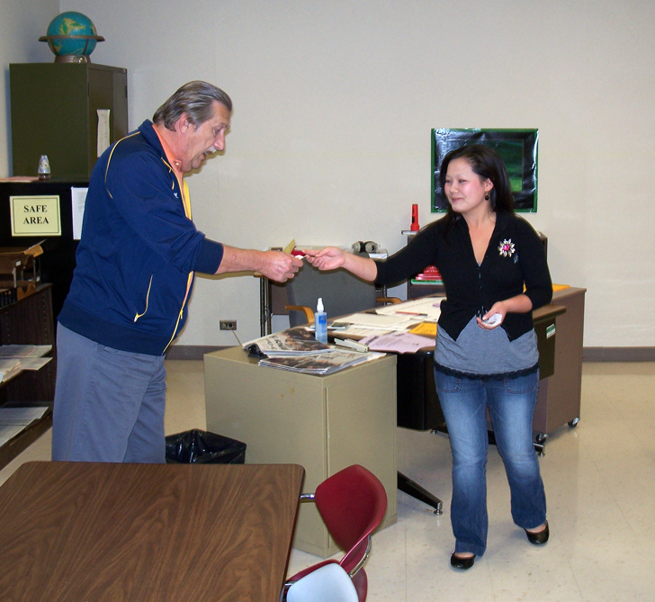

Sample voting card

“Exercise Your right to Vote!”

November 4th!

Graphic from http://office.microsoft.com/en-au/clipart/default.aspx

We developed a short script for students to read if they needed the extra help or confidence:

ESL Script

Student: Hello class, I would like to remind you all that November 4th is national voting day. Please do your civic responsibility and vote! Thank you.

The students really liked doing this and interacting with other students. I think this got them fired up and ready to pursue their own U.S. Citizenship.

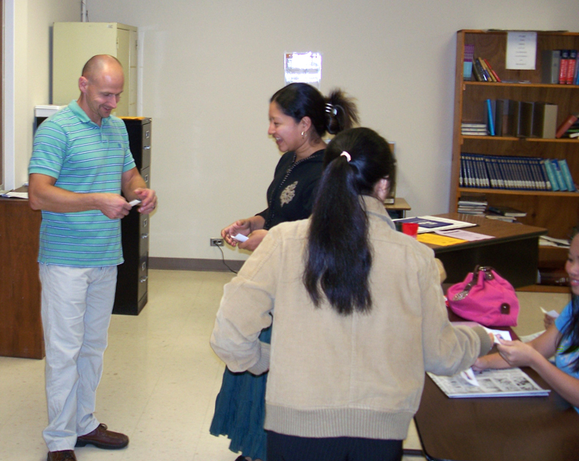

Observations
Throughout this project I could tell the students were genuinely interested in why and how the American voting process works. Because of this project, these students are more aware of the political T.V. ads and the different types of political parties. They seemed to feel more connected to their new adoptive country.

Endnotes

¹ Civics/voting lesson plans may be found at The North Carolina Network for Excellence in Teaching. Use your favorite search engine to look for nc-net.info. Put your cursor on Teaching Resources in the menu on the left of your screen and click on ESL in the drop-down menu that results. Then choose any of the following:
- Click on The North Carolina Curriculum Guide. Scroll down to Domain Eight and click on Elections and Voting under the unit on Disagreement.
- Click on The House I Live In (left screen menu). Scroll down and click on Lesson 2, What is American Democracy?
- Click on Living in America (left screen menu). Scroll down and click on Unit 18. Civic Participation.
- Click on Participatory Learning in ESL/CIVICS (left screen menu). Scroll down and click on Political Systems and Voting.
- Click on ESL: A Guide to U.S. Citizenship (left screen menu). Scroll down and click on Lesson 8 under Competency Two: Political Parties and Voting.
- Click on EL/CIVICS Education Curriculum (left screen menu). Click on Year Two (across the top of the screen). Scroll down and click on Voting.

²A Promise of Freedom: An Introduction to U.S. History and Civics for Immigrants: This 12-minute film focuses on the history and founding of our nation and the important rights and responsibilities of U.S. citizenship. It highlights the role of immigration in U.S. history.

[Google USCIS Homepage. Click on the Education and Resources tab (across the top of the page); then click on Civics and Citizenship Study Materials. Scroll down to see the item above and the one below. Both can be ordered from the U.S. Government Printing Office.]

³Becoming a U.S. Citizen: An Overview of the Naturalization Process: This 10-minute Flash® presentation provides a general overview of the naturalization process including where to find immigration information and the general requirements for U.S. citizenship.

“Exercise Your right to Vote!”  November 4th! |  | “Exercise Your right to Vote!”  November 4th!
“Exercise Your right to Vote!”  November 4th! |  | “Exercise Your right to Vote!”  November 4th!
“Exercise Your right to Vote!”  November 4th! |  | “Exercise Your right to Vote!”  November 4th!
“Exercise Your right to Vote!”  November 4th! |  | “Exercise Your right to Vote!”  November 4th!

