A Citizen’s Number One Right

A VOTER REGISTRATION PROJECT
By Marie Alston and Granville Simmons
Alamance Community College

Teaching Objectives
Students will
- Develop a concept of what voting means in a democracy
- “Walk through” the process of voter registration in the classroom
- Be introduced to the idea of citizen volunteers “giving back” to the community
- Experience serving as volunteers for voter registration

Background
The e-mail arrived in early September:
FYI
Any faculty and staff interested in helping to register voters on campus are invited to attend a brief training session . . . etc.
Alamance Community College was holding a voter registration drive in the building where our Citizenship Class meets! Registration days were scheduled for September 17th—Citizenship Day—as well as September 18th, and September 24th

In the Classroom
We explained to our Intermediate/Advanced Citizenship students that voter registration would be taking place in our building. We used this opportunity to talk about the importance of voting and the facts that (1) only citizens can vote, and (2) citizens must register to vote.

We also pointed out that September 17th is Citizenship Day--sometimes called Constitution Day—a day that honors the signing of the U.S. Constitution on September 17, 1787. This day is an important opportunity to remind ourselves and others about the rights and responsibilities of citizens. ¹

Student interest led us to move on into an explanation of the actual process of voter registration. The majority of our teaching time was spent on
- Filling out mock voter registration forms²
- Discussion
- Question-answer time
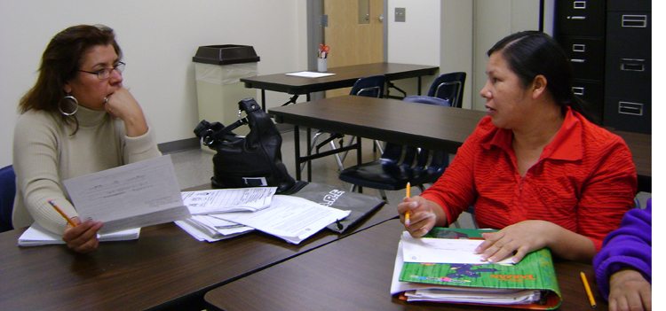
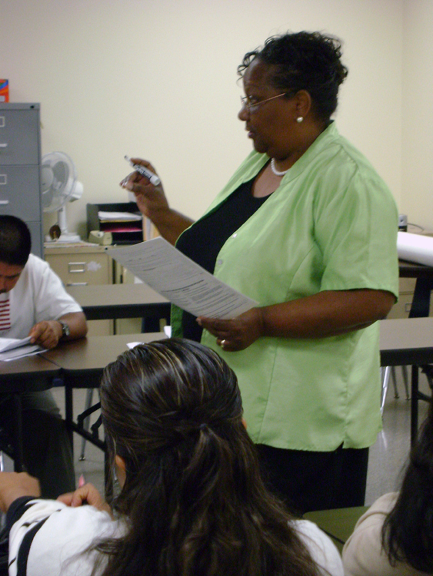
Students Esperanza and Maria discuss the form with one another as they work on filling out a mock voter registration.

Instructor Marie Alston teaches a lesson on the voter registration form.

Another activity we did in the classroom consisted of a computer demonstration. By going to http://www.sboe.state.nc.us/ (the State Board of Elections site), we were able to show students how they might check/update their voter registration, find their polling place, and read other information about voting in North Carolina.

Students were very excited and wanted to help with the registration. As a class, we decided to target students who had become citizens since the time our Citizenship Class first started. Students in the current class took home voter registration forms along with their own completed mock registration forms to share with friends and family members who are 18 years old or older and have become American citizens.

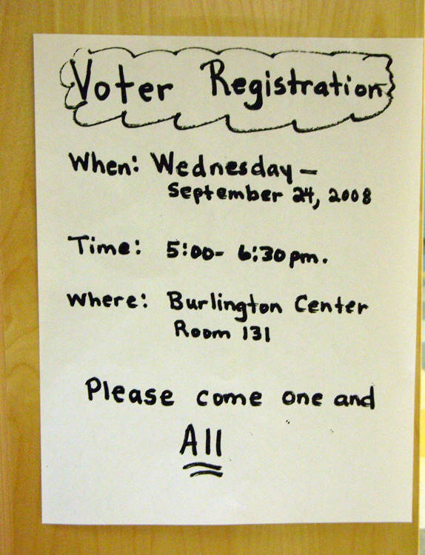
Extra Teacher Preparation
Making this project “happen” required an extra investment of teacher time to
- Phone former and current students to let them know the voter registration was going to take place
- Post signs around the building and touch base with the other ESL and GED teachers in the building

Voter Registration Night
Voter registration was open to the general public. Among those who came were people from the groups we had made a special effort to contact. Our targeting efforts alone resulted in 14 newly registered voters. These were
- 1 student from the Adult High School class
- 2 students from the Reading Class who had never registered because they couldn’t read the form well enough to complete it by themselves
- 2 students from another ESL class who are already American citizens
- 9 students from our Citizenship Class (Note: 8 others did not come because 5 had already registered and 3 had just received notice that they passed the citizenship test but had not yet had the oath ceremony.)

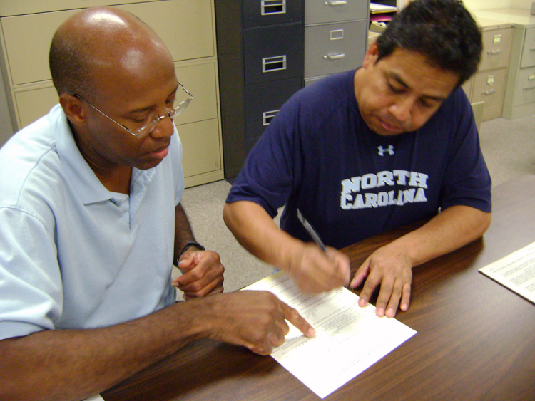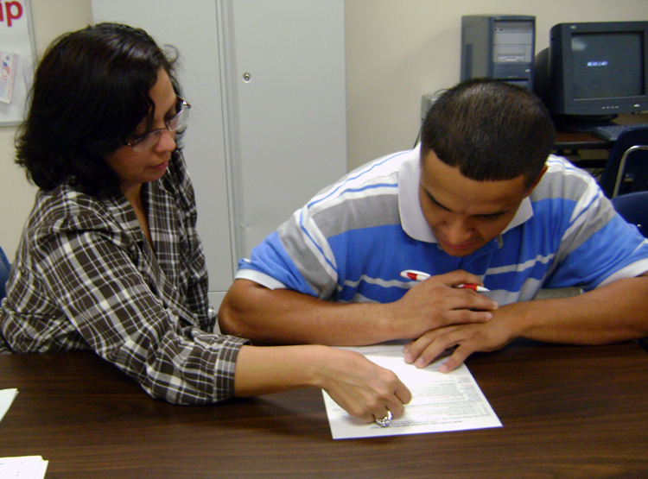
Instructor Granville Simmons helps Antonio fill out a voter registration form to vote for the first time as a U.S. citizen.
ESL/GED student volunteer Miriam Moran helps Marvin register to vote for the first time as a U.S. citizen.

We gave each person who registered a copy of the local early voting schedule showing the dates, locations, and times when they could vote prior to the November 4 election day.

We also gave each person who registered a copy of Being a Good Citizen by Phyllis Naegeil. This article may be found at http://edhelper.com/ReadingComprehension_34_31.html. If you have difficulty accessing the article, start at http://www.edhelper.com/ and type the title and author in the search bar. This article is useful for adults but intended for children. When distributing it, we suggested the adults take it home and talk about their new voter registration and the meaning of good citizenship with their children or young friends.

Evaluation
Overall, we felt our numbers were pretty impressive and the experience was a great success. We also felt privileged to have a unique opportunity of timing that made it possible for us to participate in this voter registration project for Citizenship Day.

________
¹The Act that passed the holiday also states that federally funded schools are required to provide lessons on the U. S. Constitution during the holiday. The following paragraph is from http://www.loc.gov/law/help/constitution-day.html. Note the emphasis added in Bold.

“ 2004 - Consolidated Appropriations Act, 2005, Public Law 108-447, 118 Stat. 2809, Div. J, Title I, Section 111, Dec. 8, 2004, currently codified in 36 USC 106, amends Title 36 United States Code Section 106 to rename Citizenship Day as Constitution Day and Citizenship Day. The public law, but not the codification, also has two additional provisions: first, that the head of each federal agency provide each new employee with educational and training materials concerning the Constitution and also provide such materials to every employee on September 17 of each year; and second, that each educational institution that receives Federal funds shall hold an educational program on the Constitution for students on September 17 of each year.”

²We put “sample” on real forms. Our students are not yet citizens and cannot register. You can get voter registration forms from your county Board of Elections.

