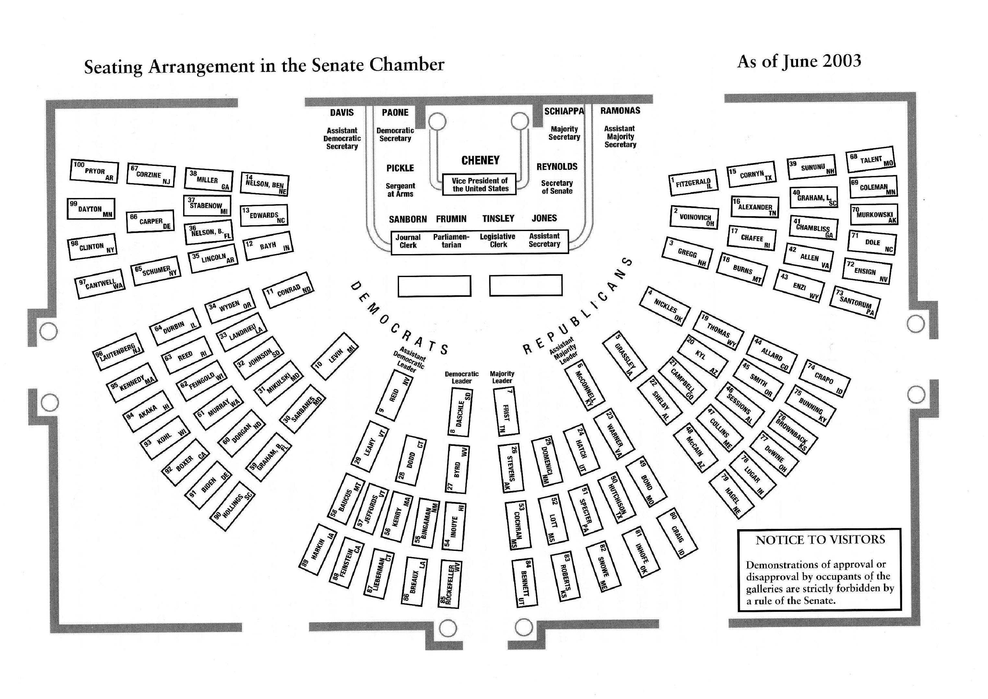
5
1
2
3
4
The Senate Chamber
6
6
6
6

