Lesson Contents

Key Words in English and Spanish 2

Lesson Plan Objectives and Outline 3

Lesson Plan Visual Aid:
Month by Month development of Baby 9

Lesson Plan Handout:
Healthy Mother, Healthy Baby 18

Lesson Plan Post Test
Test for Students and Answer Key 20

Suggested Resources for Prenatal Information 22
Key Words in English and Spanish

Pregnancy/Embarazo Placenta/Placenta
Month/Mes Bones/Huesos Organs/Organos Lungs/Pulmones
Heartbeat/Latido de el corazon Alcohol/Alcohol
Fetus/Feto Vitamins/Vitaminas

A pregnancy typically lasts 40 weeks.
Un embarazo tipicamente dura 40 semanas.

By the 4th month, the baby begins to move and kick.
Al cuarto mes, el bebe empieza a moverse y a patalear.

The baby’s organs form in the first 2 months of pregnancy.
Los organos de el bebe se forman en los 2 primeros meses de el embarazo.

By the 5th month, the baby’s heartbeat can be heard.
Al quinto mes, el latido de el corazon de el bebe se puede oir.

The fetus is another name for the developing baby.
El bebe, durante su tiempo de desarroyo, se le llama el feto.

The placenta is an organ that brings nutrients to the fetus.
La placenta es el organo que trae nutricion al feto.

The fetus’s bones begin to harden by the 6th month.
Los huesos de el feto empiezan a endurecer en el sexto mes.

The fetus’s lungs are not fully developed until the 9th month.
Los pulmones de el feto se desarroyan completamente asta el noveno mes.

If a pregnant woman drinks alcohol, her baby can be harmed.
Si una mujer embarazada toma alcohol, le puede dañar al bebe.

Eating healthy foods helps to provide vitamins and minerals that the mother and baby need.
Comidas saludables ayudan a proveer vitaminas y minerales que la mama y el bebe necesitan.
Lesson Plan and Objectives

Objectives

To explain the month by month growth and development of a baby, including organ and system development
- To explain healthy habits for a healthy baby

PART 1

- Define Pregnancy
- Review month-by-month growth of baby using real-life laminated pictures.

PART 2

- Review the “Healthy Habits for a Healthy Baby” section.
- Review “Healthy Mother, Healthy Baby” handout.

Prenatal Class (Part 1)

Pregnancy
- Typically lasts 40 weeks
- Divided into three trimesters
- First Trimester refers to the first 12 weeks
- Second Trimester – 13th week to 27th week
- Third Trimester – 28th to 40th week

REVIEW OF BABY’S GROWTH MONTH BY MONTH
(Use Month by Month Diagrams)

6 WEEKS - Month 1
- First 8 weeks the baby is called an “embryo”.
- Heart and Lungs begin to form.
- On 25th day – heart starts to beat.
- Brain, spine, and major organs begin to form.
- End of 1st month, is ½ inch long, weights < 1 ounce.
- Mom has increased hormones, morning sickness, food cravings.

8 –10 WEEKS - Month 2
- All major body organs and blood vessels formed but not completely developed.
- Ears, ankles, wrists are formed. Eyes are formed.
- Fingers and toes developed.
- End of 2nd month, is 1 inch long, weighs approx. < 1 ounce. The pancreas and gallbladder are formed. Reproductive organs start to develop but not yet visible. Outer ears are forming.

11 – 14 WEEKS - Month 3
- Fingers and toes grow nails.
- Heartbeat can be heard.
- End of 3rd month, is about 2 ½ inches long, weights approx little over 1 ounce.
- Kidneys begin to work and produce urine.
- Arms grow to normal human proportion but legs take longer.
- Yolk sac makes blood cells for the fetus. Eventually, the liver, spleen, and bone marrow will take over this job, and the sac will detach.
- The Placenta – is the organ where the embryo lives.
  - By this month, the placenta is well formed.
  - It grows as the fetus grows.
  - It brings nutrition to the fetus.
  - It stores carbohydrates, protein, calcium, and iron, and releases them as the fetus needs them.
  - It carries away waste products from the baby.
  - It acts as “lungs” until the baby can breathe on its own.
  - It protects the fetus from harmful bacteria, but cannot fully protect it from harmful substances such as drugs, alcohol, poisons found in cigarette smoke and other chemicals.

15 – 18 WEEKS - Month 4
- Fetus moves, kicks, and swallows, begins to flex arms and legs that are now forming. This helps in development of muscles and nerves.
- The eyelids fuse together.
- Nails begin to form.
- Gallbladder begins digestion process.
- Bones begin to make red blood cells.
- Teeth begin to form under the gums.
- Fine downy hair covers the whole body (lanugo).
- Eyebrows and hair begin to grow.
- Mom begins to feel the baby move for the first time.
- End of 4th month, is about 5-6 inches long, weighs about ½ pound.

19 – 22 WEEKS - Month 5
- Fetus becomes more active, can suck its thumb.
- Fingernails have grown to tips of fingers.
- Fetal heartbeat can be heard.
- Mom will feel her baby move, stretch, and kick more, now that its muscles are more developed. This movement also helps develop its brain.
- Baby senses sounds of mom’s body, and noises and conversations. Baby can become startled and cry if it hears a sudden, loud noise.
- End of 5th month, is 8-12 inches long, weighs about 10 to 12 ounces.

23 – 26 WEEKS - Month 6
- Skin is red, wrinkled, and covered with fine soft hair.
- Bones begin to store calcium, and harden.
- Lungs prepare to breathe on their own but are not yet mature.
- Eyelids begin to open, and the eyes are almost completely formed.
- If baby born this month, it might be able to survive, although lungs and blood vessels not fully formed.
- VIP for mom to be careful so baby can go full term.
- End of 6th month, is about 10-12 inches long, weighs about 1 ½ pounds.

27 – 30 WEEKS - Month 7
- Eyes open, close, and blink.
- Can now breathe on its own.
- Brain enters a period of rapid growth.
- Baby begins to make grabbing motions with hands.
- End of 7th month, is about 11 - 15 inches long, weighs about 2- 3 pounds.

31 – 34 WEEKS - Month 8
- Too big to move too much.
- You may notice shape of an elbow or heel on mom’s tummy.
- Taste buds are developed. Baby can respond to sweet and sour.
- Ears are well developed enough to hear and respond to sounds.
- Baby can curl up, stretch, yawn, swallow, and react to being touched.
- End of 8th month, is about 17 - 18 inches long, weighs about 5 pounds.

35 - 40 WEEKS - Month 9
- Lungs and major organs are fully matured
- Baby gains about ½ pound a week.
- End of 9th month, is about 19-21 inches long, and weighs 6 to 9 pounds or more.

Prenatal Class (Part 2)

Healthy Habits for a Healthy Baby

1. Visit the doctor
- A woman should visit her doctor before she becomes pregnant.
- She should visit her doctor again as soon as she thinks she is pregnant.
- Visits will be monthly until approximately 7th month
of pregnancy and then they will be every 2 weeks.
During last month of pregnancy, visits will probably be weekly.

2. Eat Healthy
- Include a variety of foods from the Food Guide Pyramid

Grains provide carbohydrates, the body’s main source of energy. Whole-grain breads and cereals, brown rice and whole wheat pasta are healthiest.

Fruits and vegetables provide important vitamins and minerals, as well as fiber. It is recommended to include at least 1 serving a day of produce rich in vitamin C (such as citrus fruits, strawberries, or cantaloupe) and beta-carotene, a nutrient the body converts to Vitamin A (such as carrots, sweet potatoes, or broccoli).

Protein foods such as meat, fish and beans are crucial for the
baby’s growth. Eggs, tofu, dried beans and nuts also provide protein.

Dairy Products are important to help build baby’s bones and teeth. Choose low-fat milk, cheese and yogurt.

Other:
Drink at least 6-8 cups of water, juice and/or milk every day. Limit high fat foods but do not drastically reduce your fat intake during pregnancy. Pregnancy is not the time to try to lose weight. In fact, most women should gain 24-28 lbs during the pregnancy. Limit sweets. Even though sweets do not have to be completely eliminated, make healthier choices when possible. Don’t cut down on salt unless instructed by the doctor to do so.

- Vitamin and Mineral Supplements

Folic Acid: Take a multi-vitamin containing folic acid beginning in planning stages of pregnancy. Also, eat foods that contain folic acid including fortified breakfast cereals, leafy green vegetables, orange juice, beans and peanuts. If all women of child bearing age took folic acid before and in the early weeks of pregnancy, the risk of certain birth defects of the brain and spinal cord could be reduced by up to 70%.

Prenatal vitamins:
Once becoming pregnant, a prenatal vitamin will probably be prescribed. Prenatal vitamins contains the recommended amounts of vitamins for pregnant women including folic acid.

Iron:
Pregnant women need extra iron. For some women, iron supplements are recommended. Check with the doctor first.

Caffeine:
Limit beverages that contain caffeine including coffee, sodas and tea. More than one to two cups per day can be harmful to the baby. Heavy caffeine consumption (five or more cups a day) during pregnancy has been linked to miscarriage and reduced-birthweight babies.

3.Exercise
- Exercise can be helpful. Walking is a good choice.
- Talk with health care provider before beginning exercise.
- Avoid hot tubs, saunas and Jacuzzis, especially in the 1st trimester. Elevated body temperatures may increase the risk of birth defectsof the brain and spinal cord.
4. Rest
- Take time to rest. Too much stress may increase the risk of preterm labor, low birth-weight and, possibly, miscarriage.
- Ask for help and support.

5. Practice Safety
- Always wear a seatbelt
- Minimize exposure to chemicals such as solvents, paints, cleansers and insect repellent. These substances are hazardous and can increase chances of birth defects or risks of miscarriage.
- As a woman’s belly gets bigger, it makes balance more difficult making it easier to fall. Be careful.

6. Say No to Alcohol
- When a pregnant woman drinks alcohol, her baby does, too.
- Women who drink during pregnancy can have a baby with a group of birth defects called fetal alcohol syndrome. (FAS). FAS is the leading preventable cause of mental retardation.
- No one knows exactly how much alcohol it takes to cause problems in the baby, so the recommendation is to avoid all alcohol during pregnancy including beer, wine, wine coolers and liquor.
.

7. No smoking
- Smoking during pregnancy can cause a variety of pregnancy complications including low birth-weight babies, miscarriages (Smokers miscarry up to 80% more often than non-smoking women), and pre-term delivery.
- Babies exposed to smoke after birth suffer from more respiratory illnesses and ear infections than other babies and are more likely to develop asthma.
- Babies exposed to smoke are more likely to die from sudden infant death syndrome. (SIDS).
- Stopping smoking at any point of the pregnancy can be beneficial. The fewer cigarettes smoked, the less likely the baby will be born with smoking-related problems.

8. Don’t Do Drugs
- Cocaine increases the risk of certain birth defects, miscarriage and pre-term labor. Babies exposed to heroin are likely to be born addicted and babies exposed to illegal drugs are also more likely to have learning or behavioral problems later in life.
- Certain prescription drugs can cause birth defects.
- Some over-the-counter drugs are not recommended during pregnancy.
- The doctor should know about any medications the pregnant woman is taking.

Supplies Needed:

Handouts: Healthy Mother, Healthy Baby

Teaching aids: Month by Month Development of baby pictures.
Month by Month Diagrams

1st month of Pregnancy

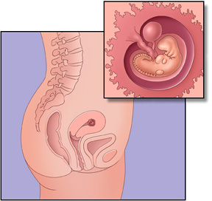

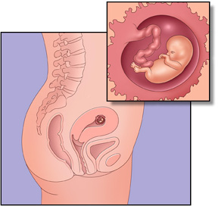
2nd Month of Pregnancy

3rd Month of Pregnancy

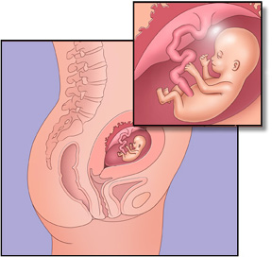

4th month of Pregnancy

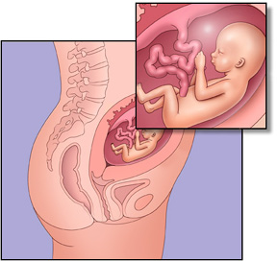

5th Month of Pregnancy

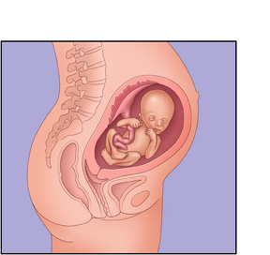

6th month of Pregnancy

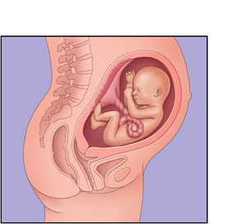

7th month of Pregnancy

8th month of Pregnancy

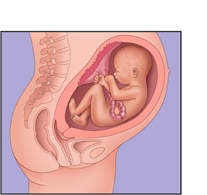

9th month of Pregnancy

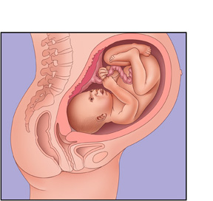

Mamá Sana, Bebe Sáno
Healthy Mother, Healthy Baby

- Visíte a su doctor al empíezo de su embarázo.
See your doctor early in your pregnancy.

- Evíte alcohol, fumár, y drogas. Cuando usted toma alcohol, fúma, o toma drogas, puede causar serios problemas de salud para el bebe.
Say “no” to alcohol, smoking and drugs. When you drink alcohol, smoke or take drugs, it can cause serious problems to your baby’s health.

- Ejercício es beneficioso. Caminar es buen ejercicio. Consúlte con su doctor antes de iniciár un plan de ejercicio.
Exercise can be helpful. Walking is a good choice. Talk with your doctor before beginning exercise.

- Durante el embarazo es importante comer una variedad de comidas saludables. El embarazo no es tiempo de ponerse a dieta o perder peso. La mayoria de mujeres deben subir 25-35 libras durante el embarazo.
Eating a variety of healthy foods is important during pregnancy. Pregnancy is not a time to “diet” or try to lose weight. Most women should gain 25-35 lbs. during pregnancy.

- Coma los alimentos que contienen Calcio cada dia. Estos incluyen leche, queso, yogurt, y algunas verduras verdes obscuras.
Eat foods that contain Calcium every day. These include milk, cheese, yogurt, and some dark green vegetables.

- Cada dia coma de 2 a 3 porciones de carne, pollo, pavo, pescado, huevo, frijoles, o lentejas, para obtener proteina.
Eat 2 to 3 servings of meat, fish, eggs, or dried beans every day for protein.

- Coma por lo menos 5 porciones de frutas y verduras cada dia para obtener vitaminas y minerales. Por ejemplo, corte un platano en tajadas y póngalo encíma del cereal en la mañana. Cóma una manzana de bocadillo en la tarde. Tambien, puede comer una zanahoria o polillos de apio con su comida, y brocolí y una ensalada en la cena.
Eat at least 5 servings of fruit and vegetables every day for vitamins and minerals. For example, slice a banana over your morning cereal and choose an apple as an afternoon snack. Also, have carrot or celery sticks with lunch and broccoli and salad with dinner.

- Cóma de 6 a 11 porciónes pequeñas de granos enteros, que son importantes para la salud y energía. Estos incluyen trigo entero, pan integral, arroz moreno, cereals morenos, tortillas de maiz.
Eat 6 to 11 small servings of whole grains, which are important for health and energy. These include whole wheat breads and cereals, and brown rice.

9. Evíte bebidas con cafeina, como el café y sodas.
Avoid drinks with caffeine, such as coffee and soft drinks.
Prenatal Care Test
Examen de Cuidado Prenatal

- The calcium in dairy products helps build baby’s bones during pregnancy. What are two sources of calcium-rich foods?

_______________________, ________________________.

El calcio que se encuentra en productos lacteos ayuda al crecimiento de los huesos de el bebe. Cuales son dos comidas que son buenas fuentes de calcio?

_______________________, ________________________.

- Once becoming pregnant, the requirement for vitamins, minerals, and iron is increased. Therefore, it is important to take a daily ______________________.

Durante el embarazo, aumenta la necesidad de vitaminas, minerales, y hierro. Por eso, es muy importante tomar una _________________________ al diario.

- Taking folic acid during pregnancy is very important. It is a vitamin that helps the baby’s brain and spinal cord develop properly. Which of the following foods
contain folic acid?

Tomar acido folico durante el embarazo es muy importante. Esta vitamina
ayuda al cerebro y a la columna vertebral del bebe a desarrollarse en forma adequada. Cuales de las siguientes comidas contienen acido folico?

- Fortified Cereals, Breads

Cereales fortificados, Panes

- Leafy green vegetables

Verduras de hojas verdes

- Orange juice

Jugo de Naranja

- Beans and Nuts

Frijoles y nueces

- All of the above

Todas las respuestas

Answer Key – Prenatal Care Test

- Milk, cheese, yogurt

Leche, quesos, yogurt

- Prenatal vitamin
Vitamina prenatal

- All of the above. They are all good sources of Folic Acid.
Todas las respuestas. Todas son buenas fuentes de acido

Suggested Resources for Prenatal Care

www.marchofdimes.com March of Dimes Birth Defects Foundation: information for students, parents, health professionals, women of child-bearing age and pregnant women to help them understand prenatal health and how to improve the health of babies. Click on more in the section called Welcome to Pregnancy. Click on During Your Pregnancy.

www.4woman.gov/ National Women’s Health Information Center, U.S. Public Health Service’s Office on Women’s Health: Information on the stages of pregnancy, fetal development, nutrition and other areas of prenatal care. Click on Health Topics, then on Pregnancy.

www.armc.com Alamance Regional Medical Center: Information about medical conditions, treatments, wellness and more. Click Your Health (left column), then on Health Info (mid-article). Under Conditions, click on In Full. Click Pregnancy Center.

http://www.mayoclinic.com Mayo Clinic: Click Healthy Living tab. Click Pregnancy.

http://www.healthfinder.gov Healthfinder: information on hot topics, smart choices and search for health topics. Search pregnancy.

