Lesson Contents

Key Words in English and Spanish 2

Lesson Plan Objectives and Outline 3

Lesson Plan Activity
“Guess the Sugar Amount” Activity 5
Snack Foods and Sugar Content 6

Lesson Plan Handouts
Food Guide Pyramid- English 7
Food Guide Pyramid- Spanish 8
Building Healthy Meals and Snacks-English 9
Building Healthy Meals and Snacks-Spanish 10
Better Choices, Better Health (Spanish & English) 11

Lesson Plan Post Test
General Nutrition Test (for Students) 12
General Nutrition Answer Key (for Teacher) 13

Resources for General Nutrition 14

Key Words in English and Spanish

Fruits / Frutas Vitamins / Vitaminas
Bread / Pan Minerals / Minerales
Vegetables / Verduras Calories / Calorias
Meats / Carnes Risk / Riesgo
Milk Products / Productos Lacteos Obesity / Obesidad
Moderation / Moderacion Portion / Porcion

Fruits and vegetables are a good source of nutrition and are low in fat.
Frutas y verduras son buena fuente de nutricion y son bajas en grasa.

Whole grain breads are a good source of fiber.
Pan integral es una buena fuente de fibra.

Trim all visible fat from meats and chicken before cooking.
Corte toda la grasa visible de la carne y el pollo antes de cocinar.

Low fat or skim milk products are excellent sources of calcium for our bones.
Productos Lacteos descremados son excelentes fuentes de calcio para nuestro huesos.

Eat a variety of foods to get the vitamins and minerals your body needs.
Coma variedad de comidas para obtener las vitaminas y minerales que su cuerpo necesita.

Eating too many calories can result in weight gain.
Comer demasiadas calorias pueden resultar en sobrepeso.

Healthy eating and exercising can reduce the risk of chronic diseases.
Una dieta sana y el ejercicio pueden reducir el riesgo de enfermedades cronicas.

Obesity can lead to diseases such as heart disease or diabetes.
Obesidad, o sobrepeso, pueden causar enfermedades de el corazon, o diabetes.

Everything in moderation. Eat small portions of all food groups.
Todo con moderacion. Coma porciones chicas de todos grupos de comidas.

Lesson Plan Objectives and Outline

Objectives
- Students will learn how healthy food choices can lower risk of chronic diseases.
- Students will learn about the Dietary Guidelines.
- Students will become familiar with the Food Pyramid.
- Students will be able to identify the food groups.

Outline
- The importance of a healthy diet
- Essential nutrients and calories to prevent nutritional deficiency.
- Can help reduce the risk for chronic diseases, such as heart disease, cancer, diabetes, stroke, and osteoporosis, which are leading causes of death and disability.
- Risk factors include obesity, high blood pressure, and high blood cholesterol.
- Offers essential nutrients such as vitamins, minerals, and protein, which the body is unable to make.

2. Dietary Guidelines for better health
- Eat a variety of foods that includes plenty of whole grains, vegetables and fruits. Use the Food Guide Pyramid as a guide (refer to the Food Guide Pyramid handouts)
- The Food Guide Pyramid was developed to help people make daily healthy food choices from the different food groups. The key is Variety, Balance, and Moderation.
- Choose foods from every food group to obtain combinations of nutrients. No single food can supply all nutrients in the amounts we need.
- Eat the recommended daily amounts from each group.
- Follow the suggested serving sizes to avoid overeating or to ensure adequate amount of food every day. (refer to “Building Healthy Meals and Snacks” handouts)

- Choose a diet moderate in sugars
- Sugar is found naturally in many foods, but there are some foods with added amounts of sugar. These sugary foods have more calories and not much nutrition, such as desserts, candy, jams, syrups, and sodas.
- Some sugary foods are also high in fat like cakes, pies, cookies, chocolates, and donuts.
- Choose small amounts of these foods.

- Choose a diet low in fat, saturated fat, and cholesterol
- Fats are found in margarine, butter, oils, salad dressings, nuts, seeds, milk, cheese, meats, fish, poultry, snack foods, ice creams, and desserts.
- Saturated fats are found in meats, dairy products, coconut, and shortening. Some pastries are also high in saturated fats.
- High levels of saturated fat and cholesterol in your diet are linked to increased blood cholesterol levels and a greater risk for heart disease and some cancers.

- If you drink alcoholic beverages, do so in moderation
i. Alcohol intake can raise the risk for high blood pressure, stroke,
heart disease, and cancer.
- Adds calories but no nutrients.
- If you drink alcohol, drink in moderation (Moderation is: 2 drinks for men, and 1 for women daily. One drink = 12oz beer, or 4oz wine, or 1.5oz hard liquor.)

- Choose a diet moderate in salt and sodium
- High levels of sodium increase the risk of high blood pressure.
- Buy fresh, or frozen, or canned “no salt added” vegetables.
- Limit smoked, cured, or processed meats.
- Reduce use of frozen prepared foods, canned soups, or broths.
- Cut back on instant or flavored rice, pasta, or cereal mixes.
- Reduce amount of salt, seasoned salt, soy, or salty sauces at the table and during cooking.

- Balance the food you eat with physical activity:
maintain or improve your weight.
- Physical activity helps to prevent weight gain.
- Associated with lowering risk for many chronic diseases, which include heart disease, diabetes, and stroke.
- Weight gain increases risk for high blood pressure, heart disease, stroke, diabetes, cancer, breathing problems, arthritis and joint diseases.
- High-fat foods contain more calories and can cause weight gain.

Handouts:

1. Food Guide Pyramid- English Version.
Note: For an updated pyramid, see http://www.mypyramid.gov and click on For Professionals (menu on left). Scroll down and choose Mini Poster.
2. Food Guide Pyramid- Spanish Version.
At the website above, click on En Español (upper right corner), then on Para Professionales (menu on left ), and Mini Afiche.
3. Building Healthy Meals and Snacks- English Version.
Note: For information on serving size in the new pyramid, go to http://www.mypyramid.gov, click on Inside the Pyramid (menu on left), click on the orange segment of the pyramid, then on Learn More. Click on What Counts as an Ounce (right side of page), then on Click Here to See Chart. Follow these same general steps with each color segment of the pyramid.
4. Building Healthy Meals and Snacks- Spanish Version.
At the website above, click on En Español at the top right corner of the screen and follow the pattern outlined above, but in Spanish.
5. Better Choices, Better Health- English/Spanish Version

Activity

“Guess the Sugar Amount”

(do this activity after lecture)

Objective: Students will learn the sugar content of foods and drinks, to help them make better choices.

Activity
The class will attempt to guess the amount of sugar in several snack foods.
One volunteer will pour the sugar amount into a container, a teaspoon at a time. The class will count each teaspoon as it goes into the jar, and will try to guess how many teaspoons each snack food has.

Example

A 20 oz. Coke has 14 teaspoons. The volunteer will begin to pour, one teaspoon at a time into the jar, and will give students the opportunity to say when to stop. The Coke exercise is complete when all 14 teaspoons are in the jar.

Do the same for all the other foods on the list.

Supplies for activity:
“Snack Foods and Sugar Content” List
Plastic container with sugar
Clear plastic container to spoon and count sugar into
Teaspoon. Use the teaspoon to spoon the sugar into the clear plastic container.

Optional supplies for activity:
Coke 20oz bottle

Jumbo Honey Bun
Fruit Loops 3 cups – bag each cup individually in a baggie
Fruit Drink 16oz bottle
Hershey’s Bar
Dole Orange Juice 16 oz bottle

Helpful Hints:
Recommend having the actual snack foods to add more impact to the activity. You can have one or a few of them.

You can also do two snack foods at a time to add more impact. For example: 20oz Coke and the honey bun have a total of 27 teaspoons of sugar!
Activity

Snack Foods and Sugar Content

Coke 20 oz --- 68g carbohydrate --- 14 teaspoons sugar

Honey bun --- 66g carbohydrate --- 13 teaspoons sugar

Fruit Loops
1 cup --- 28g carbohydrate --- 6 teaspoons sugar
2 cups --- 56g carbohydrate --- 11 teaspoons sugar
3 cups --- 84g carbohydrate --- 17 teaspoons sugar

Fruit Drink 20oz
Whole Bottle -- 75g carbohydrate --- 15 teaspoons sugar

Hershey Bar
King size --- 42g carbohydrate --- 8.4 teaspoons sugar

Dole Juice 16oz
Whole Bottle --- 27g carbohydrate --- 6 teaspoons sugar

How to determine teaspoons of sugar in sweets and sweetened beverages:
- Look at the “Nutrition Facts” food label on the product.
- Find the “Total Carbohydrate” grams on the food label.
- Divide total grams of carbohydrate by 5.

Example: 12oz. Coke= 41 grams of carbohydrate
41 grams of carbohydrate divided by 5 = 8 teasp of sugar

Please also note the “Servings Per Container” on the label. For example, a 20oz Coke label shows “Total Carbohydrate” of 27 grams. But it also has 2.5 “Servings Per Container”. To calculate total grams of cabohydrate for the whole bottle:
27 grams carbohydrate x 2.5 servings per bottle = 68 total carbohydrate grams for the total bottle. 68 divided by 5 = 14 teaspoons of sugar for the total bottle.

KEY
● Fat (naturally occurring and
added)
▼ Sugars (added)

These symbols show fat and added
sugars in foods.

A Guide to Daily Food Choices

Fats, Oils, & Sweets USE SPARINGLY
Milk, Yogurt, & Cheese Group
2-3 SERVINGS
Vegetable Group
3-5 SERVINGS
Meat,Poultry,Fish DryBeans, Eggs,
& Nuts
2-3 SERVINGS
Fruit Group
2-4
SERVINGS

Bread, Cereal,
Rice,& Pasta
Group
6-11
SERVINGS

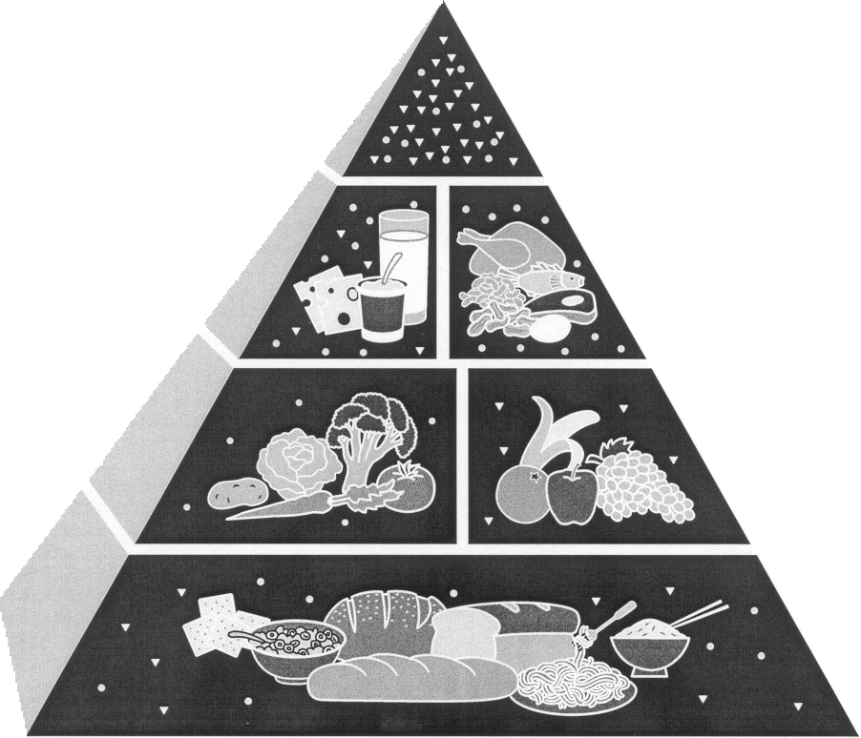
Source: U.S. Department of Agriculture/U.S. Department of Health and Human Services, August 1992.

What is the Food Guide Pyramid?
The Pyramid is an outline of what to eat each day. It's not a rigid prescription, but a general guide that lets you choose a healthful diet that’s right for you.

The Pyramid calls for eating a variety of foods to get the nutrients you need, and at the same time the right amount of calories to maintain or improve your weight.
The Pyramid also focuses on fat because most American diets are too high in fat, especially saturated fat.

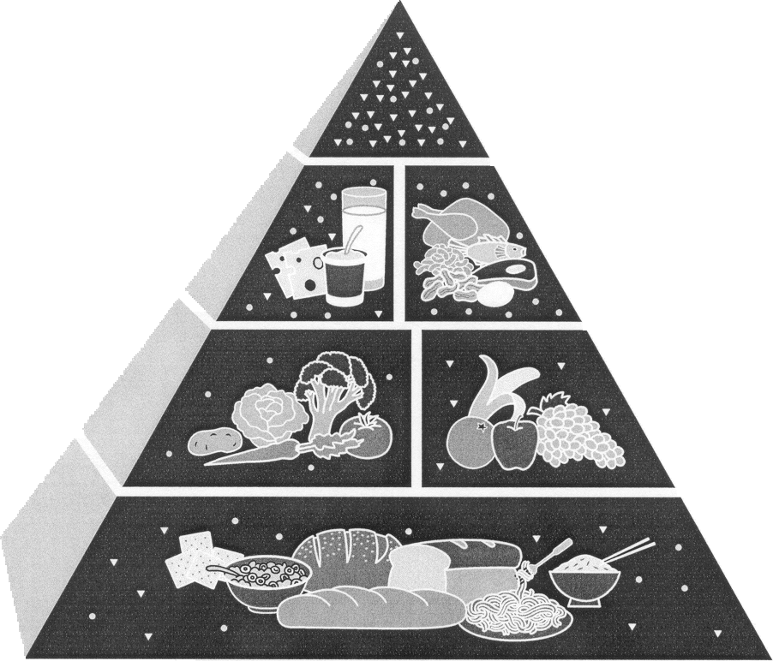

Grasas, Aceites y Dulces USELOS CON MODERACION

La Guía Pirámide de Alimentos
Una Guía Para la Selecci6n Diaria de Alimentos
Grupo de Carne, Aves, Pescado, Frijoles Secos, Huevos y Nueces
2-3 PORCIONES

Grupo de
Leche,Yogurt
y Queso
2-3 PORCIONES

Grupo de Frutas 2-4 PORCIONES
Groupo de
Pan, Cereal,
Arroz
Y Pasta
6-11
PORCIONES

C L A V E
●Grasas (naturales y agregadas)
▼Azúcares (agregados)
¿Qué es la Guía
Pirámide de Alimentos? La Pirámide recomienda
La Pirámide es un esquema consumir una variedad de alimentos
de lo que debe comerse para obtener los nutrientes
cada día. No es una receta necesarios y a la vez, la cantidad
rígida, sino una guía general adecuada de calorias para mantener
que le permite seleccionar un peso saludable.
una dieta saludable y adecuada
para usted.
La Pirámide enfoca la
grasa, porque la dieta de la
mayoríade los estadouni-
denses contiene demasiada
grasa, especialmente la grasa
saturada.
Grupo de Verduras
3-5 PORCIONES

Source: U.S. Department of Agriculture/U.S. Department of Health and Human Services, August 1992.

Building healthy meals and snacks
Use these guidelines to figure out how much food counts as one serving on the food Guide Pyramid. Information from http://www.usda.gov/cnpp/pyramid.html .

Food Group Count as one serving

Bread, Cereal, Rice • 1 slice of bread, 1 small roll or muffin
and Pasta • ½ bagel OR ½ English muffin OR ½ hamburger bun
• 1ounce ready-to-eat cereal
• ½ cup cooked cereal, rice or pasta
• 1 7-inch tortilla OR 2 corn taco shells
• 3 cups popcorn
• 6 small crackers (saltines)
• 3 graham cracker squares (1 ½ sheets)
• 1 4-inch pancake

Vegetable Group • 1 cup raw leafy vegetables
• ½ cup cooked or chopped vegetables
• ¾ cup vegetable juice
• ½ cup tomato sauce or spaghetti sauce
• 1 cup vegetable soup
• 7-8 carrot or celery sticks

Fruit Group • 1 medium apple, banana or orange
• ½ cup chopped, cooked, or canned fruit
• ¾ cup fruit juice
• ½ grapefruit
• 7 medium strawberries
• 12 grapes

Milk, Yogurt and Cheese • 1 cup milk or yogurt
Group • 1 cup pudding or custard
• 1 ½ ounces natural cheese
• 2 ounces process cheese
• 1 cup cottage cheese
• 1 ½ cups cream soup (made with milk)

Meat Poultry, Fish, Dry • 2-3 ounces cooked lean meat, poultry or fish
Beans, Eggs, and Nut Group • 2-3 ounces ground meat patty
• ½ chicken breast OR 1 thigh plus 1 leg
Count as 1 ounce of meat (about 1/3 serving):
• 1 egg
• 2 Tablespoons peanut butter
• 1 hot dog
• ½ cup cooked dry beans or lentils

Preparación de comidas y meriendas saludables
Con estas guías usted podrá averiguar la cantidad de alimentos que se considera una porción según la Guía Pirámide de Alimentos. Information from http://www.usda.gov/cnpp/pyramid.html .

Grupo de alimentos Cuánto es una porción

Grupo de Pan, Cereal, Arroz • 1 rebanada de pan, 1 rollo pequeño o panecillo
y Pasta • ½ bagel o ½ panecillo o ½ pan de hamburguesa
• ½ taza de arroz, pasta o cereal cocidos
• 1 tortilla de 7 pulgadas
• 3 tazas de palomitas de maíz
• 6 galletas pequeñas (saladitas)
• 1 onza de cereal listo para comer
• 3 galletas graham cuadradas
• 1 panqueque de 4 pulgadas

Grupo de Verduras • 1 taza de verduras de hoja crudas
• ½ taza de verduras cocidas o picadas
• ¾ taza de jugo de verduras
• ½ taza de salsa de tomate, salsa de espagueti
• 1 taza de caldo de verduras
• 7-8 zanahorias o tallos de apio

Grupo de Frutas • 1 manzana, plátano (banana) o naranja mediana
• ½ taza de fruta cortada cocida o enlatada
• ¾ taza de jugo de frütas
• ½ toronja
• 7 fresas medianas
• 12 granos de uva

Grupo de Leche, Yogurt y • 1 taza de leche o yogurt
Queso • 1 taza de postre de leche o flan
• 1 ½ onzas de queso natural
• 2 onzas de queso procesado
• 2 tazas de requesón (cottage cheese)
• 1 ½ taza de sopa de crema (preparada con leche)

Grupo de Carnes, Aves, • 2-3 onzas de carne magra, aves o pescado
Frijoles Secos, Huevos y • 2-3 onzas carne molida
Nueces • ½ pechuga de pollo o 1 muslo con pierna
Equivale a una onza de carne (más o menos 1/3 porción):
• 1 huevo
• 2 cucharadas de mantequilla de maní (cacahuate)
• 1 salchicha (1 hot dog)
• ½ taza frijoles o lentejas cocidos

Mejores Selecciones, Mejor Salud
Better Choices, Better Health

- Coma cereales sin azúcar, pan integral/trigo, avena, tortillas de maíz, arroz.
Make high fiber choices such as whole grain breads and cereals, oatmeal, bran.

- Coma 5 porciones de frutas y verduras cada día. Estas son una buena fuente de fibra, vitaminas y minerales.
Eat at least 5 servings of fruits and vegetables every day. These are good sources of fiber, vitamins, and minerals.

- Escoja cortes de carne bajos en grasa. Coma pollo sin pellejo, pescado, frijoles y lentejas.
Choose lean cuts of meat. Eat chicken without the skin, fish, beans and lentils.

- Tome leche del 1%, o leche descremada (“skim”), quesos y yogur reducidos en grasa (“low fat”).
Choose low fat or fat-free dairy products, such as skim milk, low-fat cheese or yogurt.

- Limite los dulces, las reposterías, y las bebidas alcohólicas.
Limit your intake of sweets, and alcoholic beverages.

- Use aceite de maíz, o aceite de Canola en lugar de manteca.
Use vegetable or canola oil in place of lard, animal fat, or vegetable shortening.

- Use menos sal. Limite comidas y sopas enlatadas, chorizo, jamón, salchichas, bocaditos salados como las papitas. Use hierbas y especies en vez de sal al cocinar.
Cut down on salt and sodium. Limit canned and processed foods like sausage, ham, and bologna, salty snacks like chips. Use herbs and spices to season when cooking.

- Tome por lo menos 8 vasos de agua pura, diariamente.
Drink at least 8 glasses of pure, fresh water every day.

- Manténgase activo – Agregue actividad fisica al diario, usted y su familia.
Get Active – Add activity to your daily routine, and include your family.
General Nutrition Test
Examen de Nutricion General

- Fruits and vegetables are good sources of vitamins and __________________.

Frutas y verduras son una buena fuente de vitaminas y _____________________.

- Drinking too much soda can lead to weight gain. Sodas are high in _____________.

Tomar muchas sodas puede causar sobrepeso. Sodas tienen mucha ____________.

- High levels of saturated fat and ______________________ in your diet can cause heart disease.
Altos niveles de grasa saturada y ______________________ en su dieta pueden
causar enfermedades cardiacas.

- Alcohol intake can increase the risk of ________________________________.

Tomar bebidas alcoholicas puede aumentar el riesgo de ___________________.

- Eating foods high in sodium/salt can increase the risk of _________________________.

Consumir comidas altas en sodio/sal puede aumentar su riesgo de____________________.

- High fat foods contain more ____________________________ and can cause more weight gain.
Comidas altas en grasa contienen mas ____________________________ y pueden causar sobrepeso.

General Nutrition Answer Key

- Minerals

Minerales

- Sugar

Azucar

- Cholesterol

Colesterol

- High blood pressure, or stroke, or heart disease, or cancer.
Presion Alta, o infarto, o enfermedades cardiacas, o cancer.

- High blood pressure

Presion Alta

- Calories

Calorias

Resources for General Nutrition

http://www.usda.gov/cnpp/pyramid.html Center for Nutrition Policy and Prevention offers printable versions of the Food Guide Pyramid in English and Spanish. Click on site and scroll down to “Consumer” and “Professional” areas to print the Pyramid version of your choice. Note: The most recent version of the food pyramid can be found at http://www.mypyramid.gov.

http://www.uwex.edu/ces/wnep/teach/foodfact.cfm University of Wisconsin Cooperative Extension offers a series of low-literacy food fact sheets for those with limited nutrition backgrounds. These fact sheets are in English and Spanish, ready for print. They provide information on child and adult nutrition, safe food handling, stretching the food dollar, and cooking and baking tips. Scroll down to Individual Fact Sheets and English and Spanish. Click on the green square beside individual Fact Sheets.

www.armc.com Alamance Regional Medical Center: This Food and Nutrition archive has a wealth of information on topics: Vitamins and Minerals, Nutrition and Health, Foods in the News, Changing Eating and Lifestyle Habits. Click on Site Map, then, under Wellness (left column), click Food and Nutrition.

www.eatright.org American Dietetic Association: Extensive link to nutrition and health. Topics include Daily Tips of nutrition from A to Z, Nutrition Fact sheets of different topics, weight management. Click Food and Nutrition Information tab on top left.

www.mayoclinic.com Mayo Clinic: World-renowned site that includes nutrition guidelines, weight control, special diets, and comprehensive review of the Food Guide Pyramid and dietary guidelines. Shopping strategies with recipes and healthy cooking. Click Healthy Living tab.

