Lesson Contents

Key Words in English and Spanish 2

Lesson Plan Objectives and Outline 3-4

Lesson Plan Activity:
“Know Your Foods” activity 5-6
Pictures of food and stoplights 7-19

Lesson Plan Handouts:
Hyperglycemia 20
“What Happens When You Eat?” (English) 21
“What Happens When You Eat?” (Spanish) 22

Lesson Plan Post Test
Test for Students and Answer Key 23-24

Resources for Diabetes 25

Diabetes- Key Words for English/Spanish Exercise

Glucose/Glucosa Blood test/Prueba de sangre
Blindness/Ceguera Symptoms/Síntomas
Kidney Disease/Enfermedad Renal Sodas/Sodas
Heart attack/Ataque de corazon Exercise/Ejercicio

Amputations/Amputaciones

High sugar foods/Comidas altas en azucar

Glucose is another name for blood sugar.
Glucosa es la forma de azúcar que se encuentra en la sangre.

Diabetes is the leading cause of blindness in adults ages 25-74.
Diabetes es la causa primaria de ceguera en adultos de 25 a 74 años de edad.

1 out of 10 people with diabetes develop kidney disease.
Cada 1 de 10 personas con diabetes desarrollan enfermedades renales.

People with diabetes are more likely to have a heart attack or stroke.
Personas con diabetes tienen mas propensidad a un ataque al corazon, o un infarto.

For someone who has diabetes, good foot care can help prevent amputations.
Un buen mantenimiento de cuidado de sus pies puede prevenir amputaciones.

A blood test can determine if a person has diabetes.
Una prueba de sangre puede determinar si una persona tiene diabetes.

Increased thirst and hunger can be symptoms of diabetes.
Aumento de la sed y hambre pueden ser síntomas de la diabetes.

Eating too many high sugar foods and high fat foods can cause weight gain.
El comer demasiadas comidas altas en azucar y grasas, pueden causar sobrepeso.

Sodas are very high in sugar and should be limited.
Las sodas tienen mucha azucar, y deben limitarse en la dieta.

Exercise can help prevent diabetes.
El ejercicio puede ayudar a prevenir la diabetes.
Lesson Plan and Objectives

Objectives: To explain diabetes in terms of its definition, prevalence, relation to
health problems, risk factors, symptoms and prevention.
Outline
- Definition & Impact of Diabetes
- Definition (Refer to hand-out, “What Happens When You Eat”)
- Diabetes is a chronic disease.
- It is not a contagious disease.
- It affects the way the body uses blood sugar (glucose),
which is the body’s main source of fuel or energy.
- Impact
- An estimated 16 million people in the U.S. have diabetes
and half of these people don’t know it.
- 6% of Hispanic adults in the U.S. have been diagnosed with
diabetes; 21.4% of those aged 65 and older have been
diagnosed with diabetes.
- Diabetes and Health Problems
- Cardiovascular disease
- People with diabetes are at least twice more likely to have a
a heart attack or a stroke.
- Eye disease
- Diabetes is the leading cause of blindness in adults ages 25-
74.
- Amputations
- Diabetes is the most common cause of amputations not
caused by injury.
- Kidney disease
- 1 out of 10 people with diabetes develop kidney disease.
- Diagnosing and Symptoms (Refer to hand-out, “Hyperglycemia”)
- Diabetes. Diagnosed by taking a blood test
- A fasting plasma glucose > 126 mg/dl
- A random blood glucose > 200 mg/dl plus symptoms
- Symptoms. May be a slow start of symptoms or none at all.
- Symptoms include tingling/numbness in hands or feet, recurring skin, mouth, or bladder infections, increased urination, thirst and/or appetite, problems with sexual function, blurred vision, slow-to-heal cuts or sores, tiredness, and dry itchy skin.
- Causes and Risk Factors
- Causes.
- No one knows exact cause.
- Risk factors. Some people have a higher risk of getting diabetes.
- Risk factors include being older that 40 years, being
overweight, family history of diabetes, having diabetes
during pregnancy, stress, high blood pressure, African
American, Hispanic American and Native American heritage
- Lowering the risk of getting diabetes
- Healthy food choices
- Eat 3 balanced meals per day.
- Choose a variety of foods including whole grains, fruits and
vegetables, low-fat dairy products and lean meats.
- Limit foods and beverages with added sugars such as cookies,
pies, cakes, pastries, sodas and fruit punch.
- Limit high fat foods such as fried foods, lard, butter and
margarine, foods in creams and sauces.
- Use low fat cooking methods: bake, broil, grill, microwave,
or roast.
- Include high fiber foods often such as whole grain breads and
cereals, fresh fruits and vegetables, and cooked dried beans
and peas.
- Use less salt by reducing the amount used in cooking, not
adding salt at the table, and eating fewer high-salt foods.
- Exercise
- Exercise helps prevent diabetes by helping to control weight
and by making it easier for sugar in the blood to enter the
body’s cells and be used for energy.
- Stress Management
- When a person is under physical or emotional stress,
hormones are released that make it harder for sugar in the
blood to enter the body’s cells and be used for energy.
- Blood glucose testing
- An adult should have blood sugar (glucose) checked each year.
- Sometimes health fairs at work sites, etc., will offer free glucose screenings. A small drop of blood is obtained by pricking the finger and tested using a glucose meter. If the level of glucose is higher than recommended, the person is asked to follow-up with their doctor for further tests.

Class Supplies Needed:
Handouts: “What Happens When You Eat?” (English)
“What Happens When You Eat?” (Spanish)
Hyperglycemia (English and Spanish)
“Know Your Foods” Activity

(A game in which participants categorize foods as anytime, sometimes, or rarely.)

Goal: Promote knowledge of the fat, sugar and calorie content of foods in a way that is interactive and fun.

Objectives: Students will identify anytime, sometimes, or rarely foods.
Students will learn how to balance foods based on sugar, fat, and calorie
content.

Props: Pictures of foods, laminated pictures of stoplights (3), red, yellow and
green cards, tape or tickey-tac.

Instructions: Print and cut out the pictures of food that are provided as well as the three stoplights. If the stoplights are in color, on one stoplight cross off the yellow and green, on the second, cross off the red and yellow and on the third, cross off the green and red. If the stoplights are in black and white, write the word red on the top light of one of the stoplights, the word yellow on the middle light of one of the stoplights and the word green on the bottom light of one of the stoplights. Using removable adhesive putty, post the stoplights on the board or wall leaving space between them.

Ask for a volunteer. Explain that there are three stoplights posted on the board. One is red, one is green and one is yellow. Red indicates rarely, yellow indicates sometimes, and green indicates anytime. Give the volunteer a picture of food. If he/she thinks the food is low in calories and high in nutrients, place the food under the green stoplight. If the food is high in fat and/or sugar and high in calories but low in nutrients, place under the red stoplight. If the food has some fat and sugar but also has some nutrients, place it under the yellow stoplight. Explain that pictures can be placed anywhere in between. Once the volunteer has placed the picture and explained their decision, ask the other students if they would move the food closer to a particular stoplight/color and ask them to explain their reason for doing so.

Continue to ask for new volunteers. (Usually for 8-10 food items)

Food Pictures Provided:
More toward green light: peppers, peach, turkey with no skin, strawberries, bread, peas, fish, pear, grapefruit, corn, broccoli, carrots, tomatoes.

More toward yellow light: hamburger, eggs, waffles, dairy products, chili with nachos, tacos, pizza.

More toward red light: Danish, French fries, donuts, margarine, candy.

Items needed for “Know Your Foods” activity:
Pictures of foods,
three laminated picture of stoplights
red, yellow and green cards
tape or ticky-tac.

Note: Copy Pictures of Foods and Stoplights. Cut out the pictures. Refer to the activity instructions.
Pictures of Foods and Stoplights











Print Three Copies

HYPERGLYCEMIA - HIPERGLICEMIA
(High blood sugar) (Exceso de Azucar en la Sangre)

Causes: Too much food, too little insulin or diabetes medication, illness or stress
Causas: Mucha comida, muy poca insulina, enfermedad o estres

Onset: Gradual, or can occur quickly. Can progress to a diabetic coma
Puede subir: Lentamente o de repente. Puede progresar a una coma diabética.

Vision Borrosa/Blurred vision Demasiada Sed/Extreme Thirst

Sueño/Drowsiness Piel Seca/Dry skin Hambre/Hunger

Otros síntomas podrian ser: orinar con frecuencia, nausea
Other symptoms may include: frequent urination, nausea

Si usted siente o experimenta cualquiera de estos síntomas por favor vea a su doctor.
If you are experiencing any of these symptoms, please see your doctor.
What Happens When You Eat?

- When you eat, some of the food breaks down into sugars. One of these sugars is glucose, the body’s main fuel.

- Sugar enters the bloodstream, and the level of sugar in your blood begins to rise.

- When your body senses an increase in sugar, it sends a signal to your pancreas.

- The pancreas makes insulin and sends it into the bloodstream.

- Insulin lowers the level of blood sugar by acting as a key to unlock the body’s cells and allows sugar to pass from the bloodstream into the cells.

- The body’s cells use the sugar for fuel giving you energy.
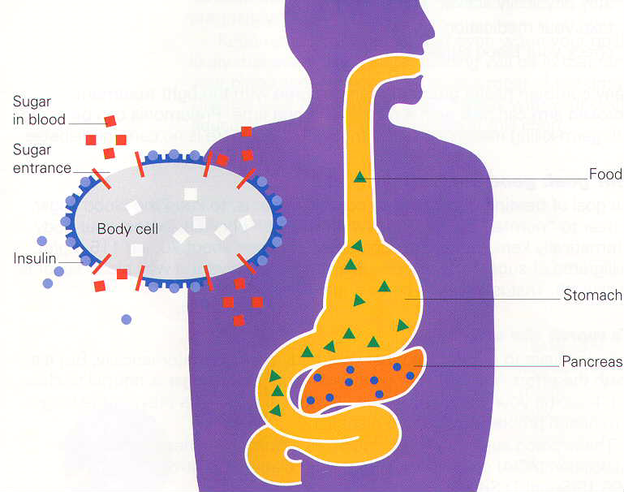

¿Qué pasa cuando comes?

- Los alimentos que usted come se convierten en una forma de azúcar llamada glucosa, el combustible principal de su cuerpo.

- El azúcar entra en la sangre, y el nivel de azúcar en la sangre comienza a subir.

- El cuerpo envía una señal al páncreas cuando siente un aumento del azúcar.

- El páncreas produce insulina y la envía a la sangre.

- La insulina hace bajar el nivel de azúcar en la sangre y permite que el azúcar pase de la sangre a las células.

- Las células utilizan el azúcar como combustible para darle energía.

Diabetes Test
Examen de la Diabetes

1. An estimated __________ million people in the U.S. have diabetes and do not know it.

Approximadamente _________ millones de personas en los Estados Unidos tienen diabetes y no lo saben.

2. A ______________ test can determine if you have diabetes.

Una prueba de _________________ puede determinar si usted tiene diabetes.

3. _________________ is the body’s main fuel.

_________________ es el combustible principal de su cuerpo.

4. People with diabetes are at greater risk of having a ___________ or ____________.

Personas con diabetes tienen mas riesgo que el resto de las personas a tener un

___________________________, o un ___________________________.

5. What are two symptoms of diabetes? 1)___________________________

2)___________________________

Cuales son dos síntomas de la diabetes? 1)_________________________

2)_________________________
Answer Key – Diabetes

1. 16 Million
16 Millones

2. Blood test
Prueba de Sangre

3. Glucose
Glucosa

4. Heart attack or stroke
Infarto de el corazón o apoplegía

5. Increased urination, increased thirst, increased appetite, blurred vision, slow to heal cuts or sores, tiredness, dry itchy skin, tingling/numbness in hands or feet, recurring skin, mouth, or bladder infections

Orinar con frequencia, hambre o sed mas de lo usual, vision borrosa, cortaduras o llagas que demoran en sanar, cansancio o sueño mas de lo usual, piel reseca o con picazón, entumecimiento o sensacion que le hormigean los dedos de los pies o de las manos, infecciones de la piel, boca, o vejiga que recurren
Suggested Resources for Diabetes

http://www.diabetes.org/ American Diabetes Association: basic information about all areas of diabetes, news and updates. Click All About Diabetes.

www.niddk.nih.gov National Institute of Diabetes and Digestive and Kidney Disease, National Institutes of Health: Informative resource for the public, patients and health care providers. Click Health Information. Click Diabetes.

http://diabetes.com Information and support for patients and professionals community board.

www.armc.com Alamance Regional Medical Center: Information about medical conditions, treatments, wellness and more. Click Your Health. Click Health Information. Click Conditions. Click Diabetes.

http://www.mayoclinic.com Mayo Clinic: Click Diseases and Conditions. Click Diabetes under the letter D.

http://www.cdc.gov CDC Home Page: statistics, health information. Click A-Z Index. Click D. Click Diabetes.

http://www.healthfinder.gov Healthfinder: information on hot topics, smart choices and search for health topics. Search Diabetes.

