Course: North Carolina

Unit: North Carolina Highlights

Lesson: North Carolina from A to Z

Competency Objectives: Learners acquire selected historical and geographical information about North Carolina.

Suggested Criteria for Success: Learners participate in class work and demonstrate recognition through matching activities.

Suggested Vocabulary: teacher and student-selected words from attached handout A to Z

Suggested Materials:  Print copies of the handouts from the end of this lesson.
⬥ A North Carolina map for each student or small group or students.
⬥ Pens or pencils and paper. Art supplies if you plan to do quilt squares or postage stamps.
⬥ A multimedia classroom is helpful, if available, to use in searching for additional information on selected topics.

Suggested Resources:
⬥ http://www.visitnc.com Visit North Carolina. Put your cursor on travel tools in the picture on your screen and click on Brochure & Travel Info. This site enables you to order a free North Carolina travel package that includes a state map. You can also call 1-800-VISITNC to inquire about purchasing multiple copies of the state map. Try http://www.ncdot.org/public/publications for another N.C. map source.
⬥ http://www.ah.dcr.state.nc.us/sections/hs/maps/eastern.htm Eastern North Carolina. Use the site names across the bottom of the screen to access the individual places.
⬥ http://www.agr.state.nc.us/agscool/commodities/porkid.htm Hogs in NC
⬥ http://www.ncbiotech.org/ncindustry/ncindustry.cfm Biotechnology Industry.
⬥ http://www.greensboronc.org Enter Mendenhall Plantation and click on Search. Also see http://www.mendenhallplantation.org.
⬥ http://www.pbs.org/wgbh/amex/wright Kitty Hawk
⬥ http://www.nps.gov/wrbr/ Kitty Hawk
⬥ http://www.outer-banks.com/flight/ Kitty Hawk
⬥ http://www.usmint.gov Click on Special Programs (left side), then on 50
State Quarters Program, then on the state of North Carolina. The North
Carolina quarter commemorates the first self propelled, heavier
than air flight was on December 17, 1903 Kitty Hawk, North Carolina.
⬥ http://nc_lighthouses.tripod.com/ NC Lighthouses. Click on the individual
lighthouses on the left side of the screen.
⬥ http://www.oldsalem.org Old Salem
⬥ http://www.nascar-info.net/nascar_history_1.html NASCAR
⬥ http://www.nps.gov/fora/search.htm The Lost Colony
⬥ http://www.rootsweb.com/~ncqualla/native.htm Qualla Boundary
⬥ http://www.westernncattractions.com/cherres.htm Qualla Boundary
⬥ http://www.ah.dcr.state.nc.us/sections/hs/capitol/stat_cap/default.htm Raleigh, NC. Click on Capitol History on the left side of the screen.
⬥ http://www.tryonpalace.org/ Tryon Palace
⬥ http://www.ga.unc.edu/UNC_Schools/UNC_History.html UNC-Chapel Hill
⬥ http://statelibrary.dcr.state.nc.us/nc/bio/public/vance.htm Zebulon B. Vance
⬥ http://www.lectlaw.com/def/h001.htm Habeas Corpus
http://www.doh.dot.state.nc.us/operations/dp_chief_eng/roadside/wildflowerbook North Carolina wildflowers
⬥ http://www.acponline.org/chapters/nc/nc_medschools.htm NC Medical Schools
⬥ http://www.broadfootsofwendell.com/riversofnc.htm NC Rivers
⬥ http://store.yahoo.com/nc-wildlife/store-rivers.html NC Rivers
⬥ http://www.nczoo.org The NC Zoo.

Suggested Methods: Discussion, Pre-reading, Reading, Map Reading, Group Work, Drawing, Matching.

Some Suggested Steps

Learning about North Carolina. Introduce the handout North Carolina from A to Z. What does your class know about North Carolina? Why is it helpful to know something about the place you are living?

Depending on the reading abilities of your class and the activities you plan to do, work with the handout as a whole or one page at a time. Activities you may use to accompany the reading include the following:
- map work to locate the sites in North Carolina from A to Z.
- a time line to show when events occurred. For events with no date given, search the Resources above.
- quilt squares or postage stamps that illustrate parts of North Carolina history or geography. Have each class member or pair class members to design and explain a square/stamp to the rest of the class.

Another activity—pronouncing the North Carolina county names—may interest your class. If you can arrange internet access (with or without sound) and an LCD projector, try the website below. When you click on any county in the NC map you will hear the county name pronounced. As an alternative, you can use the written Guide to Pronouncing County Names included on this site.
- http://www.lib.unc.edu/ncc/ref/resources/tlth.html If you have difficulty, use your favorite search engine to look for Talk Like a Tar Heel: North Carolina County Names.

Class Research/Reading. Learn more about some (teacher or student selected) topics from North Carolina from A to Z. Resources for a few items are given below, organized by topic.

The Lost Colony.  http://www.outer-banks.com/lost.cfm
⬥ http://www.icw-net.com/tales/mantlost.htm or go to http://www.icw-net.com and click on Tales and Lore. Then click on The Lost Colony.
⬥ http://www.nps.gov Click on Parks and Recreation.. Click on View All Parks A-Z, click on F, and scroll down to Fort Raleigh National Historic Site. Click on Search and type in Lost Colony. You can now choose from several references.
⬥ http://library.thinkquest.org/J002559/ or go to http://www.thinkquest.org and click on the Library tab at the upper right corner of the screen. Type How Do You Lose a Colony? and click on Search. Click on How Do You Lose a Colony.

Blackbeard.  http://www.nationalgeographic.com/pirates/bbeard.html
⬥ http://www.legends.dm.net/pirates/blackbeard.html
⬥ http://www.qaronline.org/history/search.htm
⬥ http://www.ocracoke-nc.com/blackbeard

N. C. Lighthouses.  http://www.outer-banks.com/lighthouses.asp
⬥ http://www.carolinalights.com/ocracoke.php Click on the lighthouse names at the top of the screen to view information on the seven NC lighthouses.

Underground Railroad.  http://www.nationalgeographic.com/railroad/index.html or enter http://www.nationalgeographic.com and use the search feature at the top right side of the screen to look for Underground Railroad. Click on go. Choose Underground Railroad—History of Slavery, Pictures, Information. Click on enter. This site is excellent if you have access to a multimedia classroom. Many ideas on the site are useful, even if you are unable view it in class.
⬥ http://www.42explore.com Click on Topic Index (top of screen). Follow the alphabetical listing and click on Underground Railroad.
⬥ http://www.pbs.org In the search box, type The Time of the Lincolns: Underground Railroad and explore the results, or try http://www.pbs.org/wgbh/amex/lincolns/slavery/index.html
⬥ http://encarta.msn.com Using the search function, enter Underground Railroad and click on go. You will find several pertinent selections.
⬥ http://www.freedomcenter.org/ Click on Learn, then on Underground Railroad (left of screen).
⬥ http://afroamhistory.about.com Click on Underground RR on the left side of the screen.
⬥ http://www.greensboronc.org Enter Mendenhall Plantation and click on Search. Also see http://www.mendenhallplantation.org
⬥ http://www.rootsweb.com/~quakers/quakinfo.htm Quaker Customs and Beliefs.

The Wright Brothers.  http://www.historychannel.com/classroom/classroom.html Click on Study Guides (center screen). Scroll down and click on the W in the alphabet. Scroll down to Wilbur and Orville: Dreams of Flying.
⬥ http://www.nasa.gov/home/index.html In the Search space, enter Models of the Wright Brothers Aircraft and hit Enter for how to make models of the planes from 1900-1903.
⬥ http://www.nasa.gov/audience/foreducators/informal/features Enter The Wright Brothers or Learning to Fly: the Wright Brothers Adventure in the search space at the upper right of the screen. Note: Check both the beginning and the end of these documents to locate the glider model patterns.

Test Your Knowledge. Use the Matching handout(s) from the end of this lesson. There is an easy version and a harder one.
- Answers to the easier version are E, C, G, I, H, B, D, J, F, A.
- Answers to the harder version are N, E, I, Q, A, V, B, T, L, H, U, G, C, J, K, X, O, W, D, Y, F, M, Z, P, R, S.

Journal Work. Assign or have students each pick five letters of the alphabet to write (or tell) something about their native country that begins with each of the letters. Put every entry on a separate page. Each student may sign the work with his/her name and the name of his/her country. Note: You can put together all the Journal Work to produce an alphabet about your class members’ countries that is similar in form to North Carolina from A to Z. There are alphabet letters at the end of this lesson that you can copy and enlarge to one-per-page to use as dividers for the work.
North Carolina from A to Z

The Appalachian Mountains are in western North Carolina. Crossing the Appalachians to move west was hard for early settlers.

Blackbeard was a famous pirate. He robbed and sank ships off the coast of North Carolina and Virginia. He was killed in a battle at Ocracoke Inlet in 1718.



There are fifty-eight Community Colleges
in North Carolina. This is one of the nation’s largest community college systems.

The Dogwood is North Carolina’s state flower.

Eastern North Carolina has many historic sites. Fort Fisher kept the port at Wilmington open to supply the Confederacy during the Civil War.

Fort Bragg is the largest military base in North Carolina. It is an Army base at Fayetteville.

Golf is a favorite sport in the state.

Hogs are a big cash commodity in North Carolina.

Biotechnology is a new Industry in the Tar Heel State.

The Mendenhall Plantation at Jamestown is an historic Quaker farm where you can see a false-bottom wagon that was used to transport runaway slaves in the Underground Railroad.

Kitty Hawk is where the Wright brothers flew the first airplane.

There are seven Lighthouses along the North Carolina coast. Before radar and sonar, lighthouses helped sailors navigate the dangerous North Carolina coast--the “graveyard of the Atlantic.”

Moravian settlers established a community called Salem in 1776. Today you can visit Old Salem in Winston-Salem.

NASCAR traces its history to bootleggers driving illegal whisky from hidden stills to market, often while being chased by police. People came to watch when bootleggers started racing among themselves to see who had the fastest car.

The Atlantic Ocean borders North Carolina on the east. The first English settlement in the new world was on North Carolina’s outer banks.

The Blue Ridge Parkway (a part of the National Park Service) runs through western North Carolina.

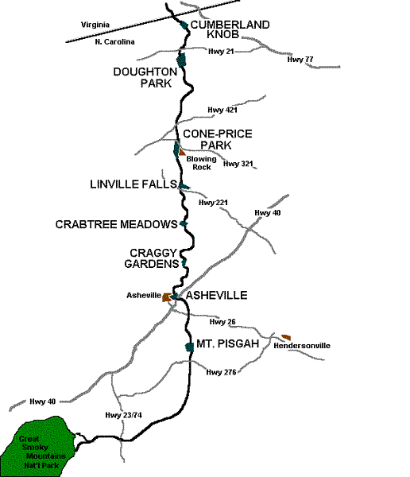

The Qualla Boundary is a reservation near the Great Smoky Mountains National Park. About 12,000 members of the Cherokee tribe live on the Qualla Boundary. The Cherokee are one of several tribes in North Carolina.

Raleigh is the capital of North Carolina.

The first Settlers in North Carolina came from England. Their leaders went back to England for supplies. When supply ships came back to North Carolina, the colonists were gone, leaving the word CROATAN carved on a post. These first settlers are known as the Lost Colony

Tryon Palace in New Bern was the first state capital in North Carolina. It was built in 1767-70 as the home of North Carolina’s royal governor. In 1792, the capital was moved inland from New Bern to Raleigh.

The University of North Carolina at Chapel Hill was the first public university in the United States to open its doors and the only one to graduate students in the eighteenth century. The University was chartered by the General Assembly of North Carolina in 1789, the year George Washington became president of the new nation.

Zebulon B. Vance (1830-1894) is best known as North Carolina's Civil War Governor. Throughout the war he insisted on the rule of law, and North Carolina is the only state that did not suspend the writ of habeas corpus.
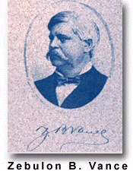

More than 3,500 acres of Wildflowers bloom along North Carolina’s highways. The Department of Transportation seeds and maintains 22 varieties of wildflowers.

X-ray technology is one part of medicine in North Carolina. There are four medical schools in the state and many hospitals and doctors’ offices.

The Yadkin River is part of more than 40,000 miles of rivers and streams in North Carolina. The longest river in the state is the Neuse River. The oldest is New River.

The North Carolina Zoo in Asheboro is the nation’s largest zoo where animals live as they would live in the wild.
Matching

___1. Dogwood | A First English Settlers
___2. Atlantic | B Appalachians
___3. Raleigh | C Ocean
___4. Famous Pirate | D Army Base
___5. Community  Colleges | E State Flower
___6. Mountains | F Golf
___7. Fort Bragg | G State Capital
___8. X-rays | H There are 58 in N.C.
___9. Outdoor sport | I Blackbeard
___10. Lost Colony | J Used in medicine

Matching

_____1. Dogwood | A Fort Fisher
_____2. Wright Brothers | B Lighthouses
_____3. Atlantic | C Car Racing
_____4. Raleigh | D Royal Governor’s Home
_____5. Civil War Fort | E Airplane at Kitty Hawk
_____6. Famous Pirate | F First English Settlers
_____7. Guided sailors | G Appalachians
_____8. Community Colleges | H Early Moravian Community
_____9. Helped the  Underground Railroad | I Ocean
_____10. Old Salem | J Biotechnology
_____11. Qualla Boundary | K Army Base
_____12. Mountains | L Mendenhall Plantation
_____13. NASCAR | M Planted along NC Highways
_____14. Important N.C.  industry | N State Flower
_____15. Fort Bragg | O Golf
_____16. X-rays | P Wild animals live here.
_____17. Outdoor sport | Q State Capital
_____18. Civil War Governor | R Cash Commodity
_____19. Tryon Palace | S Blue Ridge Parkway
_____20. North Carolina river | T There are 58 of these in N.C.
_____21. Lost Colony | U Indian Reservation
_____22. Wildflowers | V Blackbeard
_____23. The University of  North Carolina  at Chapel Hill | W Zebulon B. Vance
_____24. N. C. Zoo | X Used in medicine
_____25. Hogs | Y Yadkin
_____26. Scenic mountain road | Z First State University in the  USA

Remembering Our Countries

Course: North Carolina
Unit: NC Highlights

Lesson: The Tar Heel State

Lesson Objective: Learners will be able to identify their local county.
Learners will be able to recognize their local government representatives.
Learners will be able to identify and paraphrase pertinent information about North Carolina.

Suggested Vocabulary: North Carolina city county representative
neighborhood town state resort
community country Piedmont recreation
Esse Quam Videri

Suggested Materials: Copies of the Reading, Grammar, and Dialogue handouts included at the end of this lesson.
Pens or pencils and paper.
North Carolina recreation and travel brochures, magazines, computer clip art, or other sources of NC pictures for a collage on the Tar Heel State.
North Carolina maps.
Check http://www.enchantedlearning.com/usa/states/northcarolina/ for North Carolina Maps and quizzes.

Some Suggested Steps

Reading. Use the Reading handout from the end of this lesson to build reading proficiency and learn about types of transportation.
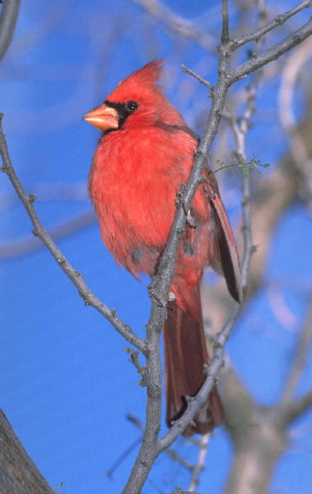

Grammar: Adjectives Use the Grammar handout to help students learn about There is/There are.

Dialogue. Use the Dialogue handout to read and practice the dialogue in the class. Lead your class in a study of the dialogue for content, context, and the grammar lesson (there is/there are).

Media. Discuss the recreation and resort areas in North Carolina. Visit the coastal or mountain region(s) through books, travel and tourism materials (http://visitnc.com), or on a day trip if you are close enough.

Make a collage by drawing the map outline of North Carolina and finding symbols that represent the Tar Heel State.
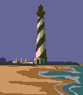

Mountains Piedmont Coast

Community Action. Write a letter to a local representative.

Reading

North Carolina is called the Tar Heel State. It is located midway between the state of Maine and the southern tip of Florida. North Carolina is divided into three regions: the coast, the piedmont, and the mountains. The coast stretches 300 miles along its shores. It is known for fishing, boating, and recreation opportunities. The piedmont is in the central part of North Carolina. It has farmlands, rolling hills, and growing urban cities. The mountain region is in western North Carolina. It is made up of beautiful landscapes and resort areas. Grandfather Mountain is a mountain tourist attraction. About 8,049,313 people live in the state. North Carolina has many symbols. The state bird is the Cardinal. The state colors are red and blue. The state motto is “Esse Quam Videri” which mean “To Be Rather Than to Seem” in Latin.

Grammar: There is/There are

When a statement starts with There, the verb can be either singular or plural. You must find the subject of the sentence to determine whether the verb is singular (is) or plural (are).

- ______________ one hundred counties in North Carolina.

- ______________ a name for each county.

- ______________cities within each county.

- ______________a governor who works to represent the state.

- ______________several communities in our town.

Dialogue

Noemí Campbell immigrated to North Carolina from Mexico two years ago She is taking English Literacy at a local community college. She is talking to her friend, Jamie Braswell.

Jamie: Noemi. How do you like North Carolina?

Noemi: I like living in North Carolina a lot. But I do not know much about it.

Jamie: What would you like to know?

Noemi: I want to know if there is a capital of North Carolina?

Jamie: Yes. The capital of North Carolina is Raleigh. Have you ever been to Raleigh?

Noemi: No, I have not. I hear that there are a lot of shopping centers in Raleigh. I would like to visit some of them one day.

Jamie: I would be glad to go with you to Raleigh. Just give me a call and we will make plans to go together.

Noemi: Thank you so much Jamie.

