Course: North Carolina

Unit: North Carolina Highlights

Lesson: North Carolina Symbols

Competency Objectives: Learners gain introductory information about selected North Carolina symbols.

Suggested Criteria for Success: Learners identify selected state symbols and tell something about them.

Suggested Vocabulary: Berries Beverage Bird Fish Flower
Insect Mammal Reptile Shell Tree
Wildflower Symbol

Flag Motto Nickname Seal

Boat Colors Dog Insect Rock
Song Stone Toast Vegetable
other teacher or student-selected words

Suggested Materials:  Teacher-selected/composed version(s) of material on selected state symbols.
⬥ A multi-media classroom can be used for class viewing online materials. An overhead projector and transparencies are an alternative.
⬥ Handouts:
From the end of this lesson:
Two pages on North Carolina symbols
One page entitled Symbols
Optional transparencies or handouts (if you are teaching these topics)
- The North Carolina flag. See Suggested Resources below. For a site with permission to print for homework assignments and non-commercial purposes, see http://www.50states.com/ncarolin.htm.
- The Great Seal of the State of North Carolina. See Suggested Resources and the seal included within this lesson.
⬥ Prepare a set (or two) of the Symbols of North Carolina with the name written in under the pictures: Strawberries, Blueberries, Carolina Lily, Pine Tree, Milk, Box Turtle, Channel Bass, Gray Squirrel, Scotch Bonnet (pronounced bonay), Dogwood, Cardinal, Honey Bee. Cut into individual squares. Laminate these if you have access to the necessary equipment.
⬥ Pens or pencils and paper (include color markers if you plan to have students design a state seal).

Suggested Resources:  North Carolina Symbols
http://www.secretary.state.nc.us/kidspg/symbols.htm At this site you can click on the underlined name of each symbol to see a picture.
http://statelibrary.dcr.state.nc.us/nc/symbols/symbols.htm At this site you can click on the word picture below the camera to show a picture of each symbol.
http://naturalsciences.org/funstuff/ncsymbols/

⬥ General Resources
http://www.enchantedlearning.com/usa/states/northcarolina/ NC Facts, Maps, and State Symbols. (Site members have access to banner-free, printer-friendly pages.)
http://homeschooling.about.com Click on Unit Studies on the left side of the screen. Scroll down and click on State Unit Studies. Scroll down and click on North Carolina for a number of state resources and ideas.
http://www.easyfunschool.com/article2201.html An excellent NC Study Unit

⬥ The North Carolina State Flag
http://www.50states.com/ncarolin.htm This site has a good NC flag. Click on the words That the flag. The page includes the statement “You may print images for homework assignments & non-commercial projects.”
http://statelibrary.dcr.state.nc.us/nc/symbols/FLAG.HTM

⬥ The Great Seal of the State of North Carolina
http://www.naturalsciences.org/funstuff/ncsymbols/seal.html
http://www.governor.state.nc.us/Highlights/NCkids/sealpage.html
http://statelibrary.dcr.state.nc.us/lbph/seal.htm
http://www.statehousegirls.net/nc/symbols/seal/

⬥ Motto
http://www.netstate.com/states/mottoes/nc_motto.htm
http://statelibrary.dcr.state.nc.us/nc/symbols/symbols.htm Click on Motto.

⬥ Nickname
http://firstnccav.home.mindspring.com/tarheel.html
http://leesvillems.wcpss.net/lionsroar/htmlfiles/career/tarheel.htm
http://ncrec.dcr.state.nc.us/Cat/CatServer.asp?WCI=MainEp&WCE=CatV1&WCU=509.16
http://leesvillems.wcpss.net/lionsroar/htmlfiles/career/tarheel.htm
http://www.secretary.state.nc.us/kidspg/symbols.html Click on State Symbols (left side of screen) and the scroll down to Nickname
http://www.columbus.k12.nc.us/carolina/symbols/nickname.htm

⬥ Visit your local library for books on North Carolina.

Suggested Methods: Discussion, Drawing, Games, Group Reading, Individual/Group Writing, Matching

Some Suggested Steps

Introductory Activity. What is a symbol? Some of the following suggestions may help you convey the idea. A page with these symbols is included at the end of this lesson.
- Yellow pages
- Handicapped
- Recycle
- American Flag (USA)
- Statue of Liberty (freedom)
- Dollar Sign (U.S. money)
- Breast Cancer Awareness Ribbon
List some other symbols you and your class can think of like the Olympic rings, McDonald’s golden arches, etc.

Some North Carolina Symbols. The State of North Carolina has symbols, too. Use the materials from the end of this lesson entitled Symbols of North Carolina. Have a preliminary discussion at a level that befits your class’s conversation/reading level. The activity goal is to match the 12 statements with the 12 pictures. Enter the correct statement number in the blue box beside the correct picture. Students may work singly or in twos. [This is a good time to show students the useful skill of completing what they know with certainty in order to eliminate some of the choices before they try to complete items they have questions about. (Numbers 3, 6, 7, 8, and 11 are probably the easiest to complete, but they are not the first items.)]

Use the internet material about State Symbols (under Suggested Resources above) to help you formulate your approach to teaching the symbols. For good readers, a multi-media classroom will enable class viewing of online materials. An overhead projector and transparencies make a desirable alternative. For the less verbal, write the name of each symbol on the board and let students copy it on the line beneath the symbol. Then distribute individual squares you have prepared with the names written in: Give each student a symbol. He/she must pronounce the item and make a sentence with it. To make the activity more complex, give each student two randomly-selected squares. He/she must make a sentence using both symbols. Some fun may result--such as “The channel bass drank the milk.” Draw--cartoon fashion--the funniest combinations.

Another alternative to promote communication is to pin or tape one of the symbols on each person’s back. He or she must take a turn standing at the front of the class (back toward the class) and asking questions that will finally enable him/her to identify the symbol he/she is wearing. For example,
Do I grow in the ground? (No)
Do I have feet? (Yes)
Can I fly? (No)
Can I climb trees? (Yes)
Am I a gray squirrel? (Yes)

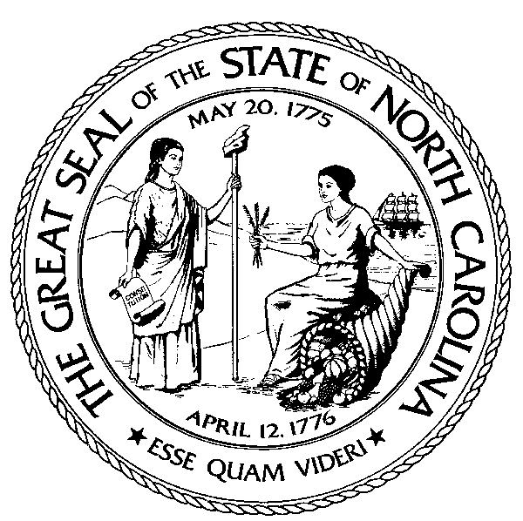The Great Seal of the State of North Carolina. Most of the sites listed above in Suggested Resources in the grouping for the state seal contain a visual representation. A multi-media classroom will enable class viewing of these online materials. An overhead projector and transparencies make a desirable alternative. Two points are key.

- North Carolina has had a state seal for nearly 350 years.
North Carolina has had a seal for official documents since 1663 when King Charles II granted the territory to eight Lords Proprietors. The seal was modified in 1765, and it has continued to be changed or adapted throughout the years to reflect changing history. In 1729 seven of the Lords Proprietors sold their interests to the Crown, and North Carolina became a royal colony, with a new seal. When an independent State of North Carolina was organized, the state constitution adopted at Halifax (1776) provided for a new state seal. A major change was made in 1792 when the general assembly authorized a new seal with only one side instead of two. Other changes and alterations have been made, with the most recent being by the addition of the date April 12, 1776.

- The parts of the seal have meaning.
The two women represent Liberty (freedom) and Plenty (the bounty of North Carolina). Liberty holds a scroll with the word constitution on it in her right hand and a pole with a liberty cap on it in her left. (See http://www.libertyforall.net/2002/archive/dec22/cap.html for an explanation of liberty cap or use your favorite search engine to look for liberty cap.) Plenty holds three stalks of grain in her right hand and the small end of a cornucopia (horn of plenty) is in her left hand. In the background on the left are the mountains and on the right, the sea with a three masted ship. The two dates are May 20 1775, the date of the Mecklenburg Declaration of Independence, and April 12, 1776, the date the Halifax Resolves were adopted. In the Halifax Resolves, North Carolina authorized her delegates to the Continental Congress to vote for independence.

Discussion and Activity. What other seals are students aware of? Does your community college have a seal? What is represented on it? Does your local township have a seal? What is represented on it? Can students remember a seal from their home country or town? What does it look like?

Ask students what they would include on a state seal that they design for North Carolina today. Why? Ask each student to draw their own design, or to work together in small groups to produce a seal. Show and explain the product.

The North Carolina State Flag. The state flag was adopted in 1861. It included the dates of the Mecklenburg Declaration of Independence and the secession of North Carolina from the Union (May 20, 1861). In 1885 the latter date was replaced with the date of the Halifax Resolves. There have been no changes in the state flag since 1885. All state institutions, public buildings, and courthouses must display the state flag.

View the North Carolina flag. See http://www.50states.com/ncarolin.htm in Suggested Resources above. (Click on That the flag.) What similarities are there in the state flag and the state seal?

State Motto. The North Carolina motto “Esse Quam Videri” is Latin. In English, it means “to be rather than to seem.” Lead class discussion designed to get students to grasp the meaning of “to be rather than to seem.” Work together on developing a story that shows the difference in “to be” and “to seem.” Choose one of the following story starters or make up your own:
- The man was old and ill. He needed a friend.
- The politician was running for office.
- The student needed a good grade.
- The manager had to balance the budget.

State Nickname: Tar Heels. People frequently acquire nicknames. Often nicknames are related to people’s looks or their actions. Ask your class if they can think of public figures (sports, entertainers, politicians) who are known by nicknames. Many United States Presidents acquired nicknames. A few examples are as follows:
- Andrew Jackson Old Hickory
- Richard Nixon Tricky Dick
- Ronald Regan The Great Communicator, The Gipper
- George Washington Father of his Country
- Abraham Lincoln Honest Abe
- Dwight D. Eisenhower Ike
- Harry S. Truman Give 'Em Hell Harry
- John Fitzgerald Kennedy JFK
- Franklin D. Roosevelt FDR

Ask students if any of them have a nickname. What is it? How did they get it? How does it represent them?

Use one or more of the internet sites (referenced in Suggested Resources above) for information on the state nickname. Help students to read in class to find the origin of the state nickname. During what period of North Carolina history was the nickname acquired?

Some Symbols of North Carolina

1. This tree grows throughout North Carolina. Usually the flowers are white. Sometimes they are pink.

2. This cannot live on land. It swims in North Carolina’s coastal waters.

3. This North Carolina creature can sing and fly.

4. This tiny fruit grows on bushes. It is a good source of vitamin C.

5. This creature moves slowly and is a model for patience and persistence.

6. There is plenty of this for your cereal, thanks to North Carolina dairy farmers.

7. This fruit is red. On many North Carolina farms you can pick your own.

8. This animal climbs trees.

9. This is North Carolina’s wildflower.

10. Important products in early North Carolina history were tar, pitch, and turpentine. They were made from this tree. They were used in shipbuilding.

11. This stinging insect makes a sweet and tasty product.

12. These wash up on the beach. People like to collect them.
Some Symbols of North Carolina

Symbols

