Course: Illness
Unit: Medication

Lesson: Prescription and Over-the-Counter Drugs

Competency Objectives: Adults will (1) know the differences and (2) be able to ask for and use prescription, generic, and over-the-counter drugs.

Suggested Criteria for Success: Adults will read and interpret medicine labels and safety warnings.
The learner will classify samples of medicines.
The learner will participate in activities on drug safety and dosage.

Suggested Vocabulary: prescription generic over-the-counter
dosage tablet capsule
teaspoon tsp. registered pharmacist (R.Ph.)
tablespoon tbsp. drug
overdose medicine side effects
pharmacy expiration date

Suggested Materials:  pens or pencils and paper
⬧ index cards and masking tape
⬧ empty prescription bottles and boxes with the labels still on
⬧ OTC medicines (decongestants, aspirin, pepto bismal, vitamins, calamine lotion, Neosporin, and similar products) or the empty boxes for same
⬧ M & Ms, tic tacs, or other small candy substitute for “pills”
⬧ teaspoons and tablespoons
⬧ water and paper cups
⬧ handouts from the end of this lesson
⬧ attached cut-apart strips and scissors

Suggested Resources:  http://www.fda.gov/cder/consumerinfo/WhatsRightForYou.htm#label Over the Counter Medicines: What’s Right for You? If you scroll up, you will see where this document can be printed as a brochure in PDF format. There is also an address to write for free bulk quantities of the printed brochure.
⬧ http://www.thomasjmoore.com/pages/drug_safety.shtml Drug Safety Checklist.
⬧ http://www.fda.gov/cder/consumerinfo/generics_q&a.htm Generic Drugs: Questions and Answers.
⬧ http://www.crbestbuydrugs.org Consumer Reports Best Buy Drugs, a free website that compares the effectiveness and prices of prescription drugs.

Suggested Methods: Lecture/Discussion, Role Play, Sorting, Following Directions, Group Work, Journal Work

Some Suggested Steps:

Introductory Activities. Bring samples of OCT medicines/boxes (preferably empty) and empty prescription bottles with labels still on. Ask questions like the following:
What do you think is in this bottle?
Where can you get medicine?
Why do people take medicine?
Do you take medicine?

Reading/Discussion. Use the attached handout on Prescription and Over-the-Counter Drugs.

What’s On the Label? Write the following sight words on index cards: patient, medicine, amount, times daily, special directions.

Draw a sample prescription label on the board. Have students use masking tape to affix the corresponding index card next to the proper information.

For more advanced learners, use the attached pages of prescription labels and cut apart strips. Ask the learners questions like who is the patient taking Doxycycline? Who is the registered pharmacist that filled the Allegra-D prescription? What is the dosage for the Ibuprofen prescription?

Copy the page of Cut-Apart Strips, cut apart the strips and have students draw one, read, and explain it.

Sorting. Provide learners with a large group of (empty) prescription bottles with labels, boxes that contained prescription medicines with the labels still affixed, over-the-counter medications or the empty boxes of same. Your goal is to have students separate the medicines into OTC and prescription drugs.
Ask questions like these:
What is the difference between these types of medicines?
What is different about the labels?
How do you buy each of these?
Where can you buy each of these?

For stronger readers, have students identify these medicines and their purposes, insofar as possible, from their labels and boxes.

Following Dosage Directions. Place M&M’s or tic tacs, cups of water, and spoons on the table. Give instructions to students for them to take the “medicine”. For example, “Take two pills.” “Take one teaspoon.” Make sure that learners can discriminate between tsp. and tbsp.

Role Play. Students can role-play getting a prescription filled, picking up a prescription, asking for instructions on how to take the medicine, and asking for a refill with the instructor acting as the pharmacist.

Drug Safety Discussion. In a class discussion, put together a list of rules for proper use and storage of prescription and OTC drugs. Examples might include:
- Keep out of reach of children.
- Don’t take someone else’s medicine.
- Don’t drink alcohol when you take medicine.
- Don’t mix OTC and/or prescription drugs without consulting a pharmacist about side effects.
- Don’t take pills in the presence of children. Children mimic what they see.
- Follow dosage directions exactly.
- Call the doctor’s office if unusual symptoms appear.
- Throw away drugs after their expiration date.

Let students copy the list in their Journals.

Journal Work. Copy these questions and write your answers to them. What is the difference between generic and name brand drugs? What is the difference in how they work? What is the difference in price? Which one would you rather use? Why?

Prescription Labels

XYZ Pharmacy Ph 336-584-9032  1234 Main Street Joe Patient  Yourtown, NC 27501 2122 E. Pretend St  Yourtown, NC 27501  Rx 78690  Take 1 tablet by mouth 3 times a day  IBUPROFEN 800 MG  No Refills Qty 50  R.Ph. U.B. Well  Date filled 4-8-2003 Discard After 4-8-2004 | XYZ Pharmacy Ph 336-584-9032  1234 Main Street Amy Older  Yourtown, NC 27501 2424 S. Pretend St  Yourtown, NC 27501  Rx 32459  Take 1 tablet by mouth every day  ACTIVELLA TABLETS UPS  11 Refills Qty 30  R.Ph. R.U. Healthy  Date filled 6-8-2003 Discard After 6-8-2004
XYZ Pharmacy Ph 336-584-9032  1234 Main Street U.R. Sick  Yourtown, NC 27501 1300 Makebelieve St  Yourtown, NC 27501  Rx 34670  Take 1 capsule twice a day after meals for 2 weeks. Take 1 capsule daily thereafter.  DOXYCYCLINE MONO 100 MG  No Refills Qty 100  R.Ph. B.A. Ouch  Date filled 2-7-2003 Discard After 2-7-2004 | XYZ Pharmacy Ph 336-584-9032  1234 Main Street Sam Sneezy  Yourtown, NC 27501 158 E. Seventh St  Yourtown, NC 27501  Rx 09751  Take 1/2 tablet by mouth every 12 hours  ALLEGRA-D 500 MG  3 Refills before 4-12-2004 Qty 30  R.Ph. I.B. Nice  Date filled 1-12-2003 Discard After 1-12-2004
XYZ Pharmacy Ph 336-584-9032  1234 Main Street J.B. Downs  Yourtown, NC 27501 5699 Big St  Yourtown, NC 27501  Rx 65195  Take 1 capsule by mouth as needed  VIAGRA  No Refills Qty 20  R.Ph. I.M. Happy  Date filled 4-8-2003 Discard After 4-8-2004 | XYZ Pharmacy Ph 336-584-9032  1234 Main Street Ima Hurt  Yourtown, NC 27501 328 Story St  Yourtown, NC 27501  Rx 45601  Take 1 tablet by mouth 2 times a day  LODINE  6 Refills before 10-8-2003 Qty 60  R.Ph. U.B. Well  Date filled 4-8-2003 Discard After 4-8-2004

Cut-Apart Strips

Take 1 capsule 1 hr. before each meal. | Apply to face every morning.
Take 1 capsule every day. | Take 1 capsule twice daily.
Take 1 to 2 tables every 6 hrs, as needed for pain. | Take 1 tablet daily with food or milk.
For external use only. | Take with food.
Do not take aspirin-containing products with this product. | May make you drowsy or dizzy. Use care with car or machinery.
Limit alcohol use. Daily alcohol use may increase risk of stomach bleeding. | Do not crush or chew.
Take exactly as directed. Do not skip doses or discontinue. | Taking more than the recommended dose may cause breathing problems.
Take 1 tablet every 8 hrs. | Avoid exposure to direct sunlight.

Fill in the blank with the word that describes the picture.

Pharmacy Capsule Teaspoon
Prescription Liquid Tablet

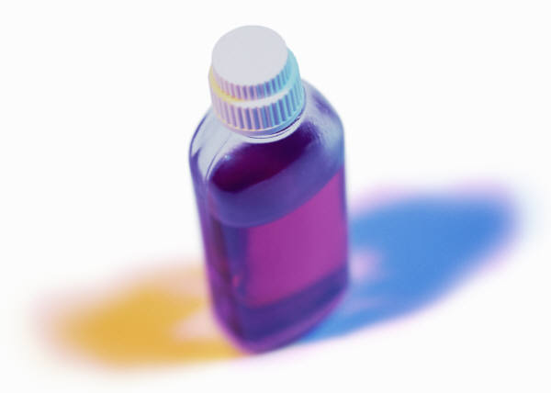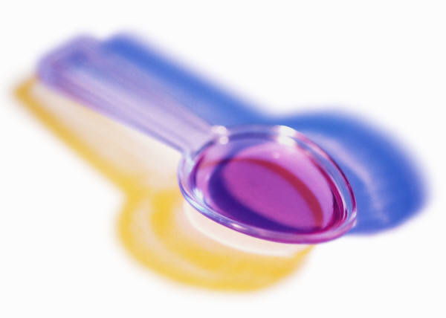

Prescription and Over-the-Counter Drugs

A drug is a chemical that affects living things. Aspirin, allergy medicine, sleeping pills, and other medications are drugs. So are vitamins, cigarettes, and alcohol.

Medicine is a legal drug used to treat an ailment or illness.

Over-the-counter drugs (OTC drugs) are legal drugs that anyone can buy at places like the supermarket or the drugstore. Aspirin, antacids, and cough medicine are some kinds of OTC drugs. Labels on OTC drugs give important information. For example,
- What is in the drug?
- What do I take the drug for?
- How much should I take?
- What are the possible side effects?
- Who should not take the drug?
- How long is it safe to take the drug?

Prescription drugs are legal drugs that can only be ordered by a doctor or a dentist. Only a licensed pharmacist can sell prescription drugs. When a drug is prescribed for you or your children, it is important to ask:
- What is the name of the drug?
- What will it do?
- Are there any side effects?
- When and how should I take the drug?
- Are there foods and drinks, or other drugs to avoid while I am taking this medicine?
- Can this prescription be refilled?
- Is there a generic form of this drug?

Side Effects. Drugs affect your whole body. Not everyone responds to drugs in the same way. In addition to treating the part of your body that needs the drug, a drug may cause a reaction in other parts of the body. These unplanned reactions are called side effects. Common side effects are nausea, headaches, and sleepiness. Sometimes side effects are caused by mixing a drug with certain other drugs or foods. Many drugs should not be mixed with alcohol: The combination can be fatal. It is best to not drink alcohol when taking any kind of medication. Dairy products prevent some antibiotics from working. OTC drugs list side effects on the label. It is best to ask your doctor or pharmacist about side effects.

Dosage. How much of a drug you take is called the dose or the dosage. Both OTC and prescription drugs have the dosage on the bottle or package. Too much medicine is dangerous. Taking too much of a drug or taking it too often leads to an overdose. An overdose can kill you.

Generic vs. Brand Name. Each company that makes a drug can give it a brand name. When a new drug comes out, the company that develops it is the only company that can make it for 17 years. After 17 years, other companies can make that drug, too. A generic name is the chemical name of the drug. When many companies can make a drug, one company will usually sell it under the generic name. Generic drugs are usually much cheaper than brand-name drugs. Ask your physician to prescribe the cheapest form.

