Course: Wellness
Unit: Preventive Health Care

Lesson: Vision Care

Competency Objectives: The adult learner will understand the need for eye exams.

Suggested Criteria for Success: The adult learner will be able to schedule an eye exam.
The learner will participate in activities that prepare him/her to know what to expect in an eye examination.

Suggested Vocabulary: examination room glasses prescription eye chart
contact lens glaucoma optometrist optician
ophthalmologist eyestrain

Suggested Materials:  pens or pencils and paper
⬧ eye chart, teacher made or acquired, or made as a class project
⬧ paper, black magic marker(s), and masking tape for class to make eye chart
⬧ phone book (Ask students to bring their telephone books to class. They will be able to mark pages as they wish, and each student will have a book to use. Another possible source may be your workplace if you work somewhere that recycles large numbers of telephone books every year.)
⬧ toy telephone or a cell phone to use for “pretend” calls
⬧ handouts at the end of this lesson

Suggested Resources:  http://www.college-optometrists.org/public/10reasons.htm Search for 10 Reasons for Having an Eye Exam or try for direct access at http://www.college-optometrists.org/index.aspx/pcms/site.Public_Related_Links.The_eye_examination.10_reasons_for_having_an_eye_examination/
⬧ http://www.marylandstrokecenter.com/medical-terms/07554.htm Click on Routine Eye Examination. This site describes the way an eye examination is done and what is evaluated by the different tests that the eye doctor does.
⬧ http://www.myvisioncare.com/eyeexam.htm This is another site that gives information of the different parts of an eye examination.
⬧ http://www.mdsupport.org/snellen.html The Snellen Chart
⬧ http://www.vision3k.com Click on Information and Eye Tests in the left column on the screen. Scroll down the screen and click on Snellen Chart.
http://teachpsych.lemoyne.edu/teachpsych/faces/script/Ch09_HTM/neuropsychology.htm About half-way through this article there is an example of the falling E or tumbling E chart.

Suggested Methods: Lecture/Discussion, Chain Drill, LEA Writing, Role-Play, Picture/Vocabulary Identification, Journal Work.

Some Suggested Steps

Introductory Activities. For the least verbal classes, do a chain drill with a single question. Ask your first student, “Han, do you wear glasses?” Han answers, “ No, I don’t wear glasses.” Then Han continues the drill by saying to the next student, “Maria, do you wear glasses?” Maria answers, “Yes, I wear glasses.” Then Maria asks the question of the next student, and so on to the end of the group of learners.

For more verbal learners, ask one or more discussion starters. A few suggestions are to start you thinking are as follows. Do you wear glasses? Does anyone in your family wear glasses? Do you think you might need to get glasses? Why? Have your children’s eyes been tested recently? What kind of frames would you get if you had to get glasses? Would you rather use contact lenses?

Picture Identification. Use the picture handout attached to this lesson to identify things you may see at the eye doctor.

Reading/Discussion. Use the handouts from the end of this lesson to cover the basics of eye care and the eye examination.

LEA Script. Help students write a script to call an optometrist’s or opthalmologist’s office and make an appointment for an examination. Make the telephone conversation between the patient and the eye doctor’s receptionist. Tell why the appointment is needed, such as current eye problems or length of time it has been since the patient’s last eye exam. Confirm the date and time of the appointment. Ask for directions to the office. Let the learners copy the script and practice it in pairs before performing it in pairs before the class.

Eye Chart Activity. You may be able to obtain an eye chart from a local eye doctor’s office, or you can make your own. There are two kinds: the “E” chart with the letter “E” facing different directions, and the regular eye chart (Snellen chart) with different letters. If you have students who speak very little English, you may choose to have students construct an eye chart (either Snellen or Tumbling E’s) using standard sheets of paper and black magic markers. If you only have one magic marker, pass it around as each student produces one letter or one line for the chart. Use this as an exercise in following directions. Tell one student what size letter, and which letter of the alphabet to draw (or what direction to make a Tumbling E). All the students except the one making the letter for the chart can produce a pencil product as you give directions. As each magic marker letter is finished, tape it into place (use masking tape) as part of the “eye chart” on the board. Ask students doing the pencil practice to check their work. Move the magic marker to the next student and repeat the process.

Role Play. Have students role play a visit to the eye doctor. They may pretend that they are having vision problems, or just going in for a check-up. Use the eye chart in your role-play. If students need to script the visit before they can do the role play, divide them into small groups to brainstorm the scene (writing down bits of conversation). Use student contributions to put together a dialog for students to use in role play. Ask students to copy the dialog and pair off for practice. Have each pair present the dialog before the class. Switch parts and repeat, if desired.

Picture Interpretation. Give students the handout of a boy getting glasses. Talk about the handout. Ask learners to compose a story about what is happening in the picture. They may give names to the characters and title their work, if they wish. You can use this activity as class work or Journal Work. An alternative is to discuss the picture in class and let students start their story in class and finish it at home.

Journal Work. Your vision is a gift. What are some of the treasures you see every day? Write in complete sentences.
PICTURE IDENTIFICATION FOR VISION CARE

CAN YOU NAME THESE THINGS YOU MIGHT SEE AT THE EYE DOCTOR?

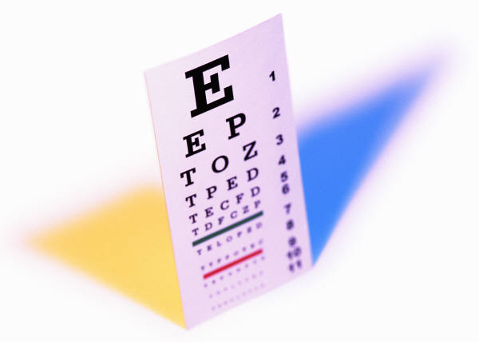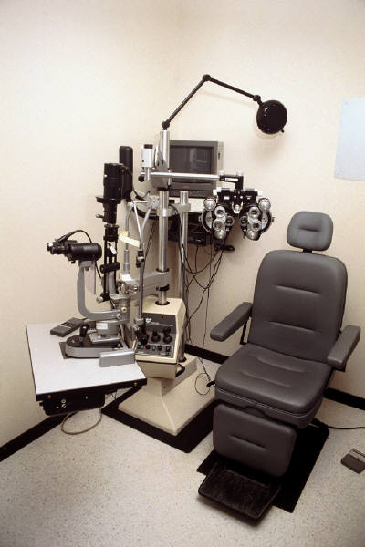

______________________ ____________________ _____________________

______________________ ____________________ _____________________

WORD BOX

GLASSES CONTACT LENS

EYE EXAMINATION ROOM
EYE CHART PUTTING A CONTACT LENS IN YOUR EYE

What is happening in this picture?

Write a story about what is going on in the picture above. _________________________

________________________________________________________________________________________________________________________________________________________________________________________________________________________________________________________________________________________________________________________________________________________________________________________________________________________________________________________________________________________________________________________________________________________________________________________________________________________________________________________________________________________________________________________________________________________________________________________________________________________________________________________________________________________________________________________________________________________________________

Vision Care

Take care of your eyes!
- Read or do close work in good light. Light should be steady, not glaring. The whole room should be lighted.
- When doing close work, rest your eyes every half-hour.
- Wear glasses or contacts if you need them.
- Don’t wear sunglasses inside.
- Don’t look directly into the sun.
- Sit at least ten feet from the TV set.
- Wash eye makeup off at night.
- Have routine eye exams every 3-5 years until the age of 40. Call for an exam right away if you have any of the following symptoms:
- pain in the eyes
- frequent headaches or eyestrain
- blurred or foggy vision
- halos around the eye
- double vision

Have routine eye exams every 1-2 years after the age of 40. Changes in vision are likely after age 40. GLAUCOMA, or high pressure in the eyeball, is a painless but dangerous disease that occurs most often after age 40. Some public clinics give free glaucoma checks.
Having Your Eyes Examined

Full eye exams are done by either
- an optometrist (a trained eye specialist who is not a physician) or by
- an ophthalmologist (an eye specialist who is also a medical doctor and can prescribe drugs and operate on the eyes).

A complete eye exam is not painful. The doctor will
- take a medical history
- check the appearance of the eyes
- check the inner linings with a special scope
- test the movement of the eyes and see how well they work together
- check near and far vision
- test for vision and color blindness
- test for glaucoma

After the exam, the doctor will discuss your eyes with you and tell you if you need glasses. If you have vision problems, you will probably need glasses or contact lens. The eye doctor will send you to an optician. An optician is an expert in making glasses and contacts. You have a choice where to buy your glasses. Shop for price and quality. Many people don’t like to wear glasses and decide to get contact lenses instead. Contacts are worn right on the eye. You need a special prescription for your contacts, and you must be very careful with them. You must wash them with special cleaner.

