Course: Consumer Spending
Unit: Buying Clothing

Lesson: Colors and Patterns

NOTE: This unit on Buying Clothing has tested as being excellent for beginners. At higher levels, the competency objectives need to change to achieving other goals, such as spelling, enunciating or articulating better, or developing writing skills.

Competency Objectives: Adults will identify selected colors and patterns.

Suggested Criteria for Success: Learners will recognize and name black, white, and the primary and secondary colors. Other colors are optional but desirable.
Learners will identify patterns by name.

Suggested Vocabulary: red black dots brown
yellow white stripes pink
blue grey checks gold
orange print lavender
green plaid light blue
purple lime
ivory

Suggested Materials: Handouts from the end of this lesson.

Paper, paste, drawing paper, pencils, pens, colored pencils or water-based paint and paper towels.

Vanilla wafers, vanilla frosting, food coloring, styrofoam bowls, paper towels, plastic knives and spoons, a large trash bag, and an instructor copy of the edible color wheel project from http://www.art-rageous.net/EdibleColorwheel-LP.html.

Supplies for any of the following that you use as reinforcement activities. See Suggested Resources below for additional internet information.
⬥ http://www.art-rageous.net/CW.html Motif Color Wheel. Prepare a design (or reproduce the sheet of stars at the end of this lesson plan) for students to use. Let learners write the color names inward toward the center of the wheel.
⬥ http://homes.aol.com/Sabbeth/Braceletcraft.html Jingle Bracelet (or anklet). Write the name of the color on each “bead.”
⬥ http://www.kinderart.com/drawing/complimentportrait.shtml Complimentary Color Portraits

Suggested Resources: NOTE: Most of these resources were designed for younger learners. The information is pertinent and clear. However, please scrutinize what you plan to use and eliminate references that might offend adult learners.

http://www.colormatters.com/colortheory.html Color Wheel

http://www.artsconnected.org/toolkit/encyc_colorwheel.html Color Wheel.

http://www.art-rageous.net/EdibleColorwheel-LP.html is a lesson plan for an edible color wheel using vanilla wafers, vanilla frosting (canned) and food coloring.

http://www.kinderart.com/drawing/complimentportrait.shtml Complimentary Color Portraits.

http://homes.aol.com/Sabbeth/Braceletcraft.html. Color Wheel Jingle Bracelet.

http://www.art-rageous.net/CW.html Motif Color Wheels (or click on http://www.art-rageous.net/ and go the ArtRageous Web Site Search Engine. Put in CW. Click on the CW plan that comes up.)

http://easternlincs.worlded.org/docs/clothing/color.html This site has printable colors and patterns. It also has a self-grading online color quiz. For those who do not have computer access in the classroom, the format of the quiz is easily reproduced for pencil and paper.

http://www.members.cox.net/mrsparker2/activities.htm gives a series of suggestions for art activities. Click on Teacher Resources at the end of this webpage for additional information.

http://members.cox.net/mrsparker2/teacher.htm Click on Color Wheel Vocabulary, then on Color Wheel.

http://www.dltk-teach.com/. This site has a series of pages on colors at the most basic level. Click on Color Buddies. Click on Alphabet Tracing Pages then on the individual colors.

Suggested Methods: Demonstration, Group Projects, Conversation, Journal Work.

Some Suggested Steps:

Primary Colors: Red, yellow, and blue are basic colors. You cannot make them from other colors. Demonstrate the colors with bottles of red, yellow, and blue food coloring. Group students in threes and give each group a paper towel and vanilla wafers. Put icing in three styrofoam bowls and color each bowl with one of the primary colors. Ice a vanilla wafer with each color. Ask your groups to do the same. Place your iced wafers in a triangle on the paper towel, red at the top, yellow on the lower right and blue on the lower left of the triangle. Draw a circle (color wheel) on the board and write the names of the primary colors.

Secondary Colors: Secondary colors can be mixed. Put icing in three other styrofoam bowls and mix: red and yellow make orange; red and blue make purple; yellow and blue to make green. Ice three more vanilla wafers and arrange orange between red and yellow, purple between red and blue, and green between yellow and blue. Write the names of the colors on the color wheel on the board.

Neutrals: What we call White is actually light. Color is that part of the light spectrum that is reflected from an object. (A prism breaks light into colors.) Black is the absence of all light. Black and white are neutrals. Ask the groups to draw a black and white design for the center of their cookie color wheels.

Add black or white to colors to produce tints (white) and shades (black), i.e., variations of a color. For example, red and white produce pink. Blue and white produce light blue. Black and white yield another neutral—grey. You can make pink and light blue with your icing and tiny amounts of food coloring.

Conversation: Ask students to name the colors as you point to them. Also ask them to tell you the colors used to make orange, green, and purple. Ask them to name the primary colors. Ask individual questions like, “Luiz, are you wearing green?” “Han, what color is Tariz wearing?”

Eat Your Color Wheels: Clean up. Leave nothing to attract bugs. Take the trash bag out of the building!

Reinforcement: Use any of the following projects to reinforce basic colors and to give students a color project to keep in their Journal or take home.
- Make a Motif Color Wheel. Prepare a design or reproduce the sheet provided at the end of this lesson) for learners to use in making a color wheel. Partially overlap the black and white stars and put them in the center. Draw lines from the center to the outer stars and write the name of the color of the outer star on the connecting line.
- Make a Jingle Bracelet (or necklace or anklet). Make a six paper triangles (make long and narrow triangles) and color one for each of the primary and secondary colors. Roll each triangle around a pencil like crescent a roll. (Start with the big end of the triangle and end with the small end.) Paste the small end down. Write the name of the color on each “bead.” String these paper beads on elastic thread with beads or bells or between them.
- Draw a self portrait. See http://www.kinderart.com/drawing/complimentportrait.shtml for a complimentary colors self-portrait project. Complimentary colors are opposites on the color wheel, but you may choose to modify the project to use either the primary colors or the secondary colors.

Patterns. So far students have worked with solids. Point out the patterns that you or the students are wearing. Ask students to take a few minutes and draw a repetitive design with colored pencils. Illustrate this assignment by making dots at regular intervals in a square on the board or on paper. Use these student-produced designs to teach vocabulary for dots, stripes, checks, plaids, and print. Be ready to do a quick drawing in case no one draws one of these patterns.

Conversation: Ask students questions about clothing and drawings such as “Marina, is Lutz wearing plaid?” Marina answers, “No, Lutz is wearing stripes.” “Hassan, did Gregor draw dots?”

Review: Use the two handouts at the end of this lesson on patterns and colors. In this lesson, students have not learned the colors of last six squares on Match the Colors. Ask students to match the names at the top of each page with the patterns and colors that they have learned. There will be six extra colors named at the top of the Match the Colors page. Can anyone identify any of the last six colors? (Light blue should be a good possibility.) Match and pronounce the last six color names with the students.

Journal Work: Write about your favorite color. Use the following questions to guide you.
- What is your favorite color? How does this color make you feel?
- What do you associate with this color? (For example, you may associate blue with the sky.)
- Do you like to wear your favorite color?
- Do you like to use your favorite color for the walls in a room? Why or why not?
- What color do you like the least?
- What do you think your favorite color shows about you?

MAKING A MOTIF COLOR WHEEL

---------------------------------------------------------------------------------------------------------------------------------
MAKING A MOTIF COLOR WHEEL

Identify the pattern

Dots Plaid Stripes Checks Print

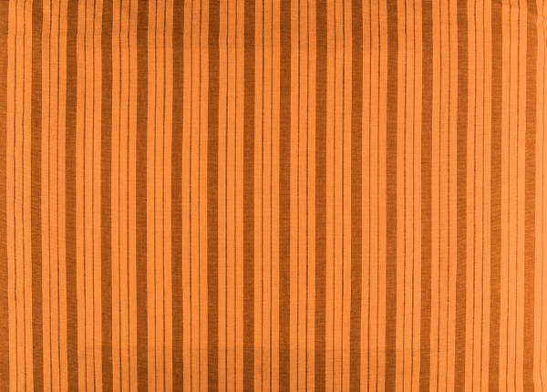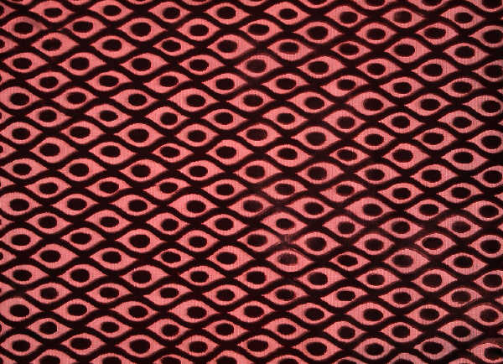
Match the colors with their names.

White | Pink | Red
Light Blue | Brown | Purple
Yellow | Orange | Gold
Grey | Blue | Lavender
Green | Black | Lime

