LESSON 6

WHAT SHOULD I DO WITH MY MONEY?

This lesson provides information on basic financial skills.

Learning Objectives:

- The students will define key words, discuss the benefits of opening a savings account, and determine how to find a good bank.

- The students will list the benefits and hazards of using a credit and debit card.

- The students will discuss the importance of paying bills on time.

- The students will fill out a generic budget.

- The students will play a board game that allows them to practice budgeting skills.

Casas Competencies:

- 1.3.1 compare different methods used to purchase goods and services
- 1.5.1 interpret information about personal and family budgets
- 1.5.2 plan for major purchases
- 1.8.5 interpret information on financial agencies and financial planning
Materials Needed:

1. A copy of worksheets 6-A, 6-B, 6-C, 6-D, for each student.

2. The board game Payday by Parker Brothers.
Suggested Activities:

- Distribute worksheet 6-A and have a student read the text out loud. Discuss the definitions and ask the students if they already have a savings account.

- Distribute worksheet 6-B. Have a student read the text out loud. Discuss the definitions. Do the bottom questions together and ask several students to read their answers to #2.

- Distribute worksheet 6-C and have a student read the text out loud. Discuss the definitions. Do the bottom questions together.

- Distribute worksheet 6-D and have the students fill out the budget using their real life expenses and income. Discuss questions #1 and #2.

- Have the students play the board game Payday (Parker Brothers). If you have more students than game pieces, have the students work in teams to make decisions for their game piece.

WORKSHEET 6-A

WHY SHOULD I SAVE MONEY?

It is important to have money saved because there are times when emergencies happen. ( A car needs repaired, a family member is sick and needs medication or needs to be in the hospital, etc. ) Emergencies can cost more money than you have to spend. If you have money saved, you can afford the costs. Having money in savings is how you can put a down payment on a house or car. If you put a little money into a savings account out of each paycheck, it will slowly add up to a lot of money.

To start a savings account, you need to find a bank that you like. The bank should be easy to get to and have friendly people who want to answer your questions.

It is better to save your money in a bank instead of your home because it could be stolen from your home. Your money will also earn interest in a savings account at the bank.

Definitions

Save=put money away and not spend it

Emergency=something that happens that you don’t expect and is serious
Repaired=to fix something that is broken

Medication=pills that a doctor gives you

Down payment=when you purchase something that you will have to borrow money to buy, you pay some of the money with cash. This cash amount is called a down payment

Bank=a business that keeps money for people and loans money to people

Earn interest=a percentage of the amount of money you have in savings will be added to you savings account each month

WORKSHEET 6-B

CREDIT CARDS

A credit card lets you pay for things without using cash or checks. You have to pay the money back to the credit card company with interest. Many people have a hard time
paying back the money. Some people buy things that they really can’t afford. Then they owe a debt.

Definitions

Interest=a percentage of the money that you owe is added to the money you owe the credit card company

Afford=to have enough money to pay cash for something

Owe=when you borrow money from someone you “owe” them that money

- Do you have a credit card?__________
If you answered “yes”, do you always use it to buy things that you can afford to pay back?______________

2. Do you think it is a good idea to use credit cards? Why or Why not?________________________________________________________________________________________

WORKSHEET 6-C

PAYING BILLS ON TIME

It’s important to always pay your bills on time. If you don’t, you will have to pay a late fee. When a person pays their bills late many times, they will have bad credit on their credit report. Having bad credit can make it difficult to buy a home.

DEFINITIONS

On Time=paying bills before (or on) the “due date” written on the bill

Late Fee=extra money you must pay the company for paying the bill late

Credit Report=a list of all of your credit cards and loans, shows how much money you owe and how long you have owed that amount…also shows if you have ever paid your bills late

WORKSHEET 6-C CONTINUED

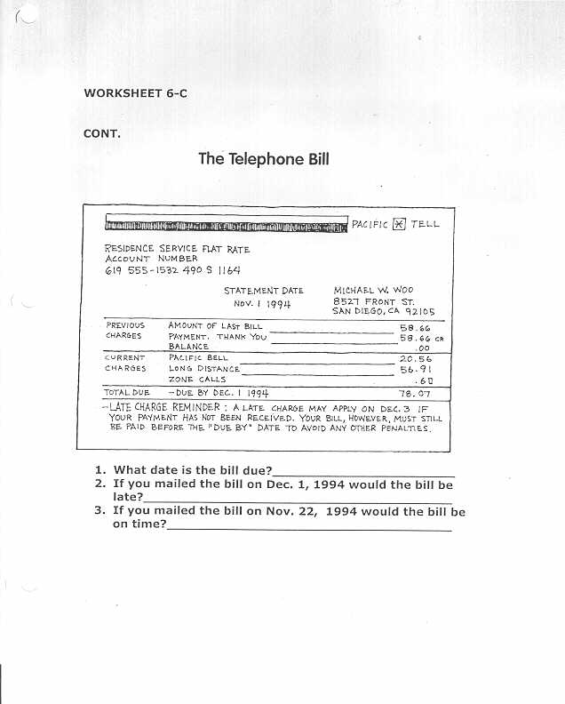

WORKSHEET 6-D

WRITING A BUDGET

Writing a budget is a good way to help save money and not go into debt. A budget is a list of your monthly expenses and monthly income. When you subtract your expenses from your income, you will see the money left over that you can put into savings. INCOME-EXPENSES=SAVINGS. When you look at your budget, you may find that you are spending more than you earn. This will make you go into debt.

Fill out the following budget

BUDGET

Monthly Expenses
Rent
Utilities
Food
Clothing
Telephone
Transportation
Entertainment
Other

Total monthly income=
Total monthly expenses=
Total monthly income-expenses=_____savings

- What expense in the budget would buying shoes be in?

- What expense in the budget would paying to ride the bus or buying gasoline for the car, and a car payment be in?

