LESSON 10

PARTICIPATING IN YOUR NEW COMMUNITY

This lesson provides hints on maintenance and discusses the concept of community involvement.

Learning Objectives:

- The students will define home maintenance vocabulary.

- The students will list ways to be involved in a community.

Casas Competencies:

- 5.6.2 interpret information about civic organizations and public service groups

- 7.2.1 identify and paraphrase pertinent information

- 8.3.2 identify an interact with persons in the community who can provide support in achieving goals (e.g., neighbors, contacts from human service agencies and recreation facilities)

Materials Needed:

1. A copy of worksheets 10-A and 10-B for each student.
SUGGESTED ACTIVITIES:

- Give the students worksheet 10-A and have a student read the text out loud. Discuss the definitions as a class and discuss the tools in the picture. Ask the students what the various tools might be used for in a house.

- Give each student worksheet 10-B. Have a student read the text. Discuss the vocabulary. Ask the students to name ways they can be involved in their current communities. Stress the point that they don’t have to own their home to be in a community.

WORKSHEET 10-A

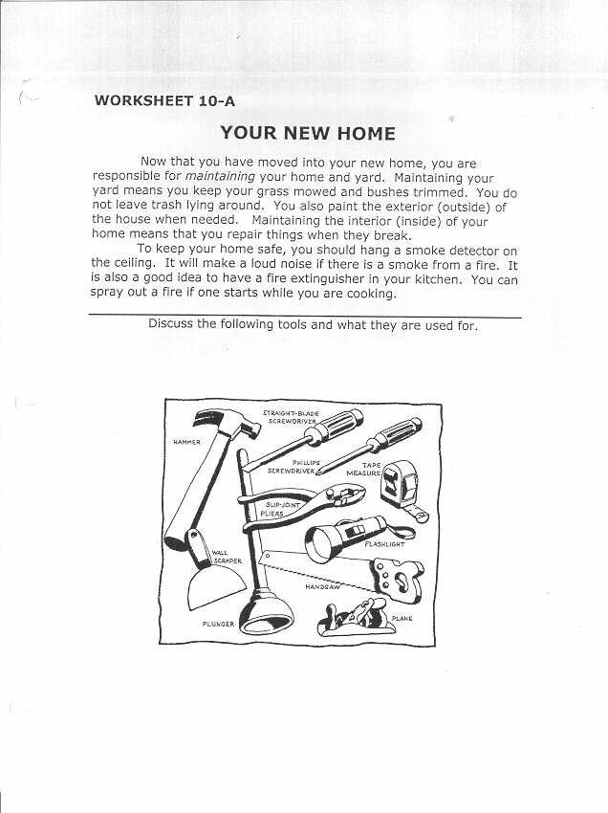
WORKSHEET 10-B

YOUR NEW COMMUNITY

It’s important to meet your new neighbors. You should introduce yourself when you see them. They can tell you information about your new community. You will want to know the location of the following;

*grocery store
*library
*hospital
*police station
*fire station
*park or playground

To participate in your new community means to be a part of what is happening. There might be a neighborhood watch meeting you could attend. You could volunteer at the hospital or elementary school. Your community may have fairs or festivals that you would enjoy. If an elderly neighbor needs help maintaining their lawn, you could mow their grass sometimes. Good neighbors help each other. The more involved you are in your community, the more you will enjoy your community.

Definitions

Neighbors=the people who live near you

Location=where something is…the address

Participate=to take part in…to join in an activity with others
Neighborhood Watch=people work together to keep their neighborhood safe
Attend=to go to a meeting or activity
Volunteer=to do a job for no money
Fair/festival=a party that is usually outside with food and music
Elderly=an older person
Involved=to be active in something

What are ways you could be involved in your community? (Whether you own or rent your home.)

