Vegetables
Vocabulary

- beans

- broccoli | 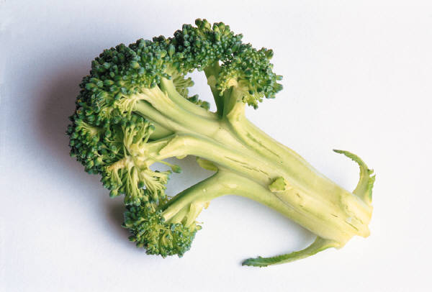
- carrot

- corn

- lettuce

- onion

- peas

- pepper

- potato

- tomato

- vegetables | 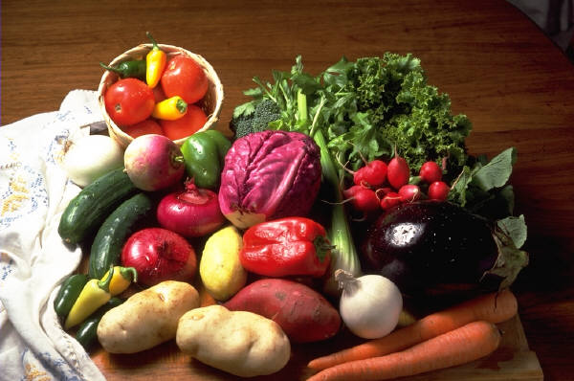

Vegetables
Word Search

Vegetables
Word Scramble

Vegetables
Listening Activity

Directions: Circle the word that you hear.

- con | corn | korn | car
- lettuce | letus | letuce | luttece
- peas | peace | please | pee
- carroot | cart | carrot | carot
- beans | bene | been | born
- tornado | tamatoe | tamoto | tomato
- patio | patatoe | potato | patato
- unyon | onion | union | young
- pepper | peper | peaper | pepeper
- brocolli | broccoli | broccolis | brockley

Vegetables

Grammar: Using “More” and “Most” with Long Adjectives

Review: The comparative and superlative forms of most one-syllable and some two-syllable adjectives are formed by adding –er and –est to the adjective:
An apple is bigger than a grape.
Watermelons are the biggest fruit of all.

For most adjectives with 2 or more syllables, the comparative and superlative are formed by adding more and most before the adjective:

Barbara: I think the corn is delicious.
David: I think the broccoli is more delicious.
Karen: I think the potatoes are the most delicious.
corn | potatoes | beans | peas | broccoli | carrots | onions | lettuce | tomatoes
Popularity
Directions: Fill in the blanks with “more” and “most.” Use the information in the graph.

- Maria: Peas are popular.
- Richard: Beans are __________ popular.
- Pat: Tomatoes are the __________popular.

