Vegetables
Pre-Test

Name ______________________ Date ____________________

Directions: Circle the word and picture that you hear.

- korn | corn
 |  | letus | lettuce
 | pee | peas
- 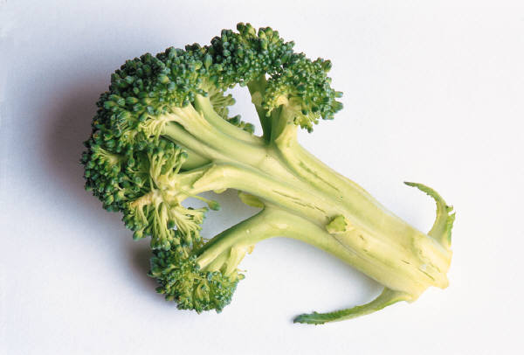 | carot |  | carrot
 | beans |  | beens
- 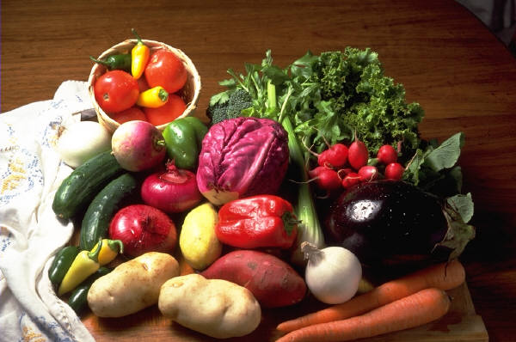 |  | tomatoe | tomato
- potato |  |  | potatoe
 | onion | unyons
 | vegetables | vegetible
 |  | broccoli | broccoli
 | peper |  | pepper

Directions: Fill in the blanks with “more” and “most.”

Student 1: | I think the corn is delicious.
Student 2: | I think broccoli is ____________ delicious.
Student 3: | I think potatoes are the ____________ delicious vegetable.

Directions: Use the graph to fill in the blanks.

Popularity

corn | potatoes | beans | peas | broccoli | carrots | onions | lettuce | tomatoes

- Peas are popular.
- ____________ are more popular than peas.
- ____________ are the most popular vegetable.
Oral Component: Pre-Test

Teacher: Test students orally and individually for this section of the test. Use the picture flash cards included with this unit. Hold up each flash card and ask the student to identify the vegetable.

 | Student’s Response | Accuracy | Pronunciation  & Clarity | Student’s Comfort Level
corn
lettuce
pea(s)
carrot
bean(s)
tomato
potato
onion
vegetable(s)
broccoli
pepper

