Easter
Vocabulary

- Easter | a holiday celebrated in the spring
- remember | to think about something from the past
- Resurrection | when Jesus returned to life after he died and was buried
- Jesus Christ | considered by Christians to be the Son of God
- Easter Sunday | the day Easter is celebrated
dye | to color something
- Easter eggs | colored eggs
- Easter egg hunt | a game children play at Easter where they try to find hidden eggs
- Easter basket | a basket that the Easter bunny leaves
- Easter bunny | a pretend rabbit that brings jellybeans, candy, and toys for Easter
- jellybeans | a favorite Easter candy |  | 

Easter
Vocabulary Matching

Directions: Draw a line from the word to its picture.

- Jesus Christ
- Resurrection
- Easter egg hunt

jelly beans
- Easter bunny
- Easter egg
- Easter basket
- dye

Easter
Read About Easter

Easter

Easter is celebrated each spring. On this holiday, we remember the Resurrection of Jesus Christ. Many people go to church on Easter Sunday.

Children dye Easter eggs and have Easter egg hunts. The night before Easter Sunday, children set out their Easter baskets. They hope the Easter bunny will fill them with jellybeans, candy, and toys.

Easter
Adjectives

Directions: Adjectives are words used to describe a noun. Write an adjective on each line to describe the Easter basket in the picture.

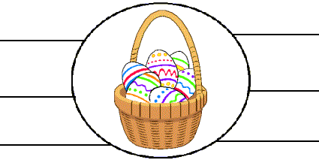

Directions: Write a sentence using each of the adjectives above.
- _________________________________________________________________________
- _________________________________________________________________________
- _________________________________________________________________________
- _________________________________________________________________________
- _________________________________________________________________________
- _________________________________________________________________________

Worksheet provided by John's ESL Community
http://www.johnsesl.com

