Gender
Vocabulary

- boy |   a male child
- female | a woman or a girl  
- gender |   male or female
- girl |   a female child
- male | a man or a boy  
- man | an adult male  
- sex | another name for gender
- woman |   an adult female

Gender
Vocabulary Matching

Directions: Draw a line from each word to the correct picture.

- girl
- boy
- man
- woman

Gender
Write Your Gender

1. Gender: _____________________________

2. GENDER:

3. Gender: (Circle your Gender)

Male Female

4.

GENDER

5. Gender: (Put a check in the correct box)

M F

Gender
Interview Sheet

Directions: Ask these questions to a student in your class. Write down their answers.

- What is your name? ___________________________

- What is your gender? __________________________

- Are you male? _______________________________

____________________________________________

- Are you female? ______________________________

- Are you a man? ______________________________

- Are you a woman? ____________________________

Gender
Grammar: Using My and Your Review

My and your are possessive pronouns. Possessive pronouns are used in English to show that something belongs to someone.

Use my to tell that something belongs to you.

1. This is my child.
2. This is my dog.
3. My house is white.

Use your to tell that something belongs to another person.

1. Your house is yellow.
2. What is your telephone number?

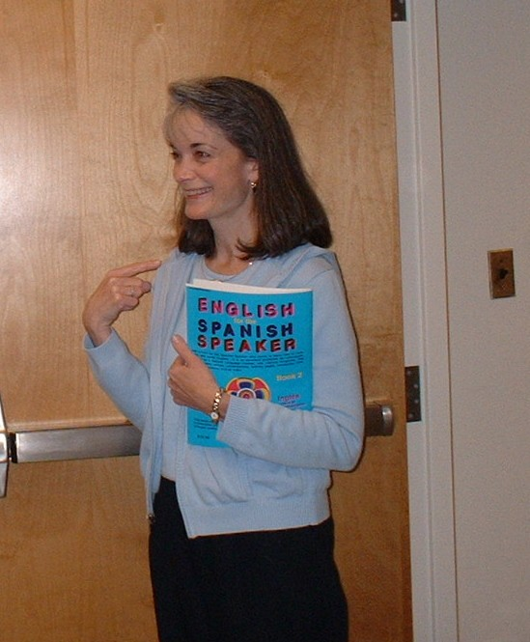
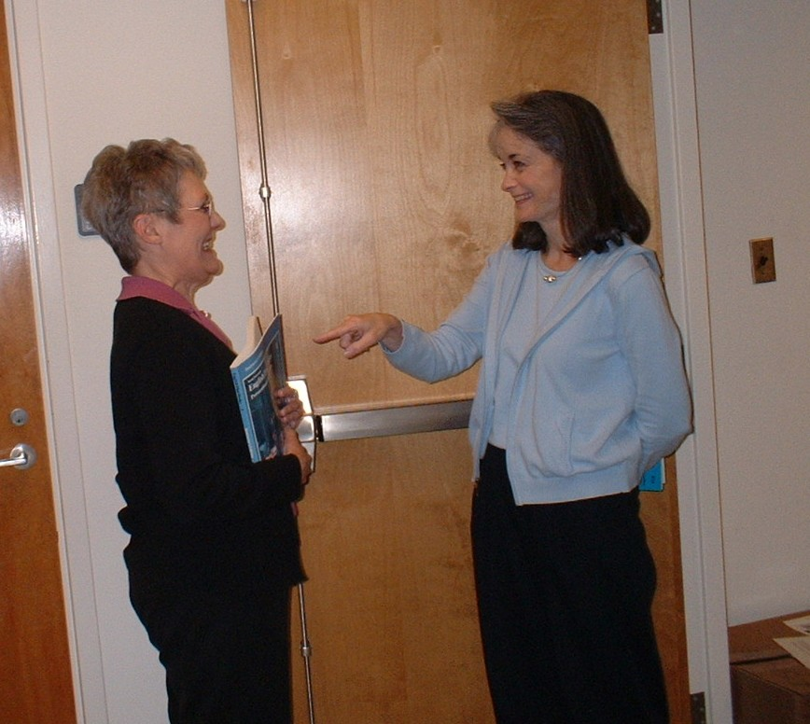

My Your

This is my book That is your book.

Gender
Listening Activity: My and Your

Directions: Listen to your teacher read the sentence. Fill in the blanks with my or your.

- Hi. __________ name is Steven Smith. What is __________ name?

- __________ name is Jason White.

- Is __________ child a boy or girl?

- __________ child is a girl.

- Is __________ cat a male?

6. No, __________ cat is a female.

Gender
Conversation

Student 1 | Hello, Mark. Do you have any children?
Student 2 | Yes, I have 1 child.
Student 1 | Is your child a boy or a girl?
Student 2 | My child is a girl. Do you have any children?
Student 1 | Yes, I have one boy and two girls.
Student 2 | That's great. Do you have any pets?
Student 1 | Yes, I have a cat and a dog.
Student 2 | Is your cat a male or female?
Student 1 | My cat is a female. My dog is a male. Do you have any pets?
Student 2 | Yes, I have a bird.
Student 1 | Is your bird a male or female?
Student 2 | My bird is a male.

Gender
Listening Activity

Directions: Circle the word you hear.

- name | man | woman | boy
- window | want | woman | child
- bend | boy | box | borrow
- good | girl | great | gender
- GIRL | GENDER | GREAT | GIFT
- six | sex | step | sit
- first | far | male | female
- make | male | marry | May

