Dictionary Vocabulary Practice

Directions: Fill in the blanks with the correct vocabulary words.

Cottontail Count down
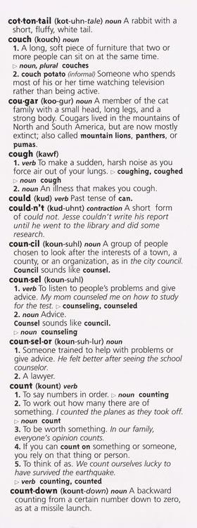

show the first and last entries on a page.

These entries are in ____________ order.
This is the _______________ of “cough.”

A noun is a _______

____ __________.
The ____________ gives you the meaning of a word.
“Cough” is an _________ on this page.

© 2002 by Education World®. Education World grants users permission to reproduce this page for educational purposes

