Traffic Signs

Optional Vocabulary Matching

Directions: Write the number of the sign beside the correct meaning.
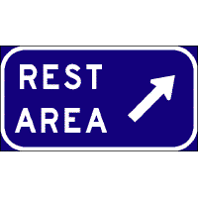
1. 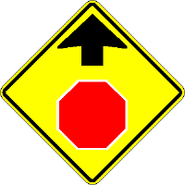 2. 3. 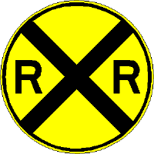 4. 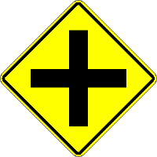

5. 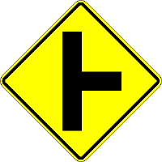 6. 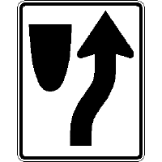 7. 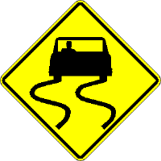 8. 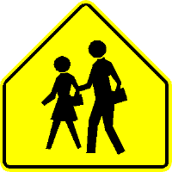 9. 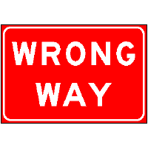

- Keep Right sign
- Crossroad ahead sign
- Rest Area sign
- Right Side Road ahead
- Stop sign ahead
- Wrong Way sign
- School Crossing sign
- Slippery When Wet sign
- Rail Road Crossing sign

