Traffic Signs Optional Vocabulary

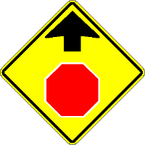 | 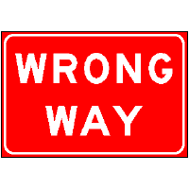 | 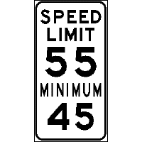 | 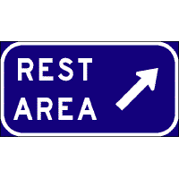
Stop sign ahead | Wrong Way sign | The fastest safe speed is 55 miles per hour. The minimum safe speed is 45 miles per hour. | Rest Area sign
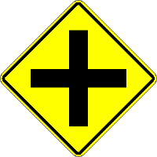 | 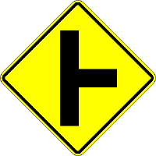 | 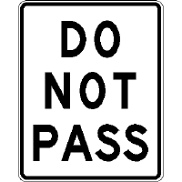 | 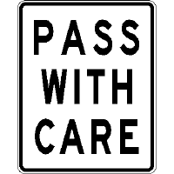
Crossroad ahead sign | Right Side Road ahead sign | Do Not Pass sign | Pass With Care sign
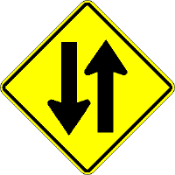 | 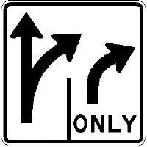 | 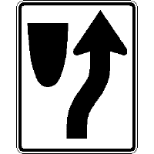 | 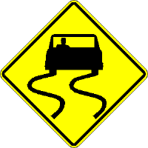
Two Way Traffic sign | Traffic in the right lane must turn right. Traffic in the left lane may go straight or turn right. | Keep Right sign | Slippery When Wet sign
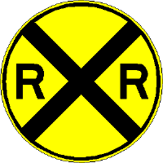 | 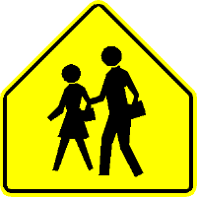 | 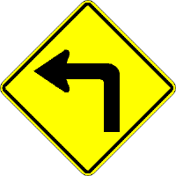
Railroad Crossing ahead sign | School Crossing ahead sign | Sharp Curve ahead sign

