Move In and Move Out Inspections Vocabulary

(Optional)

- broken |  | The light bulb is broken.
- chipped paint |  | There is chipped paint on the door.  The paint on the wall is chipped.
- cracked |  | The window is cracked.  There is a crack in the window.
- dent | 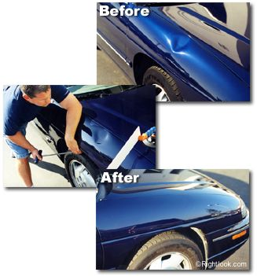 | There are dents on the refrigerator.  The refrigerator door is dented.
- drip |  | The kitchen sink drips.
- hole |  | There is a hole in the wall.
- leak |  | The sink has a leak.  The sink is leaking.
- move-in inspection | when someone writes down existing damages in a rented dwelling when they move in (These are damages that are already there.)
- move-out inspection | when the landlord writes down damage that was done to the rented dwelling after a tenant has moved out.
- paint is peeling off | 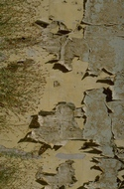 | when you can pull or scrape paint off  The paint is peeling off the back door.
- spots and stains |  | discoloration caused by spilled drinks, mud, and pet accidents. Spots are easier to clean than stains. Stains are usually permanent
- water damage | when stains are caused by water  Water damage can occur on floors, walls, and ceiling.
- isn’t working  aren’t working  doesn’t work |  |  | not functioning properly  The heat isn’t working.  The heat doesn’t work.

