Saint Patrick’s Day Vocabulary

- Ireland | a country in Western Europe | 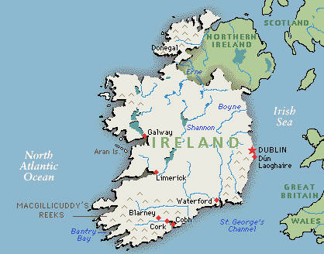
- Irish | the people, language, and things from Ireland
- legend | a story that has been told for many years
- leprechaun | a small make-believe person in Irish stories who knows about secret treasures
- parade | a public march of people to celebrate a special event
- patron saint | a person who takes special care of a country or group
- pinch | to press hard between two surfaces such as the finger and the thumb | 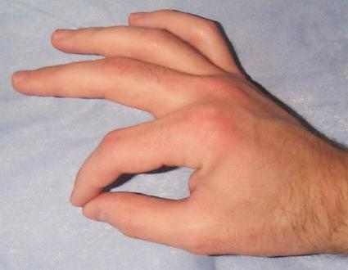
- rainbow | a curved line of many colors in the sky
- Saint Patrick | the patron saint of Ireland
- shamrock | a small green plant with three leaves
- tradition | a belief handed down from parents to children over many years
- treasure | gold, silver, money, or other valuable items that have been collected and stored up

