North Carolina Senator
Elizabeth Dole
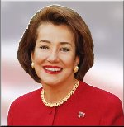
Republican

