School Supplies Vocabulary Matching

Draw a line from the word to the correct picture.

- crayon
- clipboard
- book bag
- notebook | 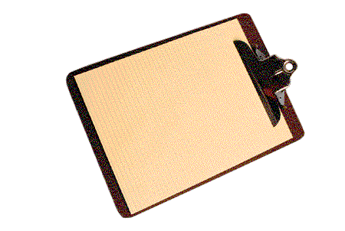
- glue
- pencil

