School Supplies Vocabulary

- book bag
- clipboard | 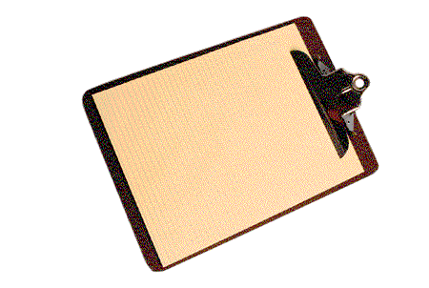
- colored pencil
- crayon
- eraser
- folder
- glue
- loose-leaf paper | 
- notebook
- pencil
- pencil sharpener
- scissor

