School Supplies
Someone/Anyone

Directions: Fill in the blanks below with “someone” or “anyone” and the correct word for each picture.
- Has _________________ seen my ________________?

- _________________ took my __________________. 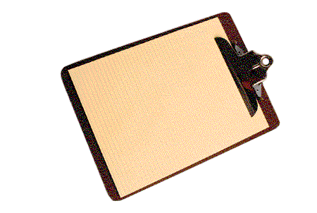
- Did _______________ borrow my ________________?

- I don’t think _____________ bought any _________.

- Does ___________ have an _________that I can borrow?

- Did ______________ see a red _______________?
- I’m pretty sure that _____________ has a bottle of ______.


- Does ______________ have a sheet of ______________?

- ____________ left a _______________ on my desk.

- This is _________________’s _________________.

- I don’t think _____________ has a _____________.

- Has _____________ seen my __________________?

