Safety Signs Vocabulary Matching

Draw a line from the word to the correct picture.

- No Passing Zone | 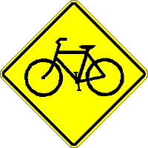
- Soft Shoulder | 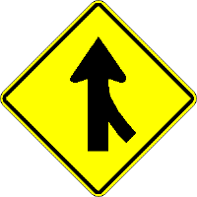
- Slippery When Wet | 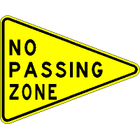
- Sharp Curve Ahead | 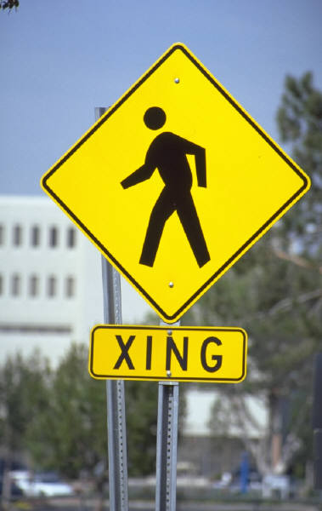
- Two-Way Traffic | 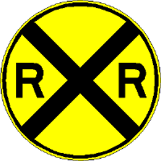
- Bicycle Crossing

- Pedestrian Crossing | 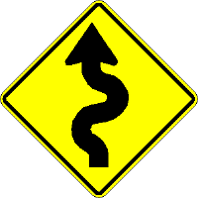
- Merging Traffic | 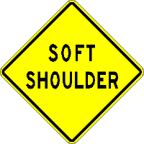
- School Crossing | 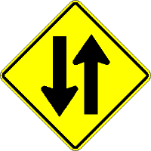
- Railroad Crossing | 