Safety Signs Vocabulary

- Bicycle Crossing | a sign that means watch out for people riding bicycles | 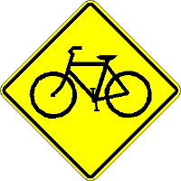
- Crossroads Ahead | a sign that means watch for cars entering or crossing road | 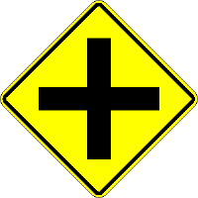
- Merging Traffic | a sign that means traffic may be merging into your lane. Be ready to change lanes or speed up | 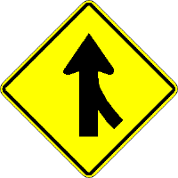
- No Passing Zone | a sign that means do not pass other vehicles | 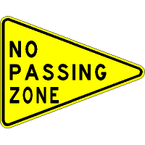
- Pedestrian Crossing | 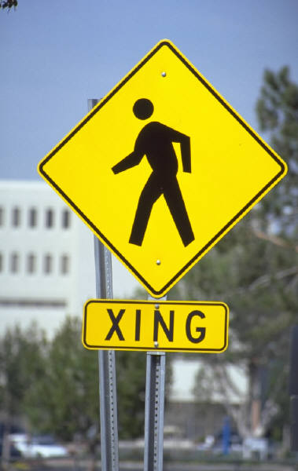  a sign that means watch out for people crossing or walking across the road.
- Railroad Crossing | a sign that means train may be coming so slow down and look | 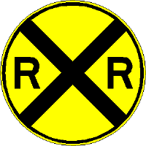
- School Crossing | a sign that means watch out for children walking to school | 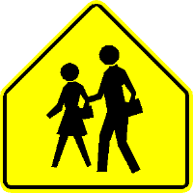
- Sharp Curve Ahead | a sign that means you should slow down | 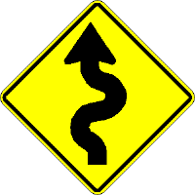
- Side Roads Ahead | a sign that means watch for cars entering or turning off the road | 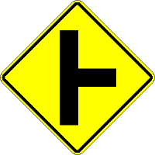
- Slippery When Wet | a sign that means slow down if the road is wet
- Soft Shoulder | a sign that means the unpaved edge of the road is soft. Stay on the pavement. | 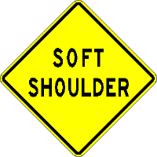
- Traffic Light Ahead | a sign that means slow down and prepare to stop
- Two-Way Traffic | a sign that means be careful when passing other vehicles | 