Safe Driving Practices Vocabulary

- air bag | 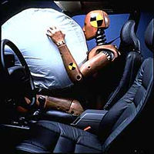
- brakes | what you use to slow down or stop a car
- caution | another word for careful
- child safety seat | a special seat for children in the car
- flagger | the person who holds the signs in a work zone; also called a flagman
- head lights | 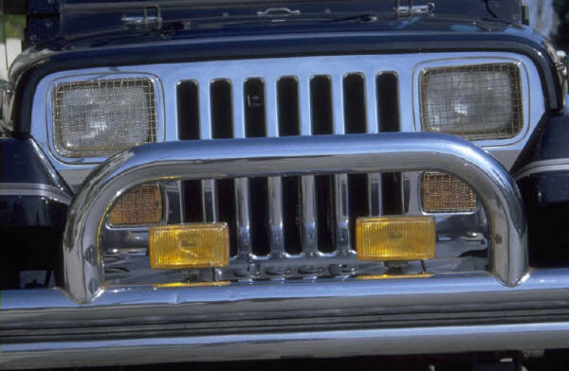  the lights on the front of the car.
- passenger | anyone who is riding in your car
- right of way | the right to use the road or intersection
- safe distance | putting enough space between your car and the car in front of you; not following too closely
- seat belt | a belt in a car that is worn over the shoulder and chest that keeps a driver or passenger from being thrown from the car
- tires
- work zone | 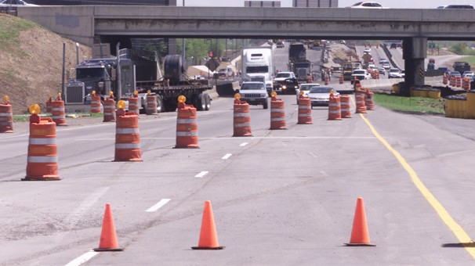  a section of the road or interstate that is being repaired or built

