Report Card Vocabulary

- absent | when a student is not at school
- art | a subject in school where a student learns about the works of artists | 
- conference | a meeting between the parents and the teacher to discuss the student | 
- failing | a grade below passing | F
- grade | a number or letter given to tell how a student is doing in his/her subjects
- mathematics | a subject in school where a student learns about numbers, also called math.
- music | a subject in school where a student learns about music; for example, chorus or band.
- passing | having good grades on a school subject
- physical education | a subject in school where students learn about sports and exercise, also called P.E. | 
- promoted | when a student has passed his or her classes and is moved to the next grade
- reading | a subject in school where a student learns how to read | 
- report card | a report sent to parents that tells how their child is doing in school. It contains grades for each subject. | 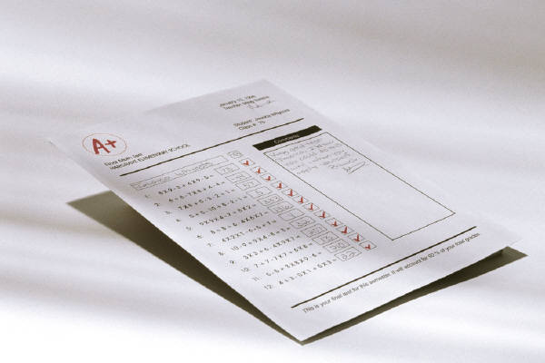
- science | a subject in school where a student learns about nature | 
- social studies | a subject in school where a student learns about history and civics | 
- spelling | a subject in school where a student learns how to spell
- subject | an area of study where the student learns Mathematics, Reading, Science, Social Studies
- tardy | when a student is late arriving to school
- writing | a subject in school where a student learns how to write | 

