Understand Police Departments Vocabulary

- arrest | to take to jail | 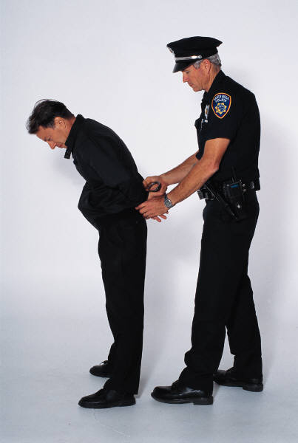
- burglary | entering or breaking into a building with the intention of theft
- citizen | a resident of a city or town
- complaint | an expression of dissatisfaction for something | He filed a complaint about the loud neighbors.
- crime | an activity that is against the law | Stealing from someone is a crime.
- criminal | someone who commits a crime
- patrol | moving around in an area to protect against criminal activity
- police department | a government building; the main job is to protect the citizens of a city or town
- police officer | someone who works for the police department | 
- respond | to go to a crime scene or an accident scene
- restore | to re-establish or bring back | The police officer restored peace in the neighborhood after the fight.
- theft | the act of stealing something
- violence | physical force in order to damage, hurt, or abuse

