The Story of Martin Luther King, Jr.

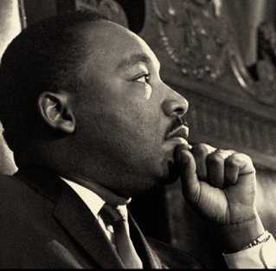
Martin Luther King, Jr. was a famous African American hero. He was born in Atlanta, Georgia, on January 15, 1929.

He grew up when it was hard for African American people in the United States. Unfair laws kept African American people apart from white people.

African Americans could not ride in the front of a bus. They could not eat in restaurants with white people. They could not go to churches or schools with white people. They could not use the same water fountains as white people. There were other unfair laws.

Martin Luther King, Jr. worked to change these unfair laws. Martin Luther King, Jr. believed in solving problems peacefully. He protested unfair laws. The laws were changed.

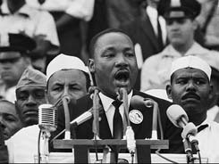
In 1963, Martin Luther King, Jr., led a march. He gave his "I have a dream" speech. In this speech he called for equal rights. He also told of his dreams for the future.

Someone who did not agree with Martin Luther King, Jr. shot and killed him. This made many people sad. Many people liked what he did to help all Americans.

Today, we honor Martin Luther King, Jr. on the third Monday in January each year. We call this holiday Martin Luther King, Jr.’s Birthday.

