Chief Justice
William H. Rehnquist
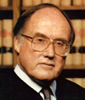

Associate Justice Clarence Thomas

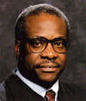

Associate Justice
Ruth Bader Ginsberg



Associate Justice
Stephen G. Breyer

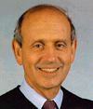
Associate Justice
John Paul Stevens
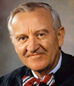

Associate Justice Sandra Day O’Connor

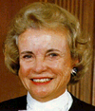

Associate Justice
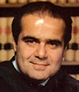
Antonin Scalia

Associate Justice
Anthony M. Kennedy

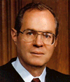
Associate Justice
David H. Souter
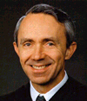

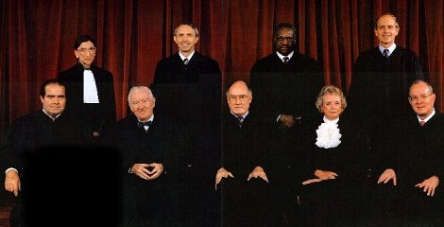
Current United States Supreme Court Justices

