Judicial Branch Vocabulary Sheet

1) Judicial Branch- the federal courts of the United States
2) judges- people who interpret the law

3) interpret- to translate; to find meaning

4) fair- just; right; honest

5) unfair- not just; not right; not honest

6) federal courts- halls of justice for the United States

7) highest- greatest; supreme

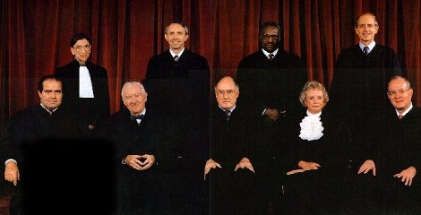
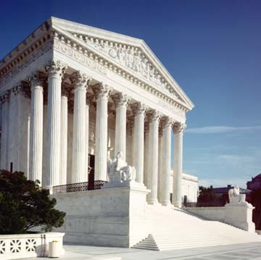
8) Supreme Court- the highest court in the United States

9) Associate Justices- 8 judges of the Supreme Court that are not the Chief Justice


10) Chief Justice- the #1 judge of the Supreme Court

11) appoint- to name or select

12) retire- to give up work; to stop working forever

