Identify Household Items, Appliances, and Kitchenware

Vocabulary

- blender | an appliance that chops, mixes, and makes juices | 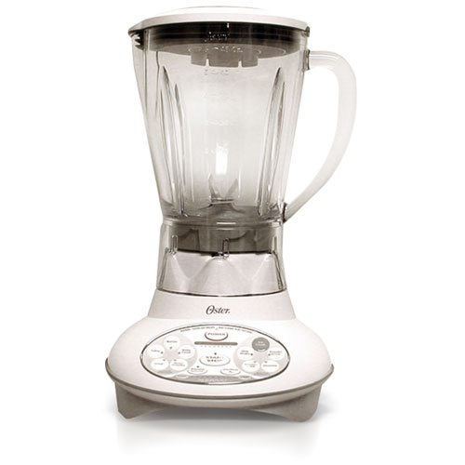
- coffee maker | a small appliance that brews coffee | 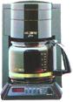
- dishwasher | an appliance that washes dishes | 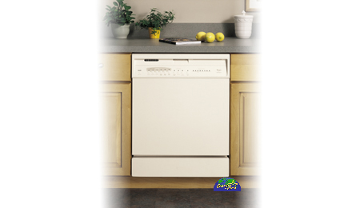
- dryer | an appliance that dries clothing | 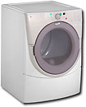
- irons | a small appliance that  uses heat to take wrinkles out of clothing | 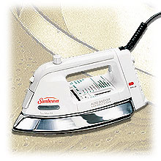
- microwave oven | a small oven that cooks food quickly | 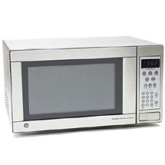
- mixer | an appliance that mixes ingredients together | 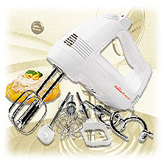
- oven | the part of the stove used for baking food | 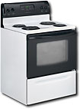
- refrigerator | an appliance that keeps food cold | 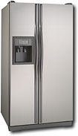
- stove | an appliance that supplies heat for cooking food
- toaster | a small appliance used to toast bread
- washing machine | an appliance that washes clothes | 