Identify Household Items, Appliances, and Kitchenware

Optional Vocabulary

- cabinets | shelves that are covered with doors | 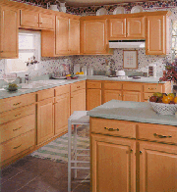
- can opener | a small appliance that opens cans | 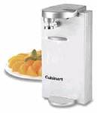
- crock pot | a small appliance that cooks foods very slowly; 8-10 hours | 