Government Vocabulary

- authority | power, leadership | 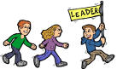
- decision | choice | 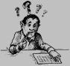
- enforce | to require obedience, sometimes by force | 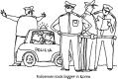
- govern | to control, to lead, to rule | 
- government | way for societies to make decisions | 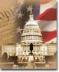
- law | rule or set of rules | 
- obey | to perform orders or tasks | 
- regulate | to manage | 
- society | group of people in an organization, community, or nation | 

