The Story of President George Washington

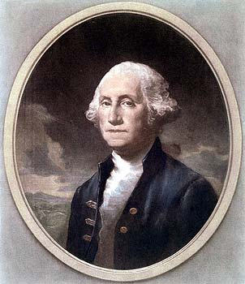
George Washington was born on February 22, 1732, in Virginia.

In 1759, he married Martha Custis. They moved to his home called Mount Vernon. They lived there many years.

George Washington led the army during the American Revolution. They fought for eight years before America was free from England.

He was elected the first president of the United States in 1789. He served for eight years and then moved back to Mount Vernon. He died on December 14, 1799.

George Washington is known as a great general who won independence for America. He is often called "the father of our country," because he was the first president of the United States.

His birthday is celebrated every year on Presidents' Day. It reminds us all of his honesty and great leadership.

