“For Rent” and “For Sale” Ads Vocabulary

- apartment  (apt.) | an individual room or rooms in a building where more than one family lives
- condominium  (condo) | a building divided into apartments that are owned by the people who live in them
- deposit  (dep.) | money that is paid in advance; pays for damages or the last month’s rent
- duplex  (dup.) | two apartments connected together
- for sale | available to buy
- furnished  (furn.) | furniture is provided
- half bath  (½ BA) | a bathroom that does not have a shower or a tub
- mobile home  (mh) (mfd hm) | a trailer connected to utilities and lived in; a manufactured home | 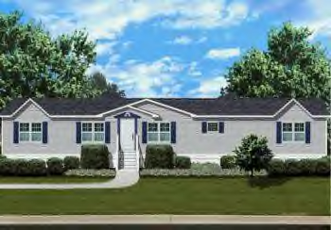
- references  (ref’s) | a statement of recommendation of someone’s character and dependability
- rent | money paid for the use of someone else’s property
- required  (req.) | needed; something you have to have
- utilities  (util.) | a service such as electricity and water

