Secretary of State General Colin Powell
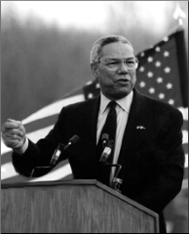

General Colin Powell helps President Bush guide the country.

