Secretary of Defense Donald Rumsfeld
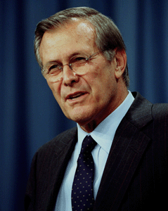

Donald Rumsfeld helps the president protect America.

